ANNEXURE
ANX.NO | CONTENT | PAGE NO
I | A BRIEF NOTE ON TEACHER EDUCATION | 2-4
II | INSTITUTION - PROFILE | 5-10
III | REGULATIONS AND SYLLABUS  (with effect from the academic year 2013-2014) | 11-29
IV | LAND USE CERTIFICATE & MASTER PLAN OF THE COLLEGE | 30-52
V | AUDITED INCOME - EXPENDITURE STATEMENT | 54-73
VI | TEACHING STAFF PROFILE | 74
VII | NON-TEACHING STAFF PROFILE | 75
VIII | CALENDAR | 76-104
IX | FEEDBACK QUESTIONNAIRE | 105-108
A | STUDENT TEACHERS FEEDBACK ON FACULTY | 105
B | STUDENT TEACHERS FEEDBACK ON CURRICULUM | 106
C | STUDENT TEACHERS FEEDBACK ON PRACTICE  TEACHING | 107
D | SCHOOL HEADS FEEDBACK ON STUDENT TEACHERS | 108
X | LIST OF TOP TEN ALUMNI | 109

ANNEXURE I
A BRIEF NOTE ON TEACHER EDUCATION
The Secondary Education commission (1952) rightly points out “We are convinced that the most important factor in the contemplated educational reconstruction is the teacher – his personal qualities, his educational qualification, his professional training and the place that he occupies in the school as well in the community.” The teacher occupies a very important place in the society because he brings about the transfer of the intellectual tradition from one generation to the next. He maintains the level of technological skill and keeps the light if civilization burning bright. He is expected to help in the silent social revolution that is taking place in the country. His duty does not end in the class room with his students. He owes as duty to the society and the nation. He should be abreast of the developments on the country and the world. He should be able to constantly adjust his methods and approach to suit the changing times.
OBJECTIVES OF TEACHER EDUCATION FOR SECONDARY STAGE:
- To posses competence to teach subjects of his specialization on the basis of accepted principles of learning and teaching in the context of the new school curriculum.
- To develop skills, understandings, interests and attitudes which would enable him to foster all round growth and development of the children under his care?
- To posses sufficient theoretical and practical knowledge of health and physical education, games and recreational activities and work experience.
- To develop understandings of psychological of growth and development, individual differences and similarities, and cognitive, psycho-motor and attitudinal learning.
- To develop skills in guiding and counselling the children in solving their personal as well as academic problems.
- To understand the role of the school in changing the society.
Teacher Preparation Course for Secondary Education, generally known as B.Ed., is a professional course that prepares teachers for upper primary/ middle level (Classes VI-VIII), Secondary (Classes IX – X) and senior secondary (Classes XI – XII) level.
The course duration is one academic year. The course programme comprises of 200 working days excluding examination and admission. 40 days are for practice teaching at upper/primary/secondary/senior level. The B.Ed., college entitled to commence admission after acquiring approval from NCTE and affiliation from University. The college has to get affiliation order from the University belonging to its jurisdiction.
The Tamil Nadu State Government has established a separate University for Teacher Education, under the banner “Tamilnadu Teachers Education University” at Chennai, which is in function from July 2008 onwards. After the establishment of this university all self finances College Education University only. For a college of Education comprising of one unit with 100 students the college has to appointment 1 Principle and 7 staff members.
A working day shall be of a minimum of 6 hours in a six day week, during which physical presence in the institution of Teachers and student – teachers in necessary to ensure their availability for individual advice, guidance dialogue and consultation as and when needed prevention.
Fire prevention faculty, Rain Water Harvesting, Provision Electricity, Safety certificate are all obtained from competent Authority.
As far as the university norms are concerned, the staff list is sent to the University for Approval. The admitted students list is also sent every year to Tamilnadu Teachers Education University for acquiring eligibility towards candidatureship.
Arrangements are made by the college for the conduct of university examination. The infrastructural facilities and learning resources are strengthened as per the suggestion offered by the visiting team members from University.
The college maintains all necessary registers and records pertaining to admission, attendance, scholarship, fees particulars, financial transactions etc.,
The college has to follow the guidelines prescribed by Tamilnadu Teachers Education University, Chennai from time to time with regard of minimum percentage of marks required for admission to B.Ed., degree course age limit, reservation rules and percentage of seats among optional subjects.
The syllabus prescribed by the Tamilnadu Teachers Education University is followed from the academic year 2008-09 onwards.
The college completes the working days prescribed by the university in the regulations prescribed for B.Ed. course in an academic year
The College collects tuition and other fees from the students at the rate as prescribed by the State Government/University.
The College has all infrastructural facilities as prescribed by NCTE and University.

ANNEXURE II
INSTITUTION- PROFILE
Sakthi College of Education for Women is a constituent unit of Sowdamman Charitable Trust, Dindigul – Palani Main Road, Oddanchatram. Sowdamman Charitable Trust was established on 26.11.2001 by the munificience and single minded devotion of the farsighted and noble hearted philanthropists Dr. K. Vembanan, M.B.B.S., M.S., Dr. V.Gokila Vembanan, M.B.B.S., DGO, with the guidance of Padmabhushan Arutchelvar Dr. N. Mahalingam.
Founded in the year 2007, the Sowdamman Charitable trust has been in the forefront of providing high quality education in the region of Dindigul, an upcoming yet-to-be developed region of Tamilnadu. Ours is the self financing college which was started in the year 2007, functioning at Dindigul district. It was affiliated to Mother Teresa Women’s University for the course of B.Ed in the year 2007 and in 2008 it is affiliated to Tamilnadu Teachers Education University (Recognition order no. TNTEU/R/Affin/Certificate/2012/704, Dated: 21.09.2012). The B.Ed course of this college recognized by NCTE in 12.11.2007 (Recognition order no. F.SRO/NCTE/B.Ed/ 2006-2007/14512, Code: APS08392)
The College strives to impart quality education, through a stimulating and innovative environment. Since inception, the college has been endeavoring to establish itself as a nodal center of learning and training.
OUR EMBLEM AND MOTTO
Our emblem has five symbols. It has one Holylamp in the middle. It also has the lamp and the book in the right and left side respectively. The bottom of the emblem, contain the sun and inside the sun, lotus is placed. The left side lamp indicates our students, and the book which is located in the right side, help the students to improve their knowledge. Because of this knowledge, our society will glow like the sun, and bloom like the lotus.
God’s divinity is manifested by his blessing to the mankind. It turn god expects us to serve the society, so that we may live this world fruitfully. So, every one’s aim ought to be “LIVE TO SERVE”.

COLLEGE OBJECTIVES
The main objectives are
- to empower Rural area Women through education
- to offer consultancy services for the development of women’s education in the district level.

OUR VISION
“INITIATE, INNOVATIVE, INCULCATE”
Sakthi Educational Institution pursues a philosophy of perpetual acquisition of knowledge. Apart from academic curriculum, equally important is our policy to provide value based education and to bring out the hidden potentials in students that equip them to approach life with optimism.
OUR MISSION
“To act as the nurturing ground for young professionals who seek to make their mark and to create a talent pool for various industries so that there may be synergetic growth for both.
It is also the mission of the college to provide the highest quality education at an affordable cost to students especially from poorest strata of the society and from an exclusively rural background of one of the most backward districts of Tamil Nadu.

QUALITY POLICY
Sakthi College of Education for Women is committed to provide quality education and achieve Institution of excellence is the fields of education with continual improvement.

The results of the University board examination are as follows.
Year | Pass Particulars
 | Course
 | B.Ed (%)
2007-08 | 87
2008-09 | 90
2009-10 | 93
2010-11 | 83
2011-12 | 87
2012-13 | 94

For Communication
Phone: 04553- 240597
Fax No: 04553- 242985
E-Mail: sakthibedwomen@gmail.com
Website: www.sakthibedwomen.com
RULES AND REGULATIONS FOR STUDENT TEACHERS
- Student should come at least 10 minutes before the commencement of the class.
- Every student should wish the teacher, as a mark of respect, when they meet him/her for the first time.
- When the teacher enters the class, every student should stand and wish him/her. Students should not sit till the teacher tells them to sit.
- It is the responsibility of the students to keep the buildings and properties of the institution clean and safe.
- Students should see the circulars and instructions in the notice board without fail. No reasons are accepted for the consequences of not seeing the notice board.
- Meetings and discussions by students are not allowed inside the campus.
- Students may inform their problems and demands to the principal in writing through the suggestion box.
- Students should not try to make or participate in any strike. Students who indulge in strike will be dismissed immediately.
- Students should always keep their identity card with them.
- All the students must maintain silence and discipline.
- Students should behave with respect both inside and outside the college. Disciplinary actions will be taken against a student who is against discipline codes.
- In case of need for the Transfer Certificate, students should pay all the fees in order to get their T.C.
- If the students indulge in any in disciplinary actions, they will be suspended or dismissed from the institution.
- Students cannot take leave for any reason except any physical illness. If they want to take leave in an unavoidable situation, they should get the permission of the Principal in advance.
- Students will be suspended or dismissed if they are irregular to class, disobedient to the teachers. Indifferent in classroom activities or indiscipline in speech and behavior.
- Students must have minimum 85% of attendance. Students won’t be allowed to appear for the University examinations if they have below 85% of attendance (As per the University norms).
- During the training period, students should follow all the rules and regulations of the Government as well as the college and the concerned teaching practice school.
- Students who indulge in ‘ragging’ will be immediately dismissed from the college.
- Students should come in clean and neat uniform.
- Disciplinary action will be taken against the students who do not follow the rules of the hostel.
- Students should not bring or use cell phones inside the campus.
- When the students go for teaching practice to other school, they should realize their duties and responsibilities and act according to the rules.
- Students those who do not come from home (Students who come from relatives / guardians house or those who stay in private hostels / rooms) have necessarily to provide a letter from their parents about their stay.
- Students are sincerely encouraged and strictly advised to take part in seminars, conferences, symposium, workshops etc., as many as they should.

FEE REGULATIONS
- The fee shall be paid by every new student before she is enrolled.
- The fees shall be paid not later than the 15th working day.
- For every payment, a receipt giving necessary particulars will be issued.
- If the fee is not paid within the date prescribed, the students name shall be struck off the rolls. If re-admitted she shall pay, in addition to the amount due at the time of dismissal a re-admission fee of Rs. 350/-
- If a student discontinues or leaves the college during the academic year they shall not have any right to claim of any portion of the fee.
- Student will not be allowed to sit for examination nor will their certificates be issued, until all their arrears fees are cleared.
- Holder of Scholarship is bound by all the foregoing rules.
- If fee is paid by draft, it must be drawn payable to Sakthi College of Education for Women, Oddanchatrm. Cheques will not be accepted.
- On any account, hostel Fees / deposit will not be adjusted for college year fees.

COLLEGE ASSOCIATION
The College association creates awareness among students, of their responsibility and provides them with opportunities for the development and exercises their leadership.
- The Tamil and English associate device to furthering the interest in library matters.
- The science association helps them to acquire up-to-date information in the field of science.
- The quiz club affords an opportunity to widen their knowledge in general.
- The mathematics club sharpens their intellectual dexterity and thirst for knowledge.
- The fine arts club offers excellent opportunity for self expression and development of its members.
- Students are expected to participate in extra – curricular activities are necessary for the complete development of character and personality.
- The college offers sports games facility to all the students with aim to develop qualities of sportsmanship.

LIBRARY RULES
- Perfect silence should be maintained in the library.
- Library is open to students from 8.45 a.m to 5.30 p.m on all the days of the week except on sundays and Government holidays.
- Books will be issued only on presentation of the library card-bearing the name, class roll number and signature of the student.
- Library books should be handled with care; marking on books is most objectionable.
- The library book is damaged or lost; the person responsible should replace it with a new copy.
- No one is allowed to sub-lend the book taken but by him/her.
- Students must, on receiving a book, examine and report to the librarian if any damage finds therein otherwise they will be held responsible for any damage that may afterwards be detected.
- Students are entitled to keep a book for a week from the date of issue.
- If the book is not returned on or before the due date a fine on daily basis will be levied including holidays. The students will not be allowed to use the library till the fine is pad and the book returned.

BUS FACILITY
College bus facility is available for the convenience of local students as well as students from the following places.
- Dindigul
- Naikarapatti
- Kovillur
- Vadamadurai
- Pattiveeranpatti
- Idiakottai
- Markampatti
- Chinnalapatti
- Vagarai
- Nallroad

NOTE TO PARENTS
Parents and guardians are requested to participate in the academic progress and conduct of their wards and respond to all the communications sent by the college authorities. Parents must attend the Parents Teacher Association meetings conducted periodically by the college.

COLLEGE WORKING HOURS
Morning Session
9.30. a.m. to 12.15.P.m.
Afternoon Session
- P.m.to 4.45 p.m.

ANNEXURE II
REGULATIONS AND SYLLABUS
(with effects from the academic year 2013-2014)

1. ELIGIBILITY FOR ADMISSION TO THE COURSE
A candidate shall be eligible for admission to the course leading to the degree of Bachelor of Education (B.Ed.) provided:
- The candidates who have undergone 10+ 2+3+(15) or 11+1+3(15) pattern of study and passed the X and XII examinations conducted by the respective state board or CBSE or any other recognized board of Education / Examination and UG Degree examination of the UGC approved Universities in any one of the school subjects offered by the Directorate of School Education at the Secondary / Higher Secondary Education level or its equivalent as it is decided by the Equivalence Committee appointed by Government of Tamilnadu from time to time.
- Candidates who have passed the UG or PG degree in Open Universities System without qualifying in 11 years SSLC examination and 1 year of Pre-University Course (PUG) examination or 10+2 pattern of school education examination shall not be considered for admission.
- However, candidates not qualified in XII examination or PUC but possessing 2 years bachelor preparatory programmer certificate/ 2 years foundation course certificate /2 years diploma course conducted by State Government /recognized Universities and qualified with three years UG degree course are also considered to be eligible for admission.
- Candidates who have studied more than one main subject in part III (under double/ triple major system) of UG degree course should have to choose only one of the main subjects and should have applied for that optional only. In such cases, marks obtained by the candidates in Two/Three major subjects shall be taken into account to arrive percentage of marks stipulated I item.
- Candidates who have passed under double degree / Additional degree programme with less than three years duration are not eligible for admission.
- Candidates who have qualified in PG degree (5 year integrated course ) under10+2+5 or 11+1+5 pattern of study shall considered for admission in such cases ,the marks obtained by the candidates in the first three years ( in major and ancillary / allied subjects alone ) of the course alone shall be takes into account for admission.
- Candidates with the following marks (which is subject to the decision of Government of Tamilnadu from time to time) in the bachelor’s degree are eligible for admission to the course other than subjects like Economics, Commerce, Home Pcience, Solitical Science, Sociology, Psychology, Philosophy, Logic and Indian Culture for which PG qualification is mandatory.

Community Minimum Marks
OC 50%
BC 45%
MBC/DNC 43%
SC/ ST 40%
Note:
- Marks obtained by the candidates in U.G degree course Part III Major and allied including practical’s (other than Economic, Commerce, Home Science, Political Science, Sociology, Psychology, Philosophy, Logic and Indian Culture) alone shall be taken into account to arrive at the percentage of marks mentioned above.
- Marks obtained by the candidates in PG degree (other than Economics, Commerce, Home Science, Political Science, Sociology, Psychology, Philosophy, Logic and Indian Culture) shall not be considered for admission.
- Rounding off of marks to the next higher integer will not be permitted

(viii) Candidates who have passed PG degree in Economics, Commerce, Home Science, Political Science, Sociology, Psychology, Philosophy, Logic and Indian Culture without undergoing 10+2+3 or 11+1+3 pattern of education shall not be considered for admission.
(ix) In the case of Physically or Visually Challenged candidates, a minimum pass in the degree is enough.
(x) Post graduate candidates in Economics, Commerce, Home Science, Political Science, Sociology, Psychology, Philosophy, Logic and Indian Culture with 50% (irrespective of their UG mark) of marks in PG degree or in the interdisciplinary subjects which are being declared equivalent by the respective University can apply.
However, the basis of selection shall be in accordance with the Regulations of the University/Government of Tamilnadu guidelines for admission to B.Ed. course in force from time to time.
2. DURATION OF THE B.Ed., COURSE:
The course of study shall be for duration of one academic year consisting of 200 working days/ Curriculum transaction days or 1200 hours (6 days per week @ 6 hours per day) excluding admission and examination days. The 200 working days will include 148 curriculum transaction days, 40 teaching practice days, 7 revision examination days and 5 days as study holidays.
3. PROGRAMME CONTENT:
The Programme will consist of a theory component and a practicum component.
Theory component
Theory component consists of Three Core Courses, one Elective Course and Two Optional Courses with the following descriptions.
L-Lecture – T- Tutorial: Practical/ Project Work
SL.No | Courses | L | T | P | Total
I. | Core courses
1. | Education in the Emerging Indian Society | 60 | 20 | 20 | 100
2. | Psychology of Learning and Human Development | 60 | 20 | 20 | 100
3. | Educational Innovations and Management | 60 | 20 | 20 | 100
II. | Elective Course | 45 | 15 | 15 | 75
III. | Optional Courses
1. | Optional I | 60 | 20 | 20 | 100
2. | Optional II | 60 | 20 | 20 | 100
IV | General
1. | Life Skills Course | 5 | - | 5 | 10
2. | First Aid | 5 | - | 5 | 10
3. | Moral and Value Education | 5 | - | - | 5
 | Total for Theory Component | 360 | 115 | 125 | 600
DETAILS OF COURSES INCLUDED IN THEORY COMPONENT
i) CORE COURSES.
- Education in the Emerging Indian Society.
- Psychology of learning and human Development
- Educational Innovations and Curriculum Development

ii) ELECTIVE COURSE.
Each college will offer minimum of any four elective courses from the list give below. A student shall choose any ONE of the elective courses by the respective college.
1. Early Childhood Education
2. Human Rights Education
3. Peace and value Education
4. Environmental Education
5. Guidance and Counseling
6. Perspectives in Special Education
7. Computers in Education
8. Educational Administration and Management
9. Pre – Primary Education
10. Physical and Health Education
11. Library and information Resource Management
12. Safety and Disaster Management Education
13. Professional Course for Teacher Proficiency

Note:
Foe all the Elective Courses opted by the students the concerned institution should conduct Minimum of Five subject specific filed based activities for each elective course during the course of study.
(III) OPTIONAL SUBJECTS
Each undergraduate has to study 1st optional course based on their parent disciplines teaching methodologies. The 2nd optional course should be English/Tamil/Urdu.
However, in the case of English (B.A. and M.A. English Literature), Tamil (B.A, B.Lit. & M.A. Tamil Literature) and Urdu (B.A. and M.A. Urdu) candidates, their optional I will be Innovations in Teaching English / Tamil and optional II will be content and methods of teaching English / Tamil / Urdu. Post Graduate candidate has to study.
Optional – I and Optional – II papers based on their major subjects in PG only.
EXPLANATORY NOTE
Degree | Major Subject | Optional Subject-I | Optional Subject-II
B.lit | Tamil or its Equivalent | Innovations in the Teaching of Tamil | Content and Methods of Teaching of Tamil
B.A | Tamil or its Equivalent | Innovations in the Teaching of Tamil | Content and Methods of Teaching of Tamil
M.A | Tamil or its Equivalent | Innovations in the Teaching of Tamil | Content and Methods of Teaching of Tamil
B.A | English or its Equivalent | Innovations in the Teaching of English | Content and Methods of Teaching of English
M.A | English or its Equivalent | Innovations in the Teaching of English | Content and Methods of Teaching of English
B.Sc. | Mathematics or its Equivalent | Content and Methods of Teaching Mathematics | Content and Methods of Teaching English
 |  |  | Content and Methods of Teaching Tamil
M.Sc. | Mathematics or its Equivalent | Innovations in the Teaching of Mathematics | Content and Methods of Teaching Mathematics (H.S. Level)
B.Sc. | Physics or its Equivalent | Content and Methods of Teaching Physical Science | Content and Methods of Teaching English
 |  |  | Content and Methods of Teaching Tamil
M.Sc. | Physics or its Equivalent | Innovations in the Teaching of Physical Science | Content and Methods of Teaching physical Science (H.S. Level)
B.Sc. | Chemistry or its Equivalent | Content and Methods of Teaching Physical Science | Content and Methods of Teaching English
 |  |  | Content and Methods of Teaching Tamil
M.Sc. | Chemistry or its Equivalent | Innovations in the Teaching of Physical Science | Content and Methods of Teaching physical Science (H.S. Level)
B.Sc. | Botany or its Equivalent | Content and Methods of Teaching Biological Science | Content and Methods of Teaching English
 |  |  | Content and Methods of Teaching Tamil
M.Sc. | Botany or its Equivalent | Innovations in the Teaching of Biological Science | Content and Methods of Teaching Biological Science (H.S. Level)
B.Sc. | Zoology or its Equivalent | Content and Methods of Teaching Biological Science Paper I | Content and Methods of Teaching English
 |  |  | Content and Methods of Teaching Tamil
M.Sc. | Zoology or its Equivalent | Innovations in the Teaching of Biological Science | Content and Methods of Teaching Biological Science (H.S. Level)
B.Sc. | Computer Science or its Equivalent | Content and Methods of Teaching Computer Science | Content and Methods of Teaching English
 |  |  | Content and Methods of Teaching Tamil
M.Sc. | Computer Science or its Equivalent | Innovations in the Teaching of Computer Science | Content and Methods of Teaching Computer Science (H.S. Level)
B.A. | History or its Equivalent | Content and Methods of Teaching History | Content and Methods of Teaching English
 |  |  | Content and Methods of Teaching Tamil
M.A | History or its Equivalent | Innovations in the Teaching of History | Content and Methods of Teaching History (H.S. Level)
B.A | Geography or its Equivalent | Content and Methods of Teaching Geography | Content and Methods of Teaching English
 |  |  | Content and Methods of Teaching Tamil
M.A | Geography or its Equivalent | Innovations in the Teaching of Geography | Content and Methods of Teaching Geography (H.S. Level)
M.A | Economics or its Equivalent | Innovations in the Teaching of Economics | Content and Methods of Teaching Economics
M.Com | Commerce or its Equivalent | Innovations in the Teaching of Commerce | Content and Methods of Teaching Commerce
M.Sc. | Home Science or its Equivalent | Innovations in the Teaching of Home Science | Content and Methods of Teaching Home Science
M.A | Political Science/Sociology, Psychology, Logic, Philosophy, Indian Culture or its Equivalent | Innovations in the Teaching of Social Science | Content and Methods of Teaching Social Science

WEIGHTAGE GIVEN FOR THEORY COMPONENT
Mark wise weightage given to three Core courses, two Optional courses and one Elective course is given below
Sl.  No | Theory component | Title of the papers |  | Maximum Marks(100)
I | Core courses |  | Internal Marks |  | External Marks
1. |  | Education in the Emerging Indian Society | 20 |  | 80
2. |  | Psychology of Learning and Human Development | 20 |  | 80
3. |  | Educational Innovations and Curriculum Development | 20 |  | 80
II | Elective course | Any one of the Electives given in the list | 20 |  | 80
III | Optional courses
1. |  | Optional-I | 20 |  | 80
2. |  | Optional-II | 20 |  | 80
IV | General | - Life skills course  - First Aid  - Moral and Value Education | Mark wise weightage is not given. It is only for internalizing all the life related skills, first aid, moral and value education
Total weightage for Theory Component |  |  | 600

COMPONENTS OF INTERNAL ASSESSMENT
Sl.  No | COMPONENT | MAXIMUM MARKS
1 | TESTS  (Aggregate of marks obtained by each candidate in minimum 3 class tests converted into 5) | 5
2 | ATTENDANCE  (Weightage for Attendance)  85% and above - 5 marks  80% to 84% - 4 marks  75% to 79% - 3 marks  Less than 75% - No marks | 5
2 | ASSIGNMENTS  (Aggregate of marks obtained by each candidate in minimum 2 assignments converted into 5) | 5
3 | SEMINAR | 5
Total |  | 20

PRACTICUM COMPONENT
The practicum component consists of the following activities.
Sl. No | Name of the Activity | Name of the Files/Records to be prepared | No. of Hrs.
1. | Observation for optional I | Observation Record optional I | 175
2. | Demonstration for optional I | Demonstration Record optional I
3. | Micro Teaching for optional I | Micro Teaching file optional I
4. | Practice Teaching for optional I | Lesson Plan Record optional I
5. | Preparation of instructional Aids/Materials for optional I | Instructional Material Record optional I
6. | Construction of an achievement test and interpretation of test scores for optional I | Test and Measurement file Optional II | 25
7. | Observation for optional II | Observation Record Optional II | 175
8. | Demonstration for optional II | Demonstration Record Optional II
9. | Micro Teaching for optional II | Micro Teaching Record Optional II
10. | Practice Teaching for optional II | Lesson Plan Record Optional II
11. | Instructional Aids/Materials for optional II | Instructional Material Record optional II
12. | Construction of an achievement test and interpretation of tests scores for optional II | Test and Measurement Record Optional II | 25
13. | Application of Educational Technology (Development of Multimedia package in their parent disciple) | Educational Technology Record | 25
14. | Case study (Individual student case study) | Case Study Record | 13
15. | Conducting Psychology Experiments | Psychology Experiments Record | 25
16. | Environmental Education Activities | Environmental Education Record | 6
17. | Citizenship Training Camp(CT camp) | CT camp Record | 25
18. | Physical Education | Physical Education Record | 14
19. | SUPW | SUPW Record and Products | 10
20 | School Text Book Review pertaining to Optional I | Text Book Review Record for optional I | 10
Total hourwise weightage for Practicum component |  |  | 528

a) Description with reference Practicum components:
1. Observation of relevant subject’s Senior Teachers classroom teaching before
commencement of internship/teaching practice (Minimum of 5 curriculum transaction
periods/sessions for each optional course)

2. Demonstration by subject Expert/Teacher Educator (Minimum of one class).

3. Teaching skills development - Micro Teaching practice for developing 5 teaching skills in
each optional

4. School based internship/teaching practice
- The practice teaching will have to be undergone on any one of the recognized schools approved by State/CBSE/Matriculation/ICSE/ or any other recognized Board for a continuous period of 40 working days inclusive of teaching of both the optional. Medium of internship/teaching practice may be decided by the Principals of Colleges of Education in consultation with the respective teacher educators based on the communication abilities of student –teachers in either English or Tamil.

- All graduates who obtained admission based on their UG mark should undergo internship/Teaching practice at upper elementary level classes i.e from Std.VI to VIII for all subjects and at secondary level classes i.e Std.IX and X for the relevant subject studied at the UG level. All Post Graduates in any one of the higher secondary level school subjects should undergo the internship/ Teaching Practice at upper elementary, secondary and higher secondary levels.

- However, post graduates in Economics, Commerce and Accountancy, Home Science, Political Science, Sociology, Psychology, Logic, Philosophy and Indian Culture should undergo the internship/ teaching practice only at the higher secondary level for their master subject.

Teaching of Optional Course I
- Preparation of lesson plans (20 lesson plans)
- Preparation and use of Educational Software materials based on their teaching lessons (minimum 2 teaching aids for each lesson plan)
- Preparation of Self-learning packages (Based on the principles of Linear programming-minimum of 25 frames)
- Downloading Web resources related to the optional course and evaluating the same.

Teaching of Optional Course II
- Preparation of lesson plans (20 lesson plans)
- Preparation and use of Educational Software materials based on their teaching lessons (minimum 2 teaching aids for each lesson plan)
- Preparation of Self-learning packages (Based on the principles of Branching programming-minimum of 15 frames)
- Downloading Web resources related to the optional course and evaluating the same.
- Preparation of Instructional Material Record, Preparation and use of AV aids based on Edger Dale’s Cone of Experience.
- Construction and Administration of Teacher made Achievement test, analysis and interpretation of test scores.
- 7 to 12 All these activities have to be carried out as above for optional II
13. Integrating Emerging Educational Technologies (Development of Multimedia
Package in their Parent discipline only)
14. Case Study (Individual)
15. Conducting Psychological Experiments (Any six out of the following). Each student-
teacher has to perform any 4 psychology experiments from Group A and 2
psychology experiments from Group B.

Group A Group B
(Related to Adolescence) (Related to Childhood)
- Intelligence 1. Distraction of Attention
- Learning 2. Division of Attention
- Transfer of Training 3. Creativity
- Aptitude 4. Piaget’s task
- Adjustment 5. Non-Verbal Intelligence
- Concept Formation 6. Sociometry
- Level of Aspiration 7. Measure of Anger
- Interest 8. Emotional Stability
- Personality Types 9. Moral Values
- Attention 10. Motivation
- Creativity 11. Span of Attention
- Achievement Motivation 12. Motor Skills

16. Environmental Education related activities
17. Camp: A 5 day Citizenship Training Camp either inside or outside the campus including
night stays which are different from scout camp/ Guides camp/NSS Camp should be
organized. All activities conducted in the five day Citizenship Training Camp should help
the student teachers to develop civic sense and social skills.
18.Physical Education related activities
19. SUPW: Each Student teacher should acquire experience in the preparation of any fove
socially useful products which are tangible.
20. Text book review: Each Students teacher should review a school text book relevant to the
subject of Optional I (Major Based Subject) and prepare a report.

Life Skills Course:
Life Skills Course should consist of experiences related to
a. Stress Coping Management b. Transaction Analysis
c. Communication skills Development d. Self Awareness and Self Motivation
e. Positive-thinking f. Emotional Intelligence
g. Time Management h. Empowerment

This course should be organized as a bridge course soon after the commencement of the curricular transaction days.
4. MEDIUM OF INSTRUCTION
Each candidate admitted into B.Ed. course in any one of the colleges of education affiliated to Tamil Nadu Teachers Education University needs to select the Medium of instruction either as English or as Tamil (as per the availability of Medium of Instruction in the Colleges of Educational). After the last date of admission, Principals of the Colleges of Education should submit the name list along with the Medium of Instruction opted by each candidate to Tamil Nadu Teachers Education University. In case, if the admitted candidates prefer to change their medium of instruction at later stage of the course it should be permitted only after obtaining necessary written permission from the Tamil Nadu Teachers Education University, prior to the publication of Nominal Roll. Medium of instruction chosen by the candidate to pursue the B.Ed course will be indicated in the B.Ed course transfer certificate alone. Class room instruction shall be carried out separately for the different medium of instruction.

5. ATTENDANCE
Each candidate whose admission is approved by Tamil Nadu Teachers Education University should gain 85% (i.e 170 days) of attendance, failing which they will not be permitted to appear for the B.Ed degree examination. However, as per the decision of the syndicate of Tamilnadu Teachers Education University in its meeting held on 10.08.2010 candidates who are able to gain attendance only upto 75% on medical ground will be permitted to appear for the examination after getting condonation of attendance, adhering to the norms of Tamilnadu Teachers Education University.

6. EXAMINATIONS
Each candidate whose admission is approved by Tamilnadu Teachers Education University should apply for the practical examination and written examinations in the first attempt itself. Candidates who have failed to satisfy the minimum attendance norms of Tamilnadu Teachers Education University will not be permitted to appear for the written examination. Such candidates’ appearance in the practical examination will stand cancelled automatically.

7. WRITTEN EXAMINATIONS
The written examinations will be conducted by the university after the completion of 200 working days. The written examinations will be held for three Core Courses, one Elective Course and two Optional Courses.

Each theory course question paper will be designed for 3 hours duration which consists of Section A, sectional B and Section C with the number of questions and allotments of marks as described below.
Section | Type of Questions | Marks | Total Marks | Maximum word limit for each answer
A | Very Short Answer Type Questions with open choice (Any Ten Questions out of Twelve Questions) | 10 x 2 | 20 | 50 words for each question
B | Short Answer Type Questions with open choice  (Any Six Questions out of Eight questions) | 6 x 5 | 30 | 200 words for each questions
C | Essay Type Questions with Internal Choice ( Two Essay Questions) | 2 x 15 | 30 | 600 Words for each questions
Total Marks |  |  | 80

PASSING MINIMUM FOR WRITTEN EXAMINATION
Each candidate should apply for the written examination in the first attempt. A candidate shall be declared to have passed the Written Examination only if he or she secures not less than 50% in aggregate each of the six courses, with a minimum of 45 % in the external examination in each paper. All other candidates shall be deemed to have failed written examination. A candidate who fails in one or more courses in the written examination shall be permitted to appear again only for those courses in which he/she failed.
REVALUATION / RETOTALLING
A candidate applying for revaluation / retotalling should have secured a minimum of 18 marks and above in the External examination to become eligible for revaluation / retotalling (i.e) 50% of 36 marks minimum required to get a pass = 18 marks. Revaluation / retotalling is eligible for those candidates who appear in the main examination only.
Candidates can apply for either retotalling or revaluation or both to the Tamilnadu Teachers Education University within 10 days after the publication of results by paying necessary fee prescribed by the University.
REAPPEARANCE FOR WRITTEN EXAMINATION
Each unsuccessful candidate shall be permitted to reappear for the written examinations within the next three consecutive academic years.
8. PRACTICAL EXAMINATION
Tamilnadu Teachers Education University will conduct practical examination three months prior to the commencement of written examination. A Panel consisting of three external members (one Convener, one member and one Headmaster/ Headmistress / Assistant concerned) appointed by the University will examine the teaching competency of each candidate and also his / her practical works, records and instructional materials.
Students should develop and maintain Work Books, Record Note Books and Other Reports of the activities related to all practicum components bearing the following weightage.

Activity No |  | Name of the Record to be submitted | Marks allotted
Group - A
1. |  | Teaching Competency- Optional I | 80
2. |  | Lesson Plan Record - Optional I | 20
3. |  | Teaching Competency- Optional II | 80
4. |  | Lesson Plan Record - Optional II | 20
Group – A Total |  |  | 200
Activity No |  | Name of the Record to be submitted | Marks allotted
Group - B
5. | Observation Record - Optional I |  | 05
6. | Demonstration Record - Optional I |  | 05
7. | Micro Teaching Record -Optional I |  | 10
8. | Instruction Material Record - Optional I |  | 15
9. | Test and Measurement Record- Optional I |  | 15
10. | Test Book Review Records pertaining to Optional I |  | 10
11. | Observation Record for Optional II |  | 05
12. | Demonstration Record for Optional II |  | 05
13. | Micro Teaching Record for Optional II |  | 10
14. | Instruction Material Record - Optional II |  | 15
15. | Test and Measurement Record- Optional II |  | 15
16. | Case Study Record |  | 20
17. | Psychology Experiments Record |  | 20
18. | Educational Technology Record |  | 10
19. | Environmental Technology Record |  | 10
20. | CT Camp Record |  | 10
21. | Physical Education Record |  | 10
22. | SUPW Record |  | 10
Total Marks |  |  | 200

Passing Minimum for Practicum Components
Each candidate should apply for the practical examination in the first attempt. Candidate who have secured not less than 50% in each of the practical activities for which weightage is given shall be deemed to have passed in the practical examination. Others will be treated as unsuccessful candidates in the practical examination.
All the records related to the Practical Components should be made available to the duly appointed Practical Examination Board at the time of Practical Examination and their decision on the marks to be awarded shall be final.
Reappearance for Practicum Component
Each unsuccessful candidate shall be permitted to reappear for the practicum components examinations within the next three consecutive academic years in the main examinations only.
Classification of Successful Candidates
A candidate shall be awarded the B.Ed degree if he / she passed both the thory component and the practicum components. Successful candidates shall be classified as specified hereunder by taking into account of the their secured marks in Theory and Practical Examination separately.
CLASSIFICATION FOR WRITTEN EXAMINATION
Percentage of Marks Classification
50 to 59 Second Class
60 to 74 First Class
75 and Above Distinction
CLASSIFICATION FOR PRACTICUM COMPONENTS
Percentage of Marks Classification
50 to 59 Second Class
60 to 74 First Class
75 and Above Distinction

Marks Secured in Activities GROUP A | Marks Secured in Activities Group B | Over all Classification for Practicum components
I Class | I Class | I Class
II Class | I Class | II Class
I Class | II Class | II Class
Distinction | I Class | I Class
I Class | Distinction | I Class
Distinction | Distinction | Distinction

OVER ALL CLASSIFICATION
Theory | Practical | Over all
I Class | I Class | I Class
II Class | I Class | II Class
I Class | II Class | II Class
Distinction | I Class | I Class
I Class | Distinction | I Class
Distinction | Distinction | Distinction

ANNEXURE IV
LAND USE CERTIFICATE & MASTER PLAN OF THE COLLEGE
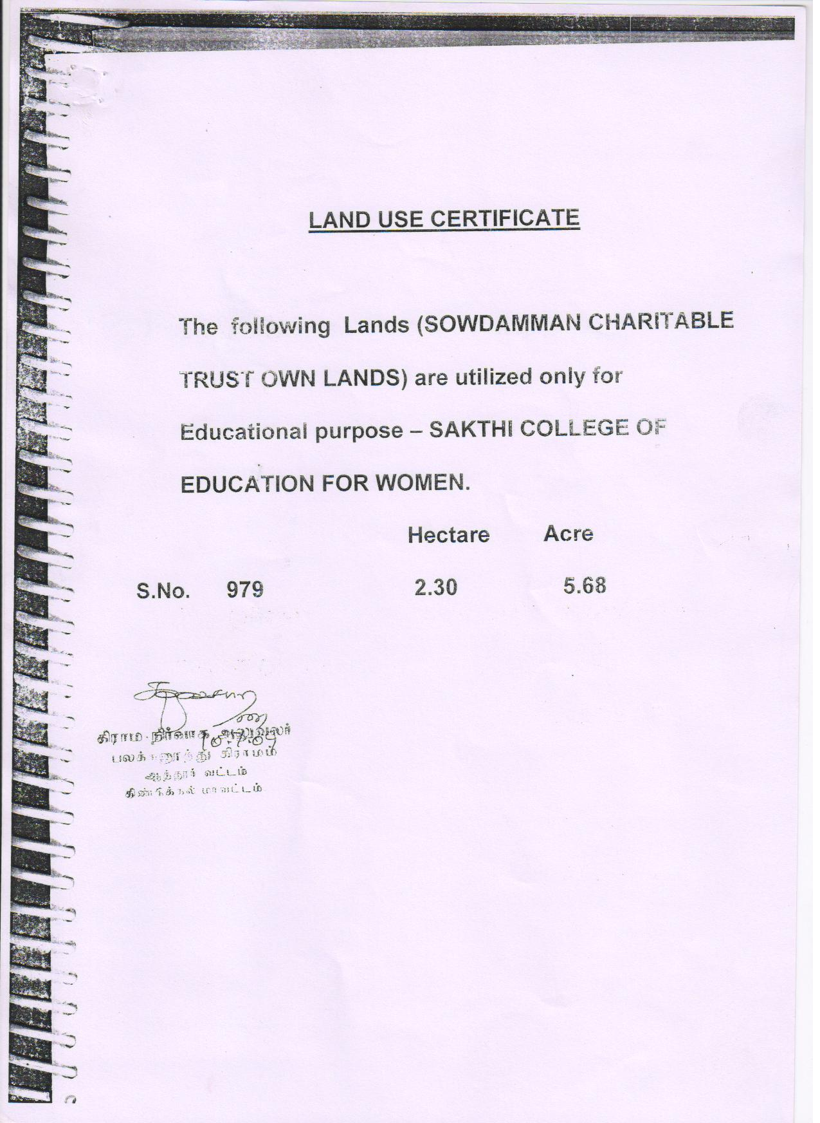
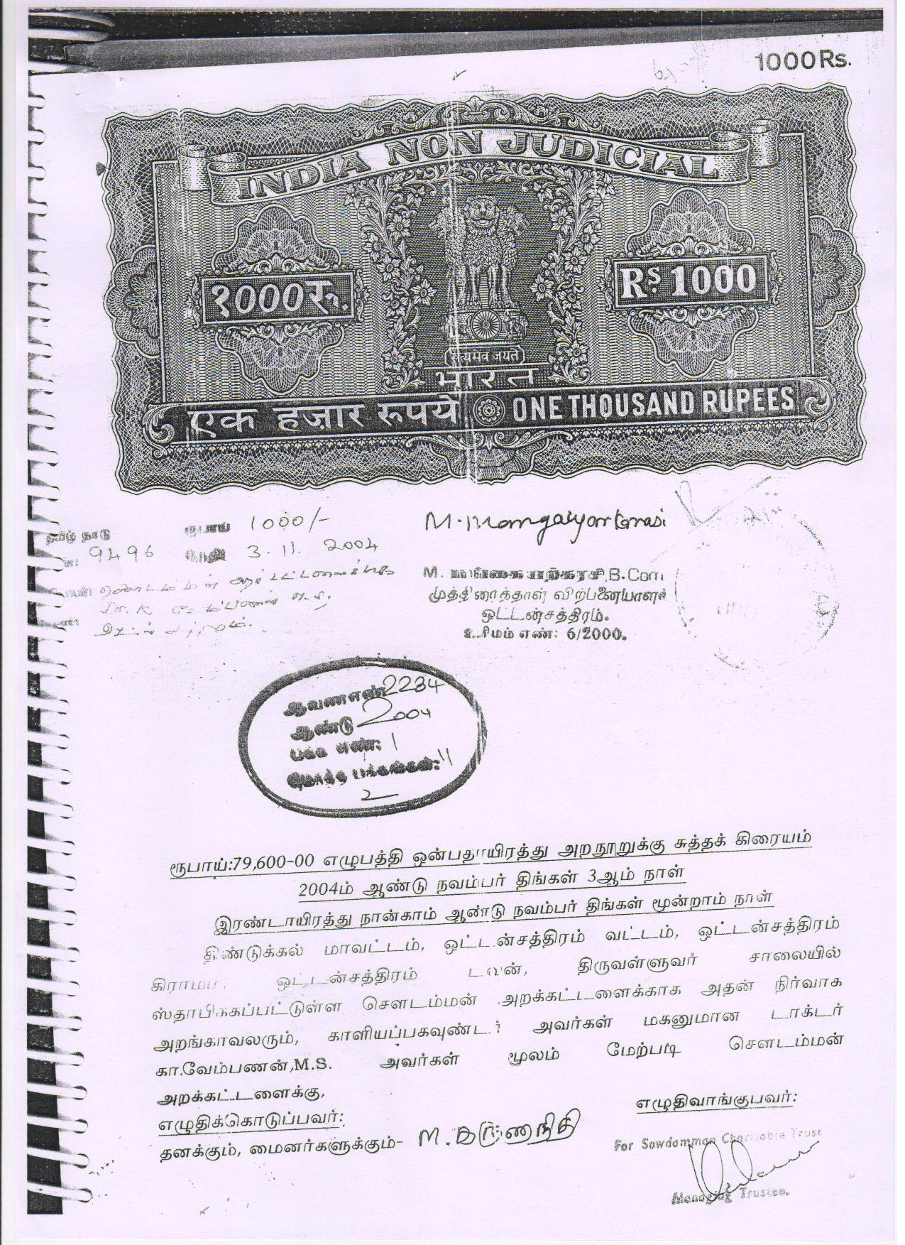

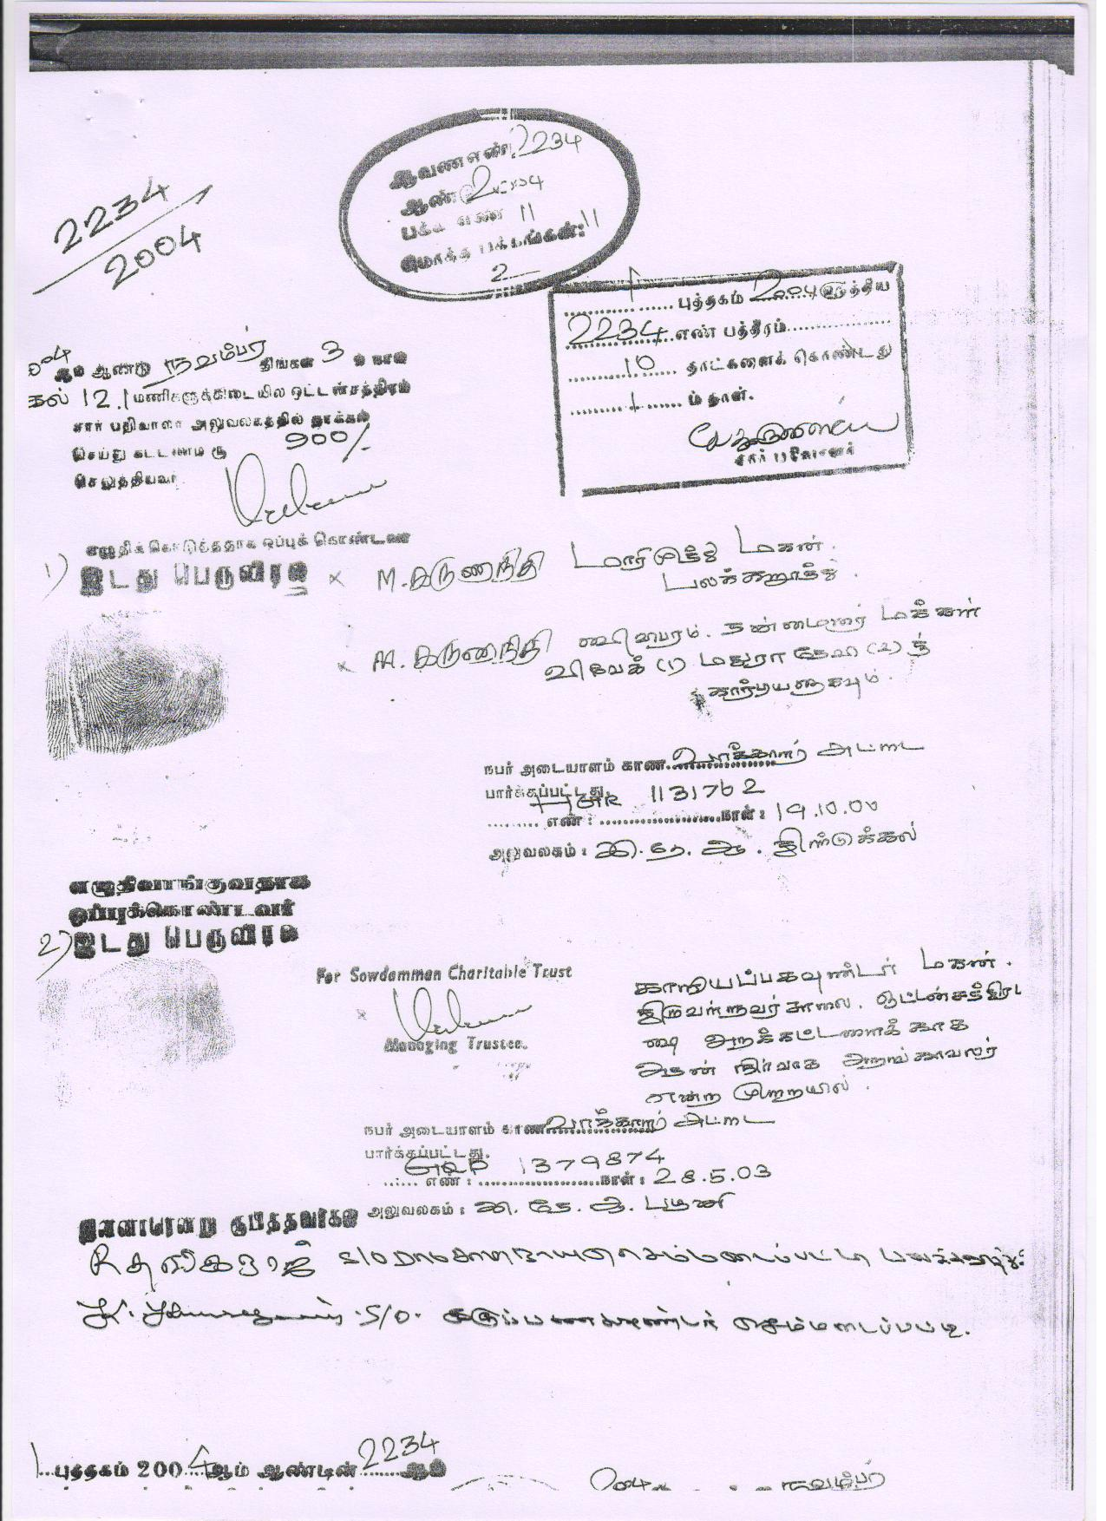

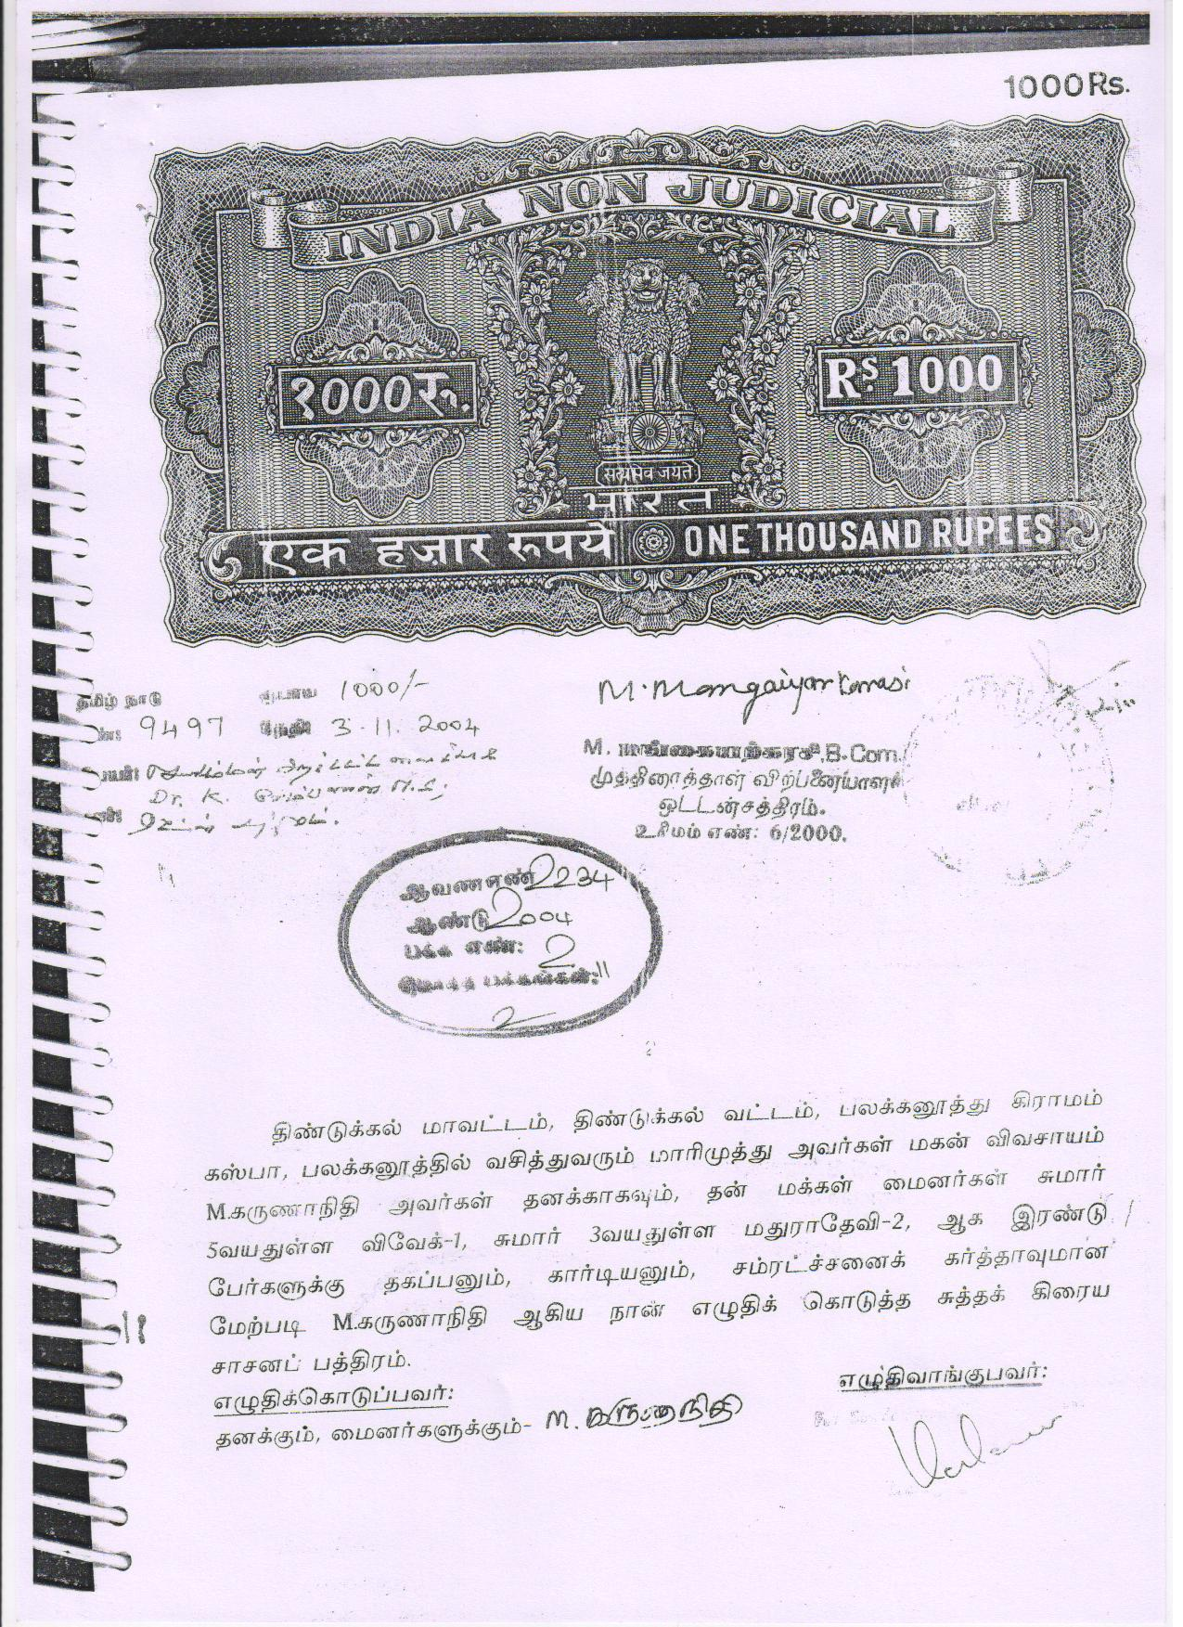

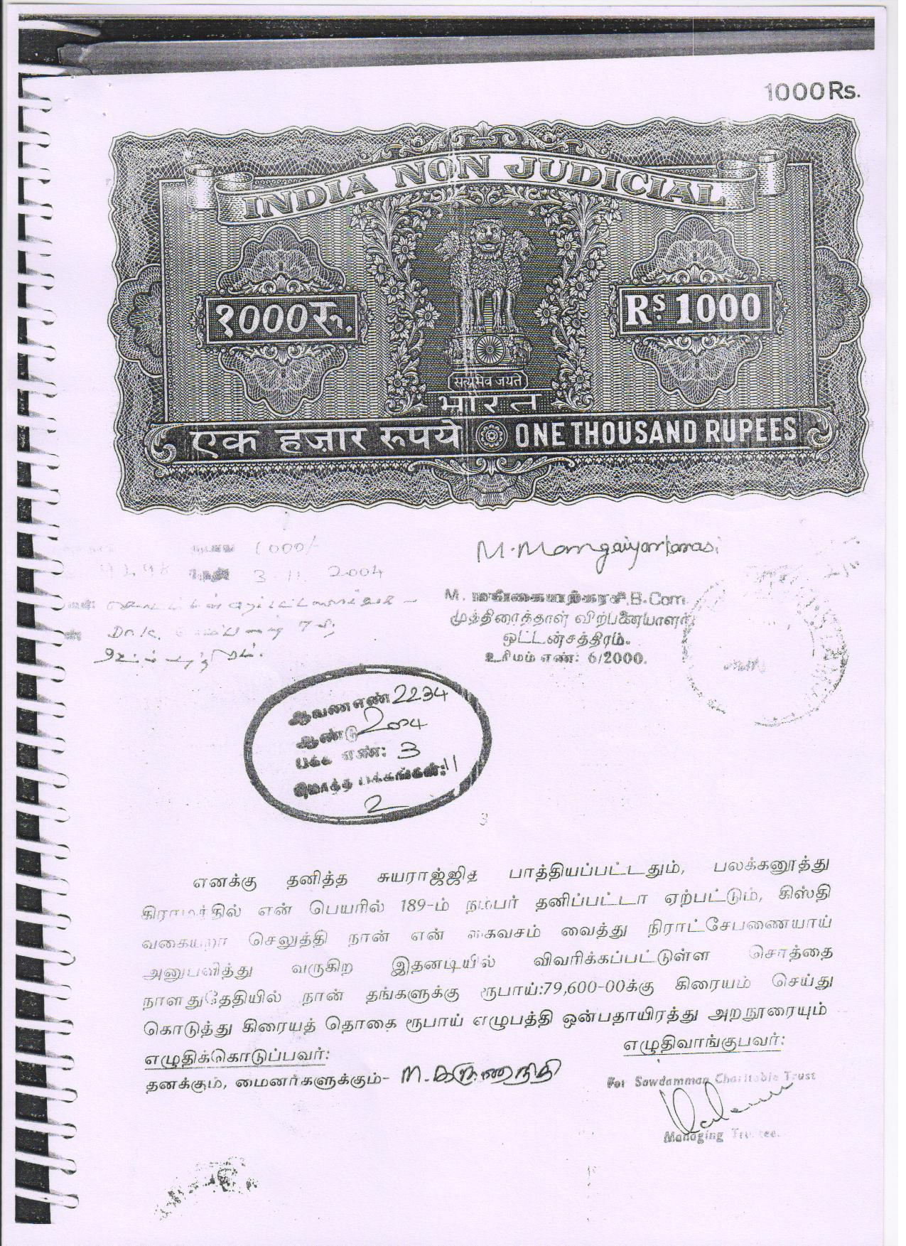

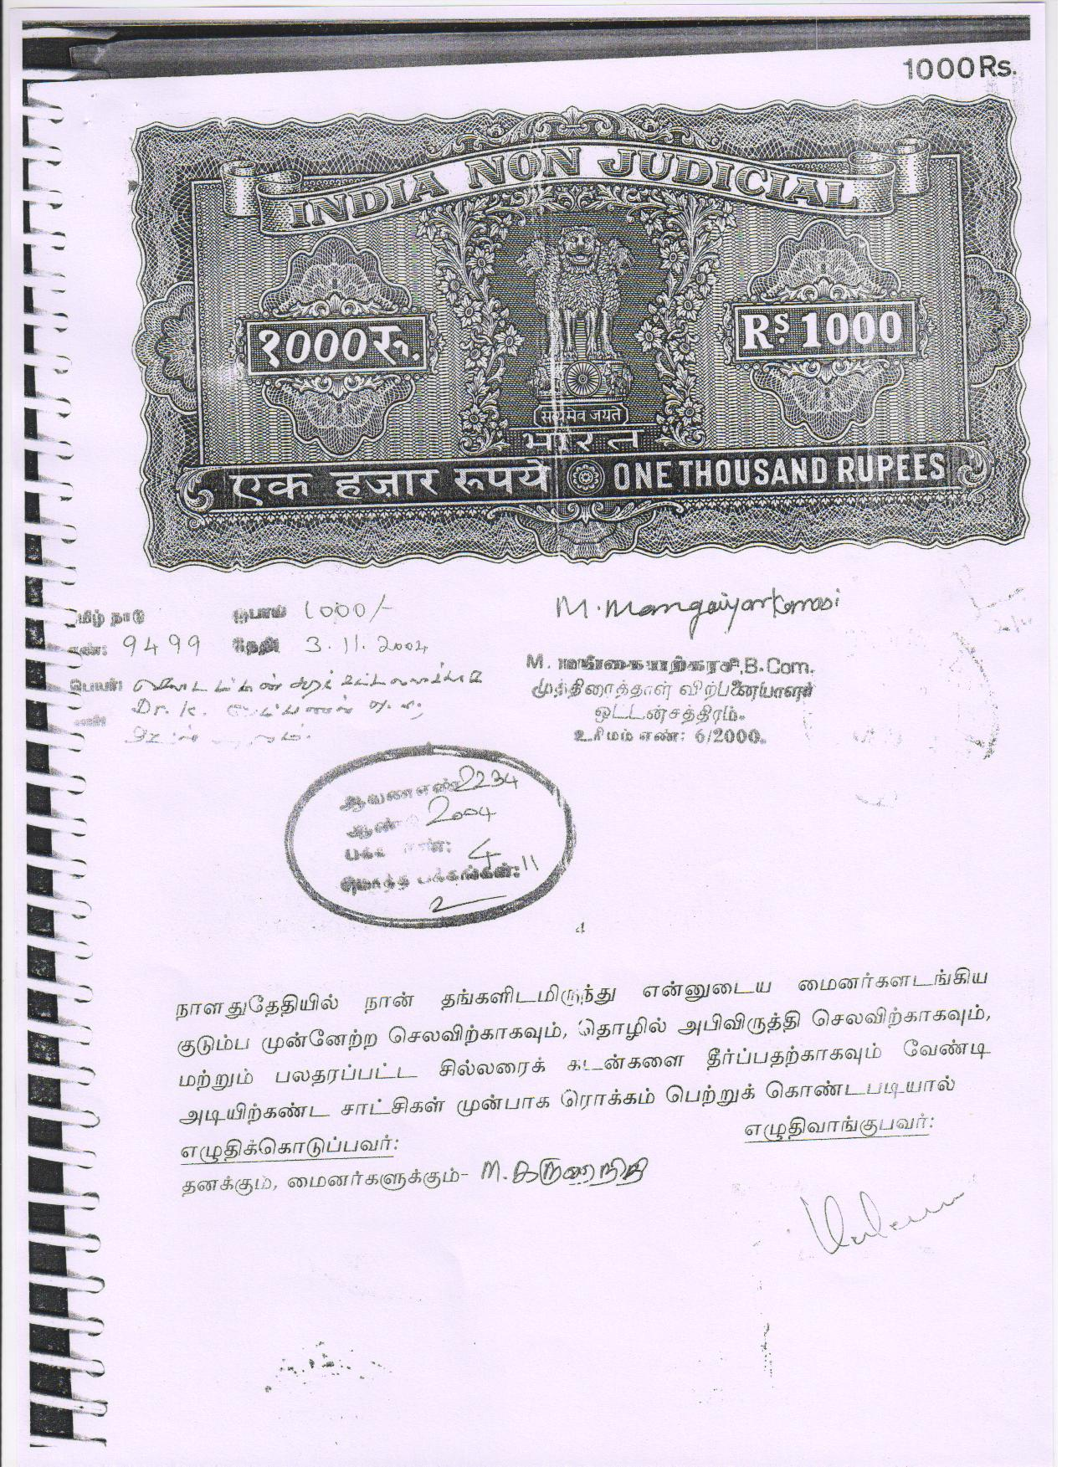

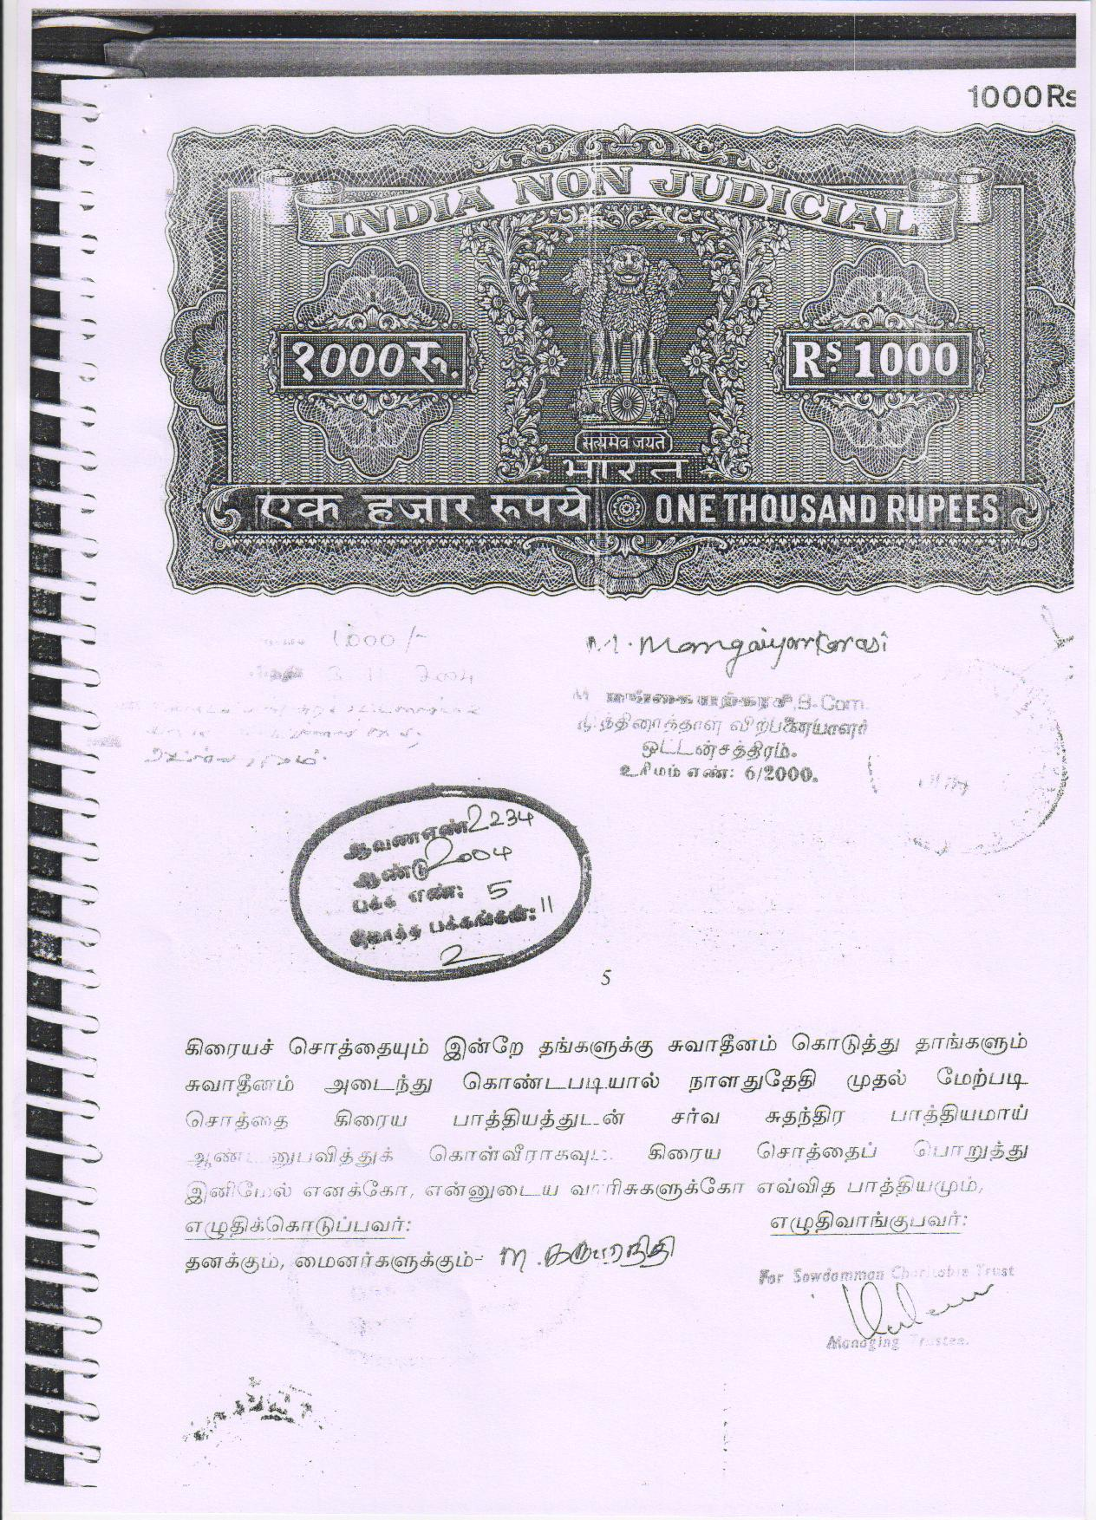

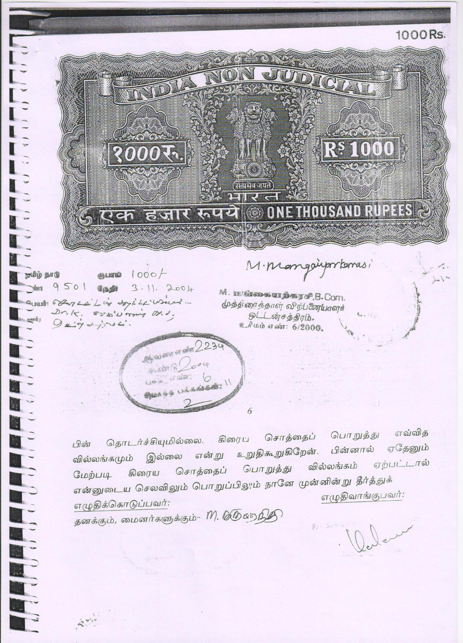

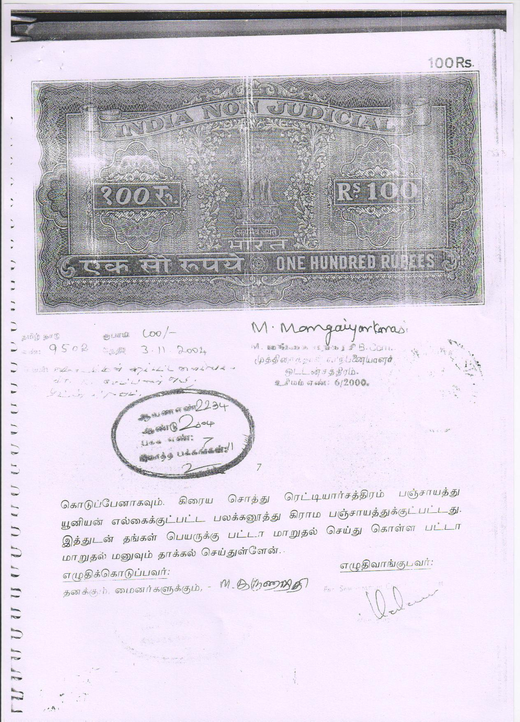

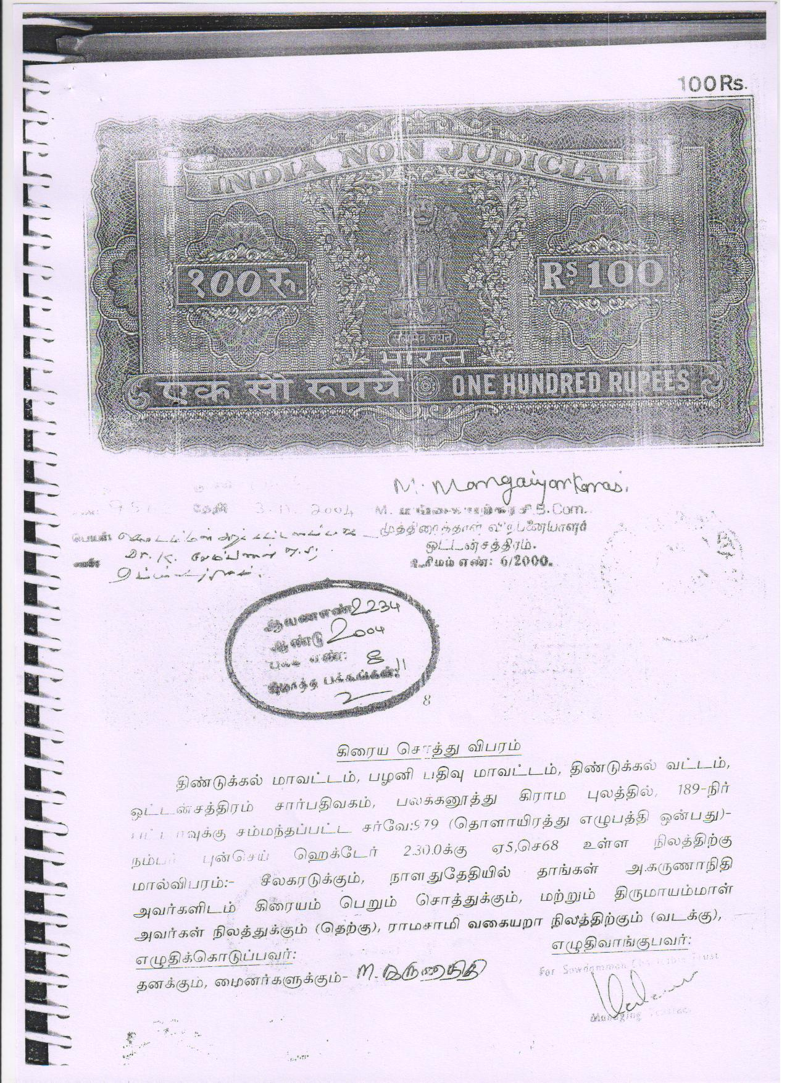

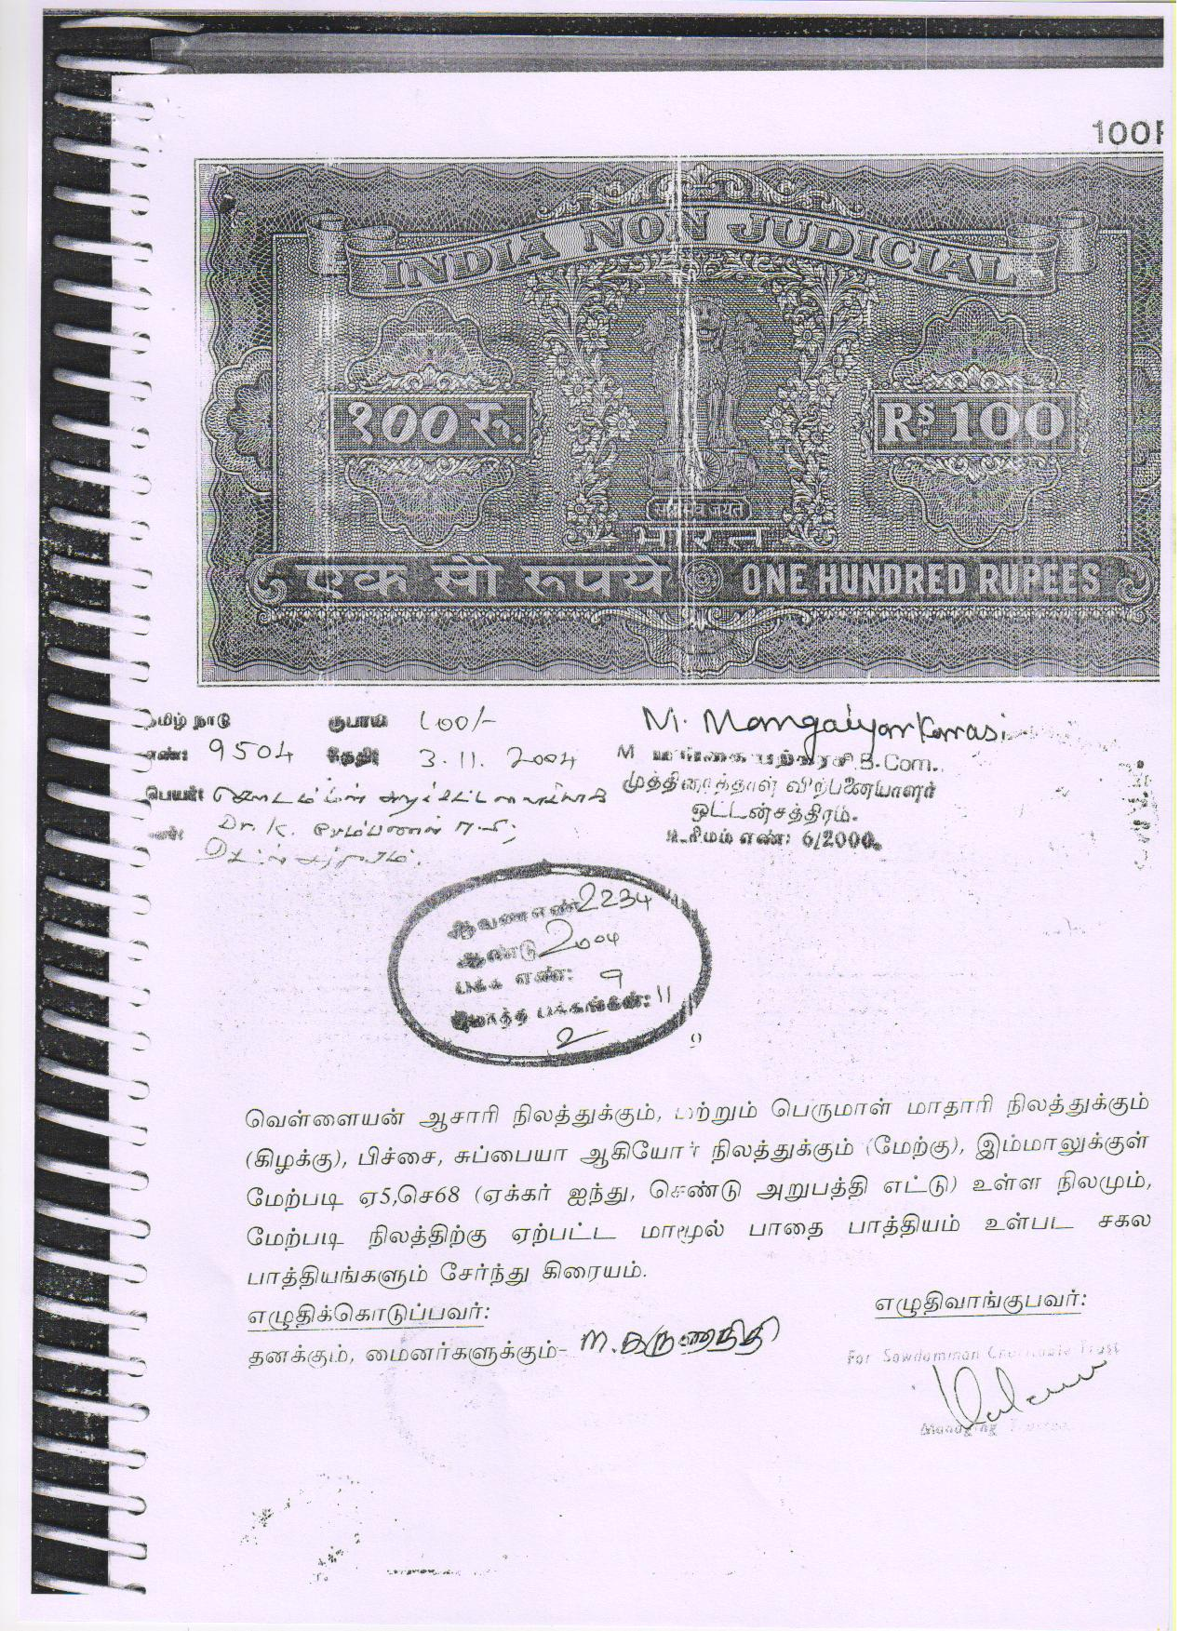

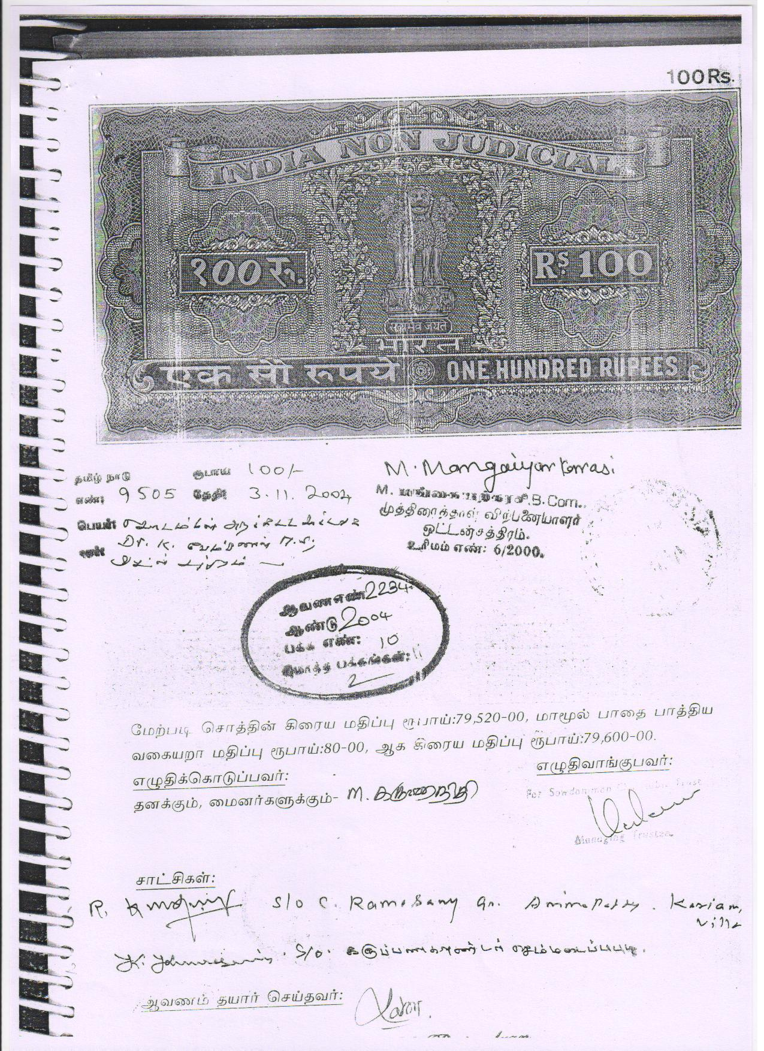

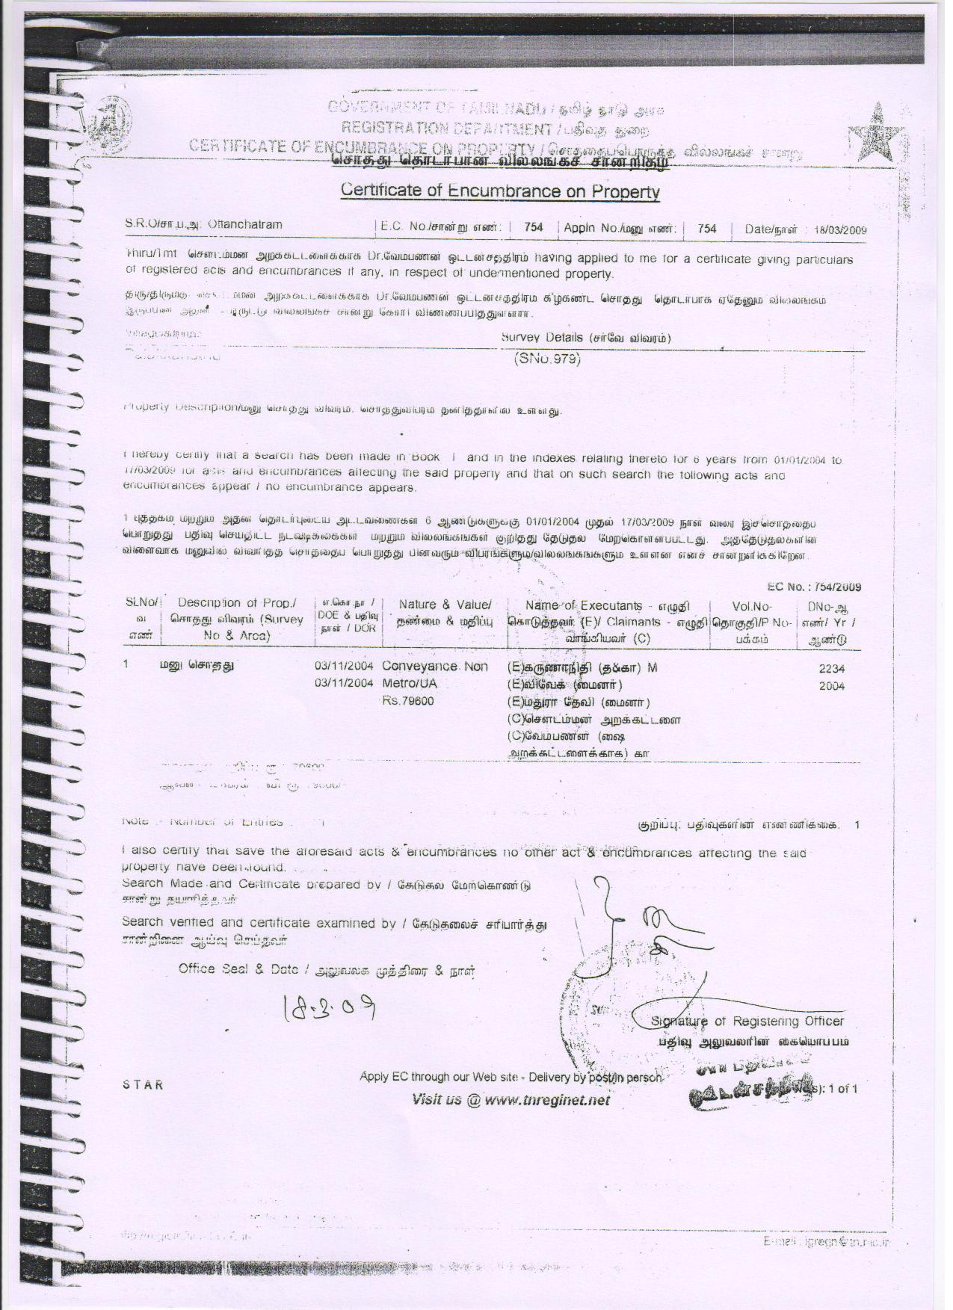

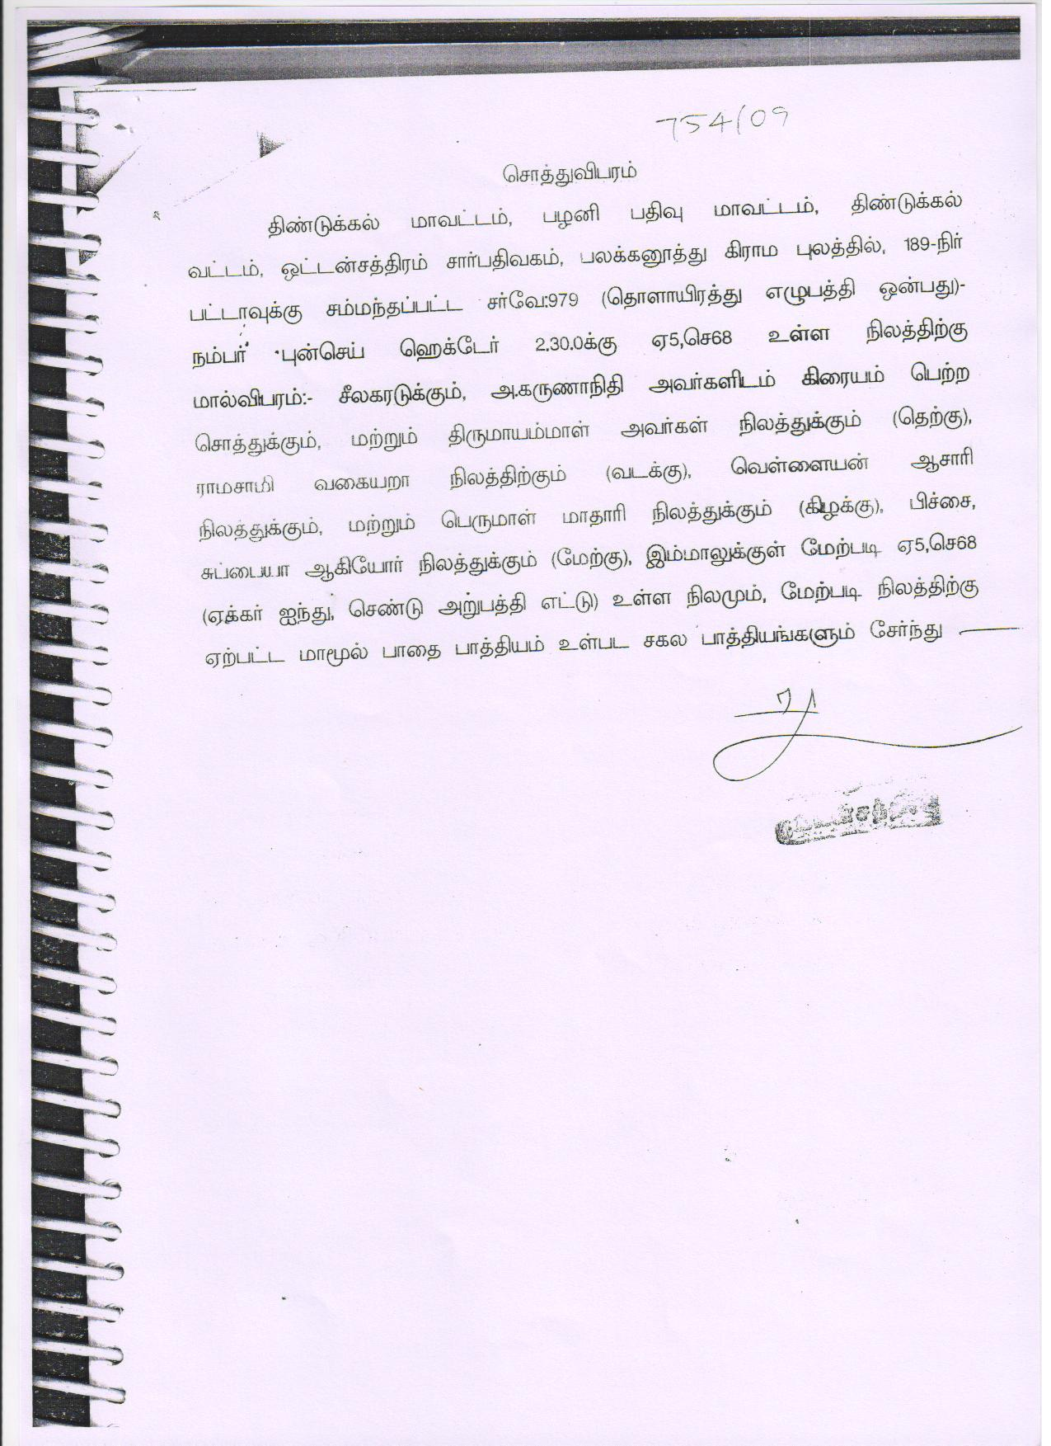

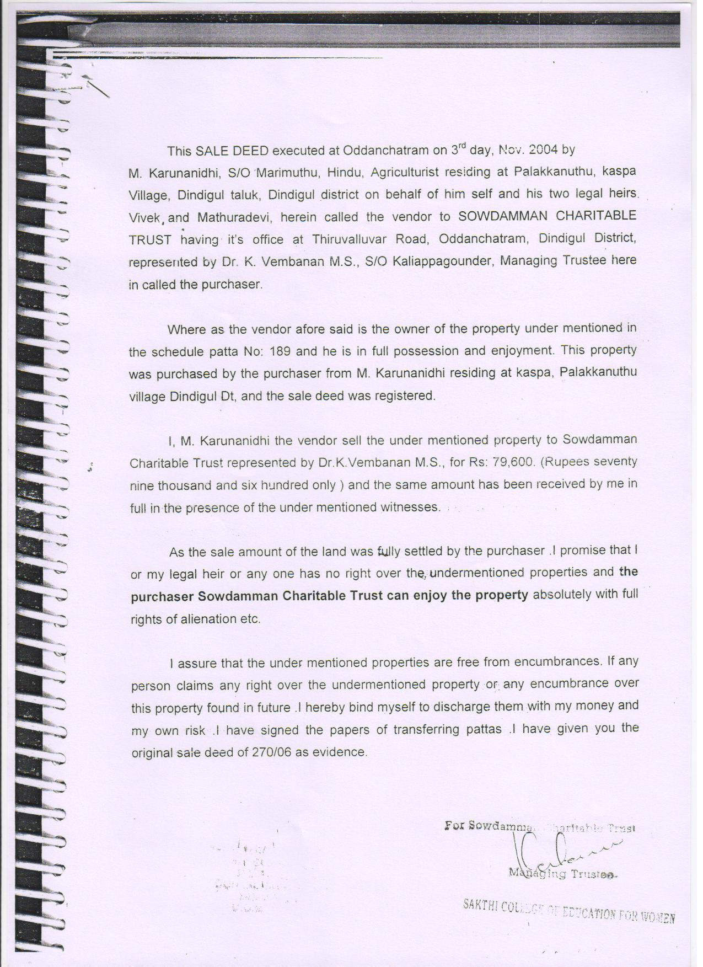

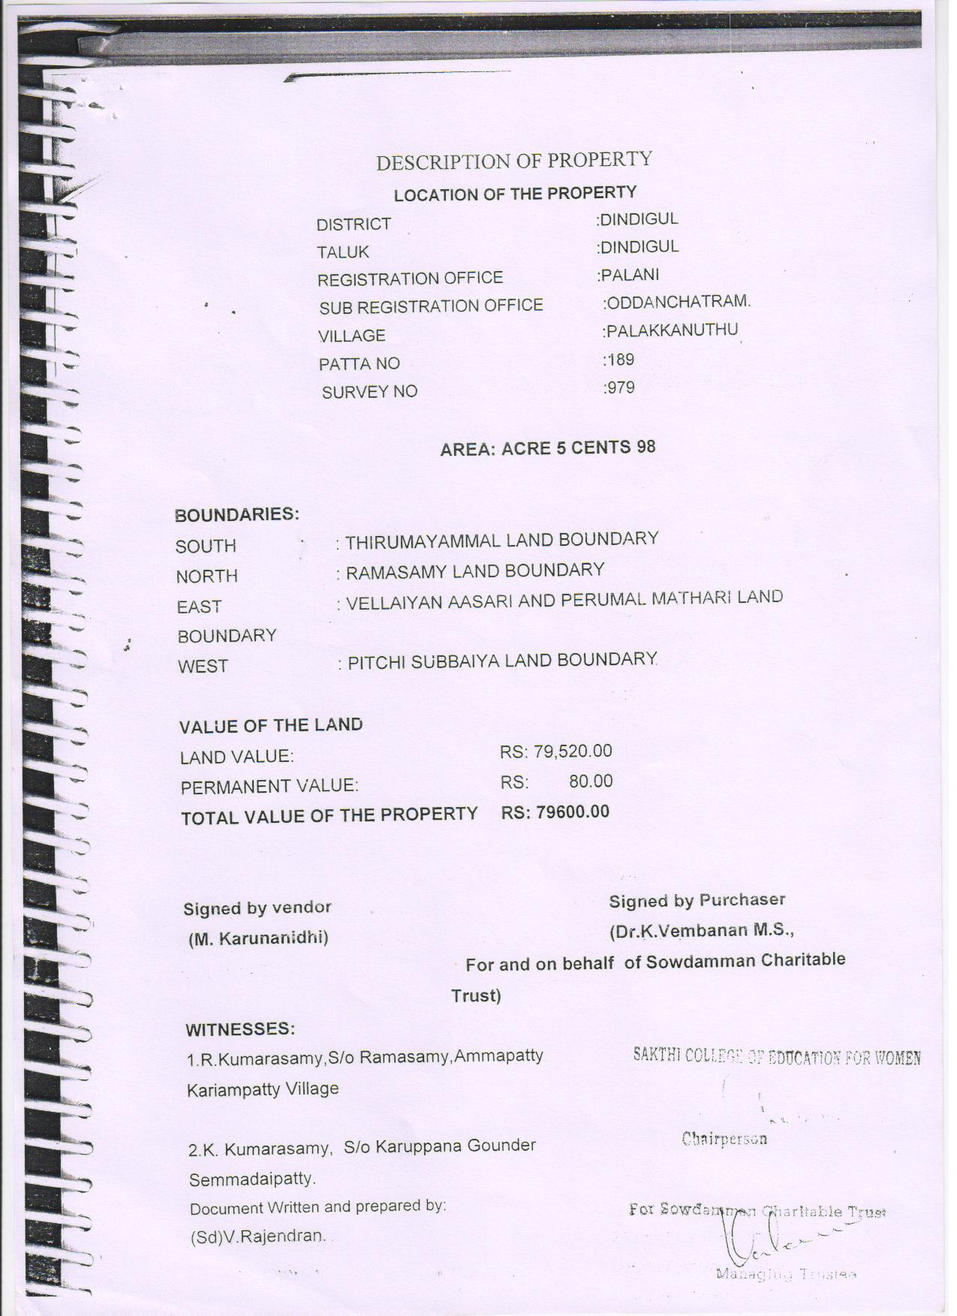

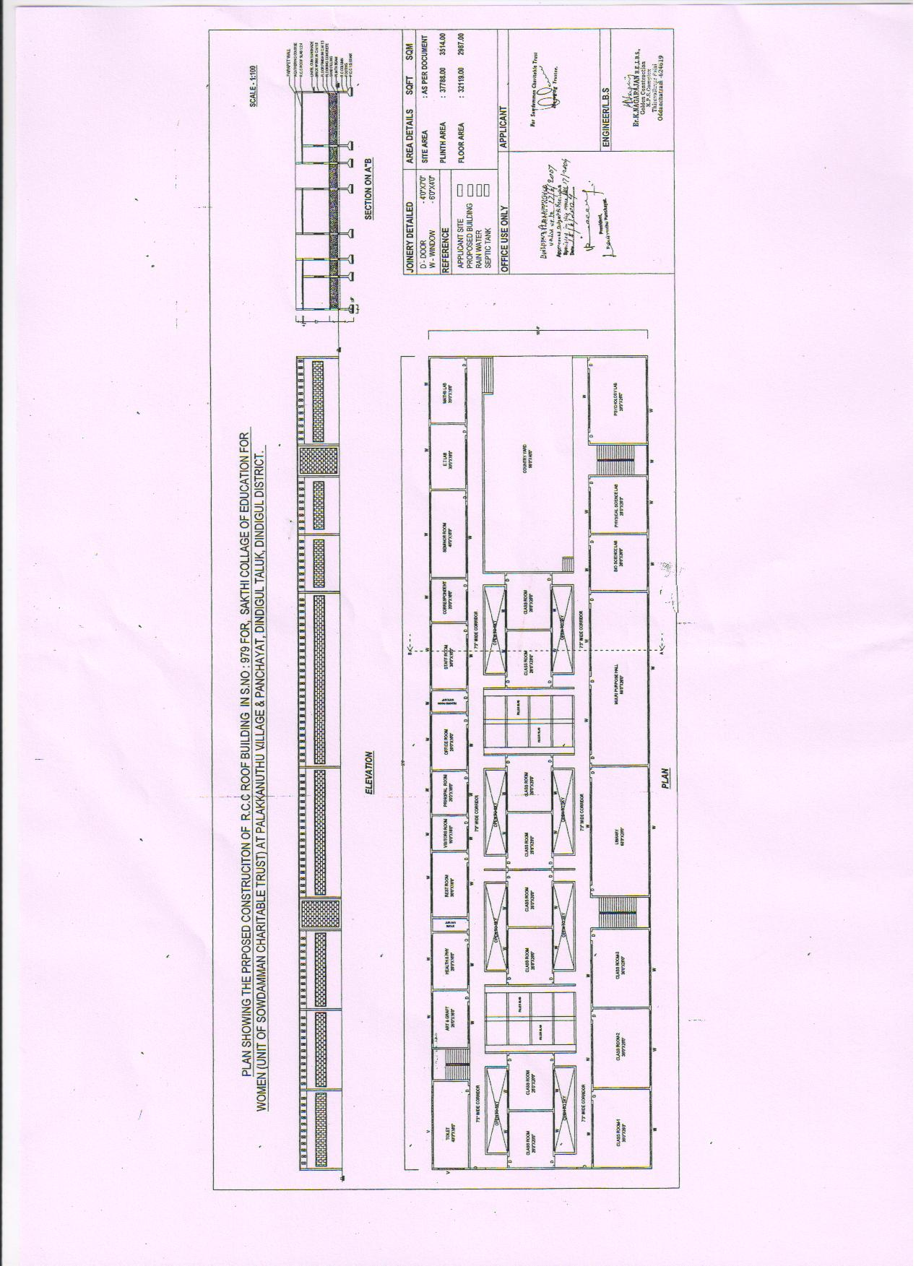

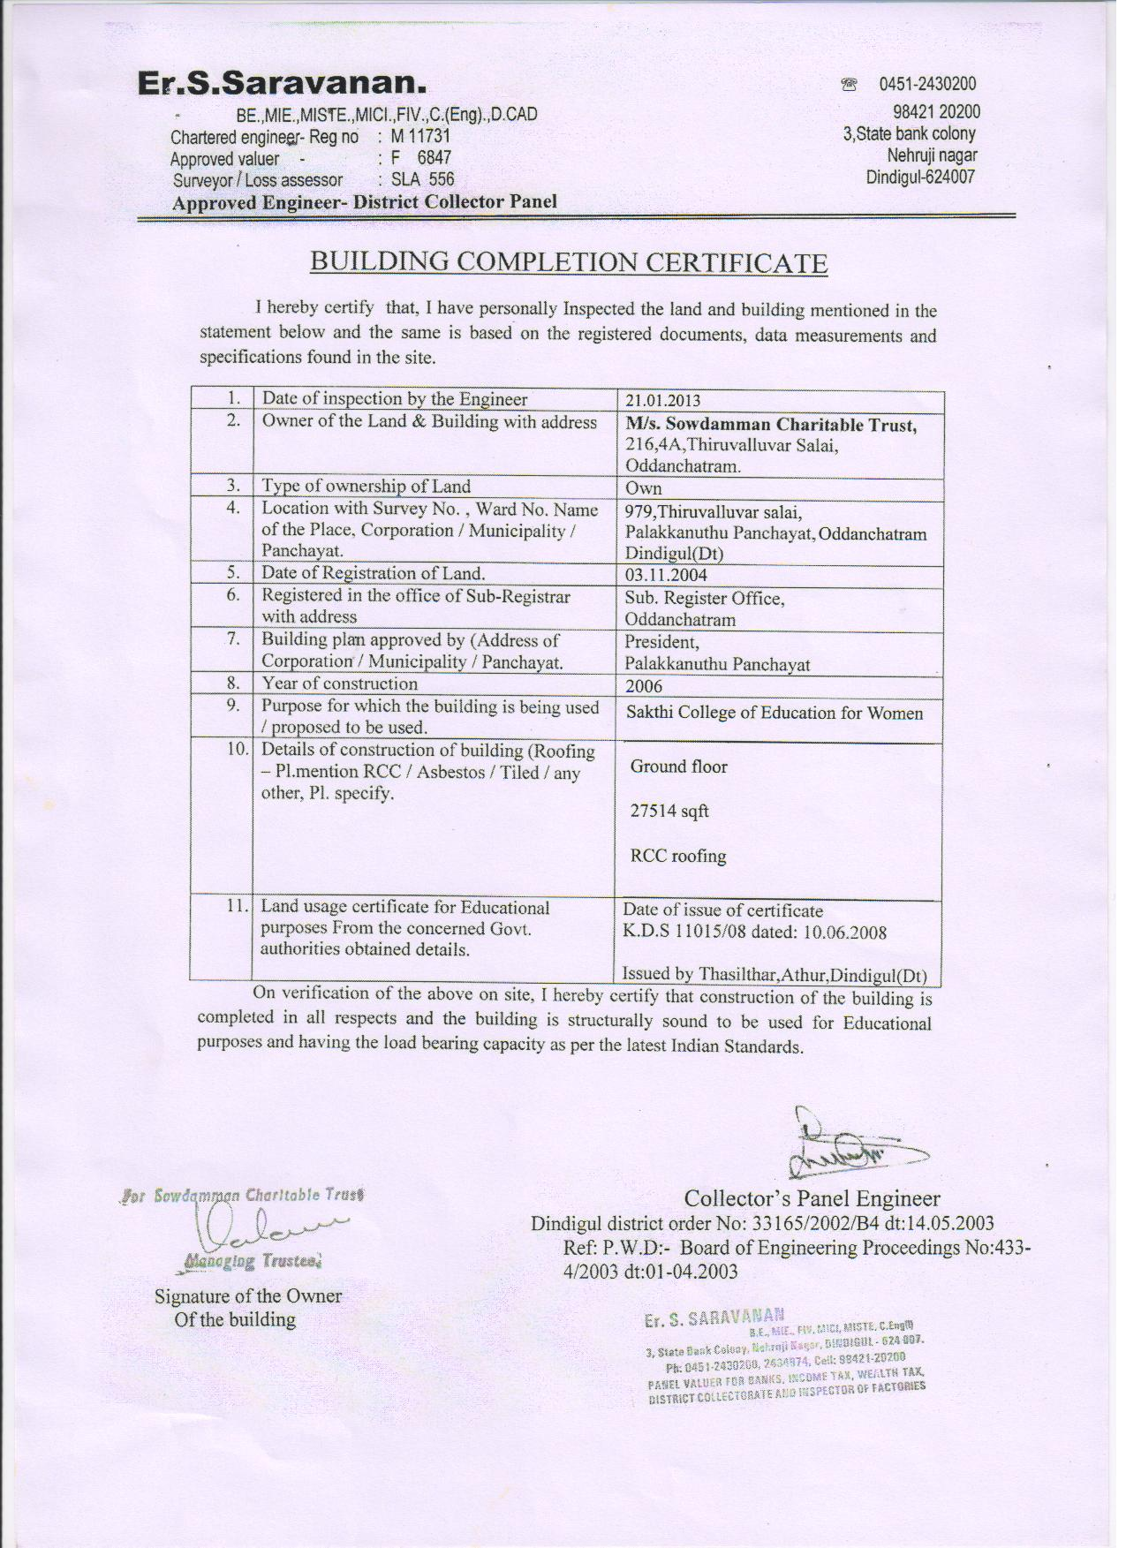

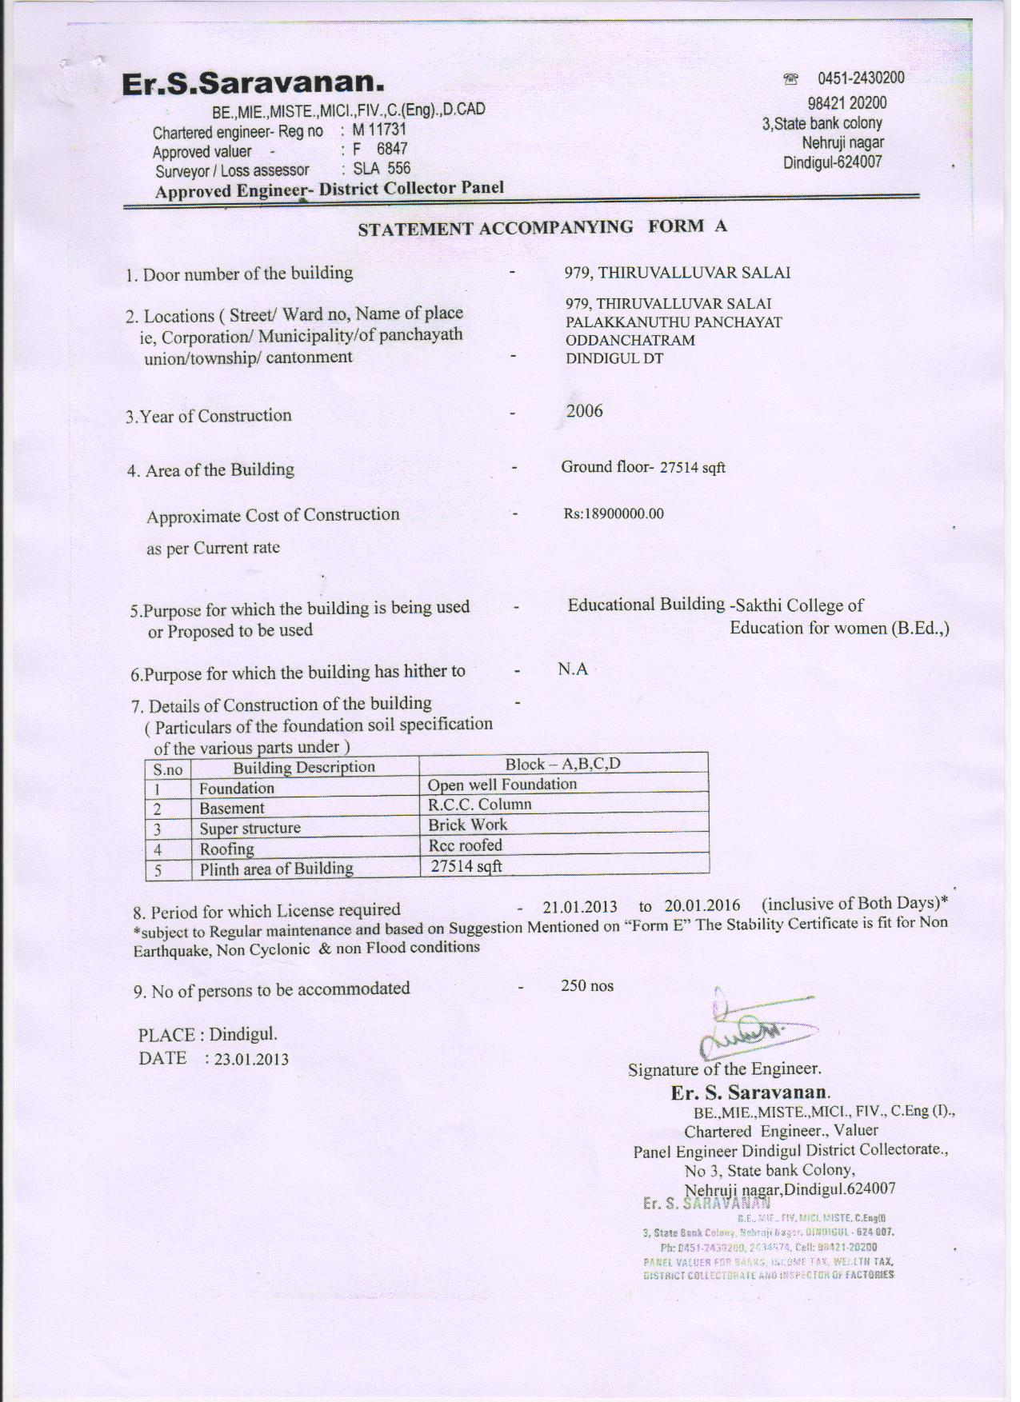

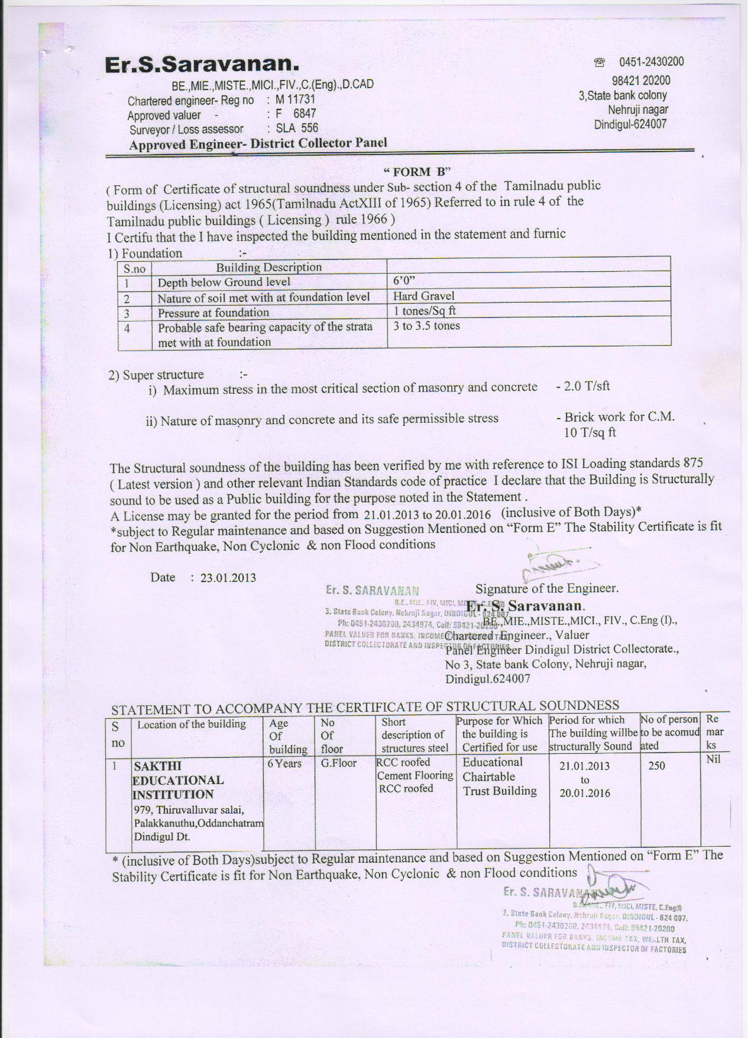

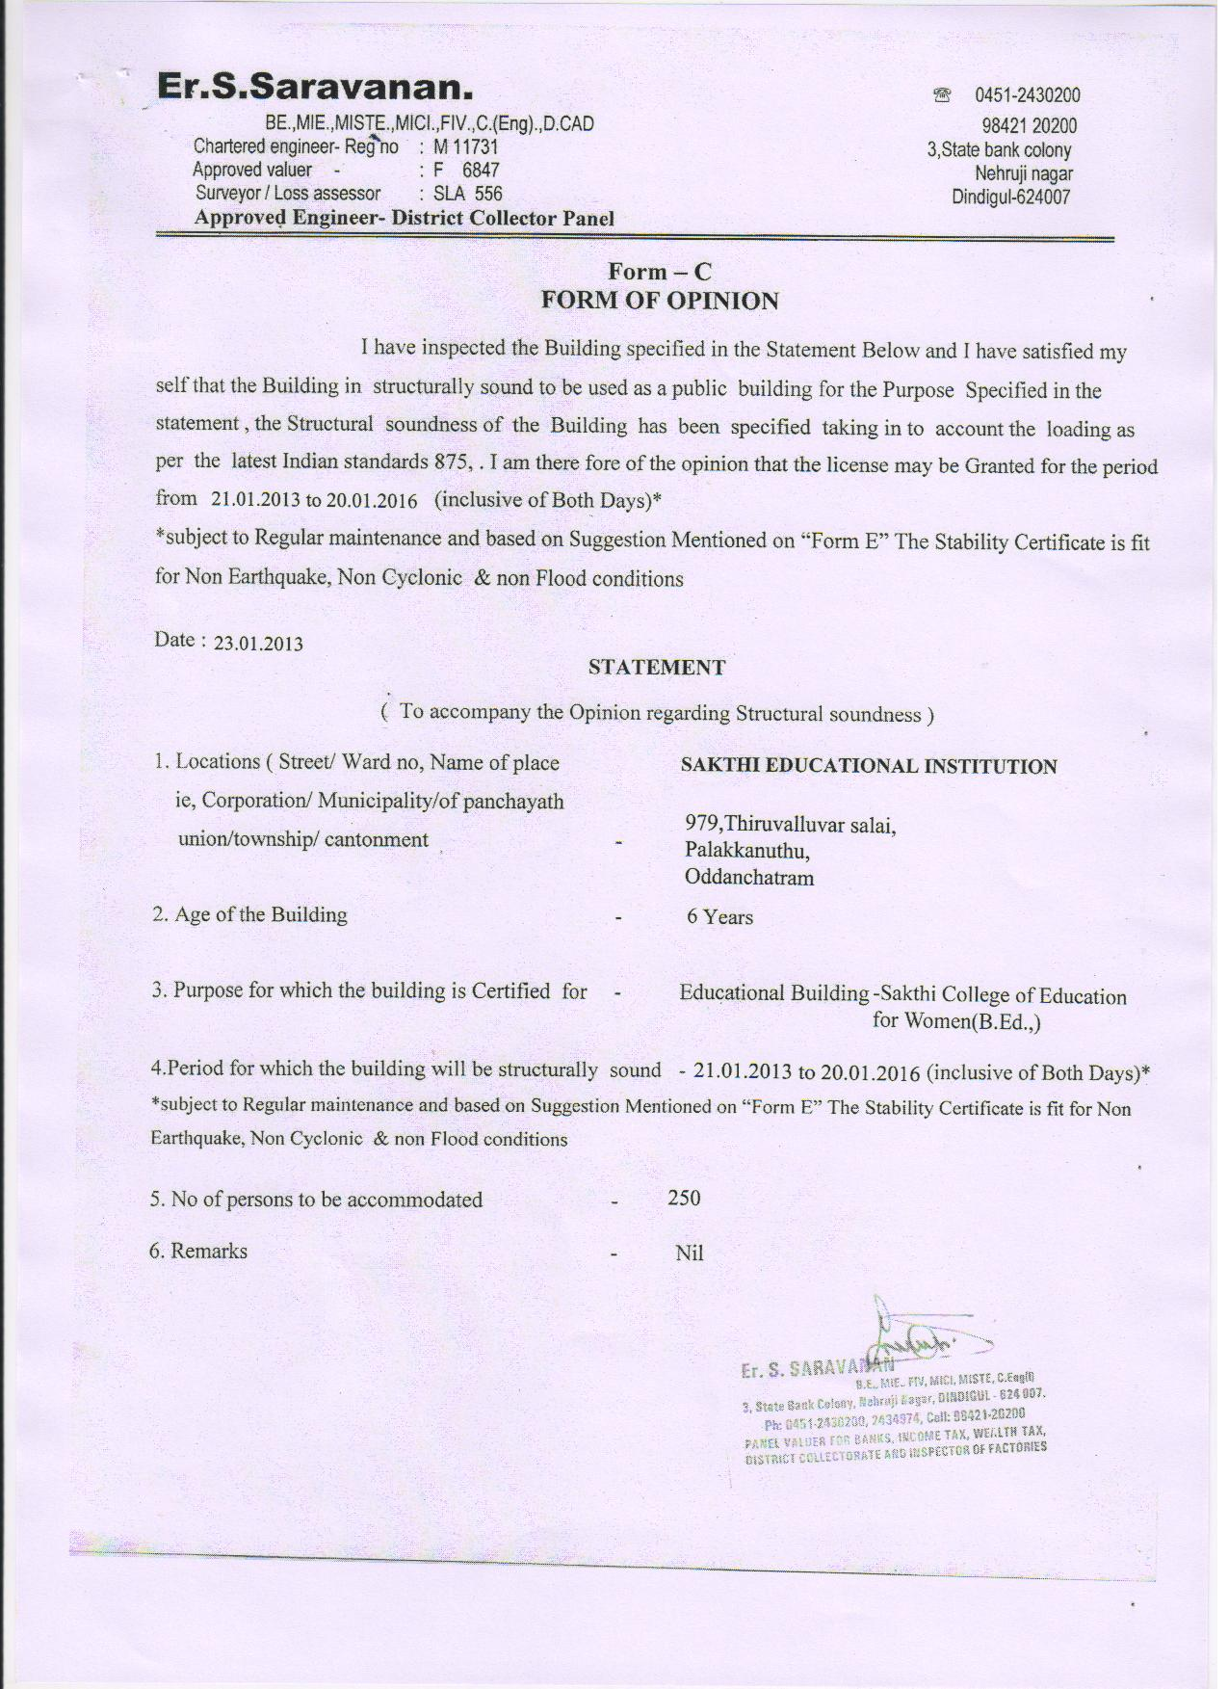

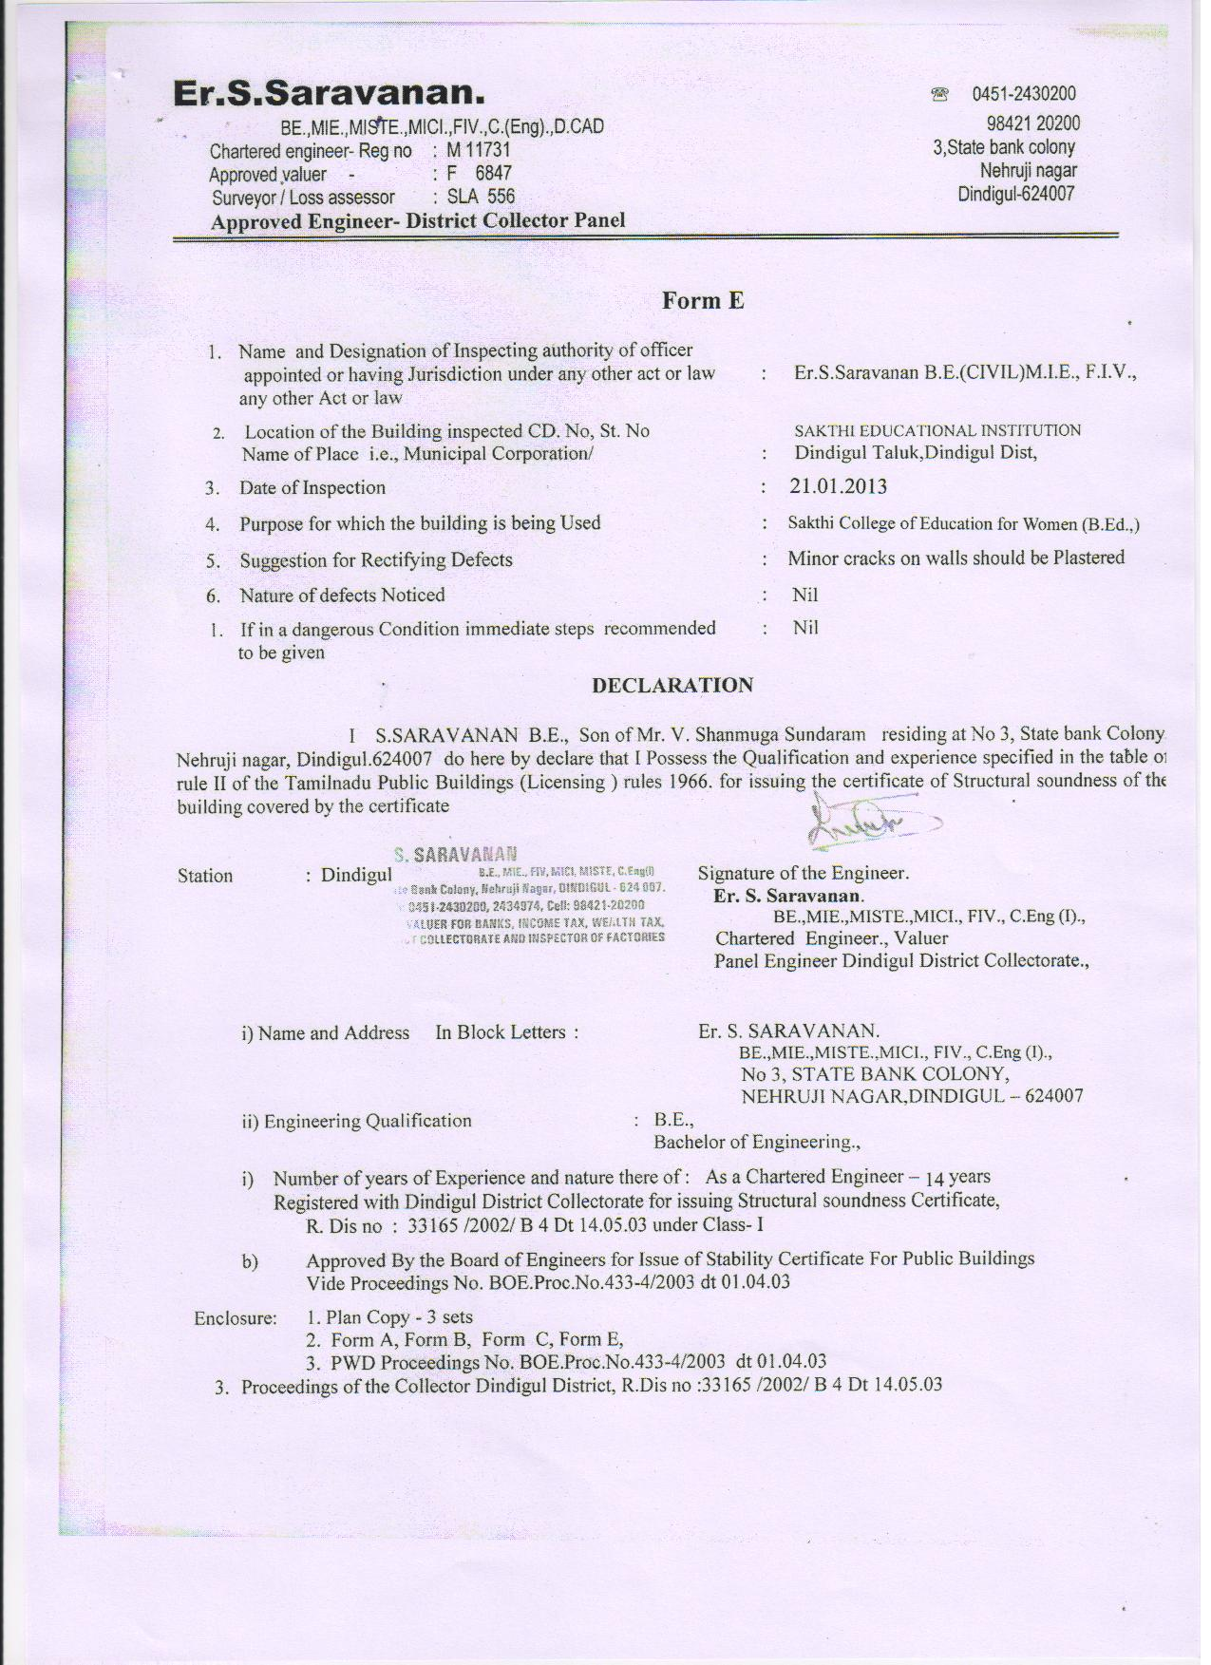

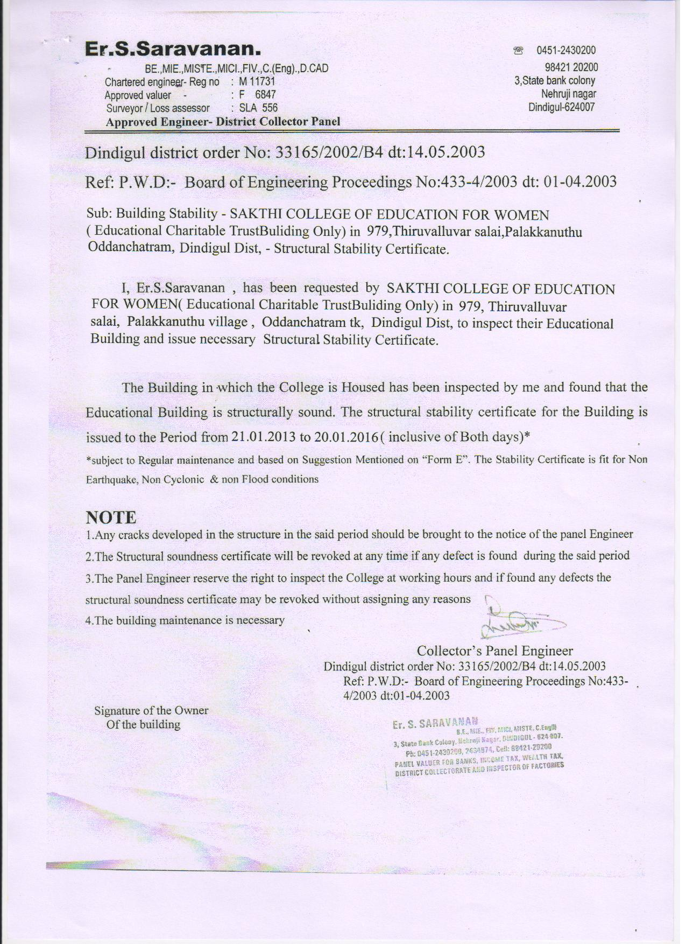

ANNEXURE V

AUDITED INCOME - EXPENDITURE STATEMENT

FORMAT FOR THE SUBMISSION OF PROPOSAL
1. INSTITUTIONAL DETAILS:
1 |  | Name of the Institution |  |  | Sakthi College of Education for women
2 |  | Address of the Institution |  |  | Sakthi College of Education for Women, Thiruvalluvar Salai, Dindigul – Palani Main Road, Oddanchatram(PO),Dindigul(Dt)
3 |  | Phone with STD Code: |  |  | 04553 240597
 |  | Fax: |  |  | 04553 242985
 |  | E-mail ID: |  |  | sakthibedwomen@gmail.com
4 |  | Date and Year of Establishment |  |  | 2007-2008
5 |  | Type of the Institution |  |  | Private Self-financing
6 |  | Aided and Unaided Courses |  |  | No. of Aided Courses |  |  |  |  | No. of Unaided Courses
 |  |  |  |  | NIL |  |  |  |  | 1
7 |  | Programme being conducted |  |  | UG Programmes |  | PG Programmes |  |  | Diploma Programmes
 |  |  |  |  | BED |  | Nil |  |  | Nil
8 |  | Whether approved by NCTE / Govt. |  |  | NCTE
9 |  | Whether affiliated by University/Govt. |  |  | University
10 |  | Name of the Principal
 |  | Qualification & Experience
11 |  | Full postal address of the Principal (Residence)
12 |  | Phone with STD Code:
 |  | Fax:
 |  | E-mail ID:
13 |  | Name of the Trust / Society |  |  | Sowdamman Charitable Trust
14 |  | Full postal address of the Trust/ Society |  |  | Sakthi College of Education for Women, Thiruvalluvar Salai, Dindigul - Palani Main Road, Oddanchatram(PO), Dindigul-624619
15 |  | Phone with STD Code: |  |  | 04553 240597
 |  | Fax: |  |  | 04553242985
 |  | E-mail ID:
16 |  | Name of the Chairman/President |  |  | Dr.K.Gokila Vembanan, M.B.B.S., DGO.,
17 |  | Address of the Chairman/President |  |  | Sakthi College of Education for Women, Thiruvalluvar Salai, Dindigul - Palani Main Road, Oddanchatram(PO), Dindigul-624619
18 |  | Phone with STD Code: |  |  | 04553 240597
 |  | Fax: |  |  | 04553242985
 |  | E-mail ID: |  |  | drkvms@gmail.com
2. NAME OF THE COURSE FOR THE ACADEMIC YEAR 2013-2014 AND NUMBER OF STUDENTS IN EACH YEAR
Sl. | Name of the Course |  | First |  |  | Second
No. |  |  | Year |  |  | Year
 |  |  | S | A |  | S |  | A
1 | B.Ed |  | 100 | 100
2
3
4
5
Total |  |  | 100 | 100
 | S – Sanctioned, A - Admitted
2.1. NAME OF THE COURSE AND STUDENTS STRENGTH FOR THE ACADEMIC YEAR 2013-14 (COMMUNITY-WISE)
Sl. | Name of the Course |  | First |  |  | Second
No. |  |  | Year |  |  | Year
 |  |  | S | A |  | S |  | A
1 | BC |  | 64 | 64
2 | MBC |  | 15 | 15
3 | SC |  | 17 | 17
4 | DNC |  | 4 | 4
5
Total |  |  | 100 | 100
 | S – Sanctioned, A - Admitted

2 |  | BUILDINGS | Year of construction | Carpet area in Square Meters* |  |  |  | Investment (Rs. in Lakhs) | Rate of Depreciation
 |  | (General, Academic)
2.1 |  | Existing (Numbers ..........) , Name |  | Existing | As per NCTE/Govt. Norms
 |  | Academic Block | 05_06 | 2453.96 | NCTE Norms |  |  | 19,98,500
 |  | Total |  | 2453.96 |  |  |  | 19,98,500
 |  | Hostels, Residential and others
2.2 |  | Existing (Numbers ..........) , Name |  | Existing | As per NCTE/Govt. Norms
 |  |  |  |  | NCTE Norms
 |  | Total
2.3 |  | Proposed /Planned (with proof)
2.2.1
2.2.2 |  | Construction of Staff Quarters Approximately Rs.150 Lakhs.
2.2.3
2.2.4
 |  | Total
2.4. |  | FURNITURE - Classrooms, Laboratory etc. | No. | Cost In lakhs | Rate of Depreciation
 |  | Table &Bench | 115 | 488750 | 20%
 |  | self | 20 | 95000 | 20%
 |  | office table | 15 | 52500 | 20%
 |  | chairs | 140 | 189000 | 20%
 |  | Total | 290 | 825250 | 20%
Buildings: Please list chronologically (indicate the year of completion) the number of buildings in the campus giving the name of each building.
* Carpet area of all the floors to be given.
3. INFRASTRUCTURE FACILITIES
Sl. | Infrastructure |  |  |  |  | Existing | As per NCTE/GOVT. Norms
No.
1 | LAND
1.1 | Extent in Acres |  |  |  |  | 9.41 Acres | As per NCTE Norms
1.2 | Purchased / Leased/ Donated |  |  |  |  | Purchased
1.3 | If Purchased amount (in lakhs) and year of purchase |  |  |  |  | 19,98,500
1.4 | If leased from Private/Government source |  |  |  |  | ___
1.5 | If on lease, date of lease and period in years |  |  |  |  | ___
1.6 | Lease amount payable annually |  |  |  |  | ___
1.7 | Layout Plan of the campus showing all the buildings and features on A3 size format. |  |  |  |  | enclosed
1.8 | Future Plans if any for investment on land acquisition or development (in Lakhs) |  |  |  |  | Nil

Sl.No. | Infrastructure | Requirement as per NCTE/Govt norms | Actually Provided | Cost In lakhs | Year of Purchase | Rate of Deprec-iation
3.1 | Laboratory equipments
 | (Course-wise)
3.1.1 | Physical science | NCTE | As per NCTE | 1.75 | 2006-07 | 20%
3.1.2 | Bioscience | NCTE | As per NCTE | 1.4 | 2006-07 | 20%
3.1.3 | psychology | NCTE | As per NCTE | 1.9 | 2006-07 | 20%
Sl.No. | Infrastructure | Area Available | Cost In lakhs | Year of Purchase | Rate of Depreciation
3.2 | Sports facilities & equipments
3.2.1 | volleyball,shuttle,khokho court | 3 Acres | 24 | 2006-07
3.2.2 | Tenikat court
3.2.3 | Equipments |  | 1.50 | 2006-07 | 20%
Sl.No. | Infrastructure | Cost In lakhs | Year of Purchase | Rate of Depreciation
3.3 | Office equipments
3.3.1 | Computer,printer,ups | 2.45 | 2006-07 | 20%
3.3.2 | scanner,Xerox machine, | 0.72 | 2006-07 | 20%
3.3.3 | OHP slide projector | 2.45 | 2006-07 | 20%
Sl.No. | Infrastructure | Cost In lakhs | Year of Purchase | Rate of Depreciation
3.4 | Students amenities Eg.: Canteen facilities, Medical facilities etc.
3.4.1 | Canteen (30x20) | 4.8 | 2006-07
3.4.2 | Medical (30x20) | 4.35 | 2006-07
3.4.3
Sl.No. | Infrastructure | Cost In lakhs | Year of Purchase | Rate of Depreciation
3.5 | Any others –future capital expenditure to be provided (give details with necessary documents)
3.5.1 | Infrastructure for forbidden intake B.Ed., and P.G M.Ed., (15,000 sq. ft.) | 105 | 2012 to 2013
3.5.2
3.5.3
Sl.No. | Infrastructure | Cost In lakhs | Year of Purchase | Rate of Depreciation
3.6 | Any others – additional equipments to be purchased in future , (give details with necessary documents)
3.6.1 | Lab Equipments & Library Books | 7.5 | 2012-2014
3.6.2

4. REVENUE Calculation Sheet (from Students) for the past three years (Rs. in lakhs):
Sl.No | Particulars |  | Rate/ |  | No. of |  | Total in |  | Rate/ | No. of |  | Total in |  | Rate/ |  | No. of |  |  | Total in
 |  |  | Student |  | Students |  | Rupees |  | Student | Students |  | Rupees |  | Student |  | Students |  |  | Rupees
A | Recurring Revenue |  | 2010-11 in lakhs |  |  |  |  |  | 2011-12 |  |  |  |  | 2012-13
1 | Tuition fee |  | 0.31 |  | 99 |  | 30.69 |  | 0.31 | 100 |  | 31.00 |  | 0.31 |  |  | 100 |  | 31.00
2 | Development fee |  | 0.055 |  | 99 |  | 5.445 |  | 0.055 | 100 |  | 5.5 |  | 0.055 |  |  | 100 |  | 5.5
3 | Application and Prospectus Fee |  | 0.005 |  | 99 |  | 0.495 |  | 0.005 | 100 |  | 0.5 |  | 0.005 |  |  | 100 |  | 0.5
4 | Registration/Admission fee |  | 0.015 |  | 99 |  | 1.485 |  | 0.015 | 100 |  | 1.5 |  | 0.015 |  |  | 100 |  | 1.5
5 | Digital Library/Internet/Browsing |  | 0.02 |  | 99 |  | 1.98 |  | 0.02 | 100 |  | 2.0 |  | 0.02 |  |  | 100 |  | 2.0
6 | Any other fee collected by the Institution (specify) |  | 0.01 |  | 99 |  | 0.99 |  | 0.01 | 100 |  | 1.0 |  | 0.01 |  |  | 100 |  | 1.0
 | Sub Total |  | 0.415 |  | 99 |  | 41.08 |  | 0.415 | 100 |  | 41.5 |  | 0.415 |  |  | 100 |  | 41.5
 | Deposits (Refundable)
7 | Caution Deposit
C | Hostels |  | 0.8 |  | 12 |  | 0.96 |  | 0.018 | 15 |  | 1.2 |  | 0.09 |  |  | 17 |  | 1.5
D | Transportation
1 | Charges per year |  | 0.015 |  | 47 |  | 0.705 |  | 0.017 | 80 |  | 1.36 |  | 0.0195 |  |  | 70 |  | 1.365
 | Sub Total |  | 0.815 |  | 59 |  | 1.665 |  | 0.035 | 95 |  | 2.56 |  | 0.1095 |  |  | 87 |  | 2.865
E | Cooperative Society share(s) |  | ___ |  | ___ |  | ___ |  | ___ | ___ |  | ___ |  | ___ |  |  | ___ |  | ___
F | Deposits (Refundable) |  | ___ |  | ___ |  | ___ |  | ___ | ___ |  | ___ |  | ___ |  |  | ___ |  | ___
1 | Hostel Deposit
2 | Mess Deposit
3 | Transport Deposit
 | Sub Total
 |  | The details to be furnished based on Audited Statement
5. ABSTRACT OF REVENUE: (Rs. in lakhs) (Compiled from 4 )
Sl.No |  | Particulars |  | 2010-11 |  | 2011-12 |  | 2012-13 |  |  | Total in Rupees
A |  | Recurring Revenue
1 |  | Tuition fee |  | 30.69 |  | 31.00 |  | 31.00 |  |  | 92.69
2 |  | Development fee |  | 5.445 |  | 5.5 |  | 5.5 |  |  | 16.445
3 |  | Application and Prospectus Fee |  | 0.495 |  | 0.5 |  | 0.5 |  |  | 1.495
4 |  | Registration/Admission fee |  | 1.485 |  | 1.5 |  | 1.5 |  |  | 4.485
5 |  | Digital Library/Internet/Browsing |  | 1.98 |  | 2.0 |  | 2.0 |  |  | 5.98
6 |  | Any other fee collected by the Institution (specify) |  | 0.99 |  | 1.0 |  | 1.0 |  |  | 2.99
 |  | Sub Total |  | 41.08 |  | 41.5 |  | 41.5 |  |  | 124.08
 |  | Deposits (Refundable)
 |  | Caution Deposit
B |  | Hostels
 |  | Rent per Year |  | 0.96 |  | 1.2 |  | 1.5 |  |  | 3.66
C |  | Transportation
1 |  | Charges per year |  | 0.705 |  | 1.36 |  | 1.365 |  |  | 3.43
 |  | Sub Total |  | 1.665 |  | 2.56 |  | 2.865 |  |  | 7.09
D |  | Cooperative Society share(s) |  | ___ |  |  |  | ___ |  |  | ___
E |  | Deposits (Refundable) |  | ___ |  | ___ |  | ___ |  |  | ___
1 |  | Hostel Deposit
2 |  | Mess Deposit
3 |  | Transport Deposit
 |  | Sub Total
 |  | The details to be furnished based on Audited Statement

6. REVENUE FROM ASSETS AND SERVICES AND OTHERS(Rs. in lakhs):
Sl. | Particulars | 2010-11 | 2011-12 | 2012-13 | Total in Rupees
No.
 | Fixed Deposits during the period* | 10 |  |  | 10
1 | Interest earned on Fixed Deposits | Interest will be Accumulated.
2 | Other Rentals realized if any
3 | Interest realized on staff loans
4 | Any other revenue (specify)
5 | Donations, if any (specify the source)
 | Total | 10 |  |  | 10
 | Note: * Please indicate the details of Deposits for reference.
7. EXPENDITURE ON FACULTY AND STAFF FOR AIDED COURSES(Rs. in lakhs):
 | (Not Applicable)
Sl. | Particulars | 2010-11 | 2011-12 | 2012-13 | Total in Rupees
No.
1 | Faculty - Teaching Staff
2 | Non-Teaching Staff - Technical
3 | Administrative Staff
4 | Library Staff
5 | Others (Specify ....................................)
 | Total
 | Number of students
 | Average expenditure per student

10. EXPENDITURE FOR FACULTY AND STAFF FOR UNAIDED COURSES

10.1 EXPENDITURE – TEACHING STAFF (Financial years) (Rs.in lakhs): (Only for Un-Aided Courses)

Name of the faculty | Department | Designation | Gross Salary in Rs.
 |  |  | Mar-12 | Apr-12 | May-12 | Jun-12 | Jul-12 | Aug-12 | Sep-12 | Oct-12 | Nov-12 | Dec-12 | Jan-13 | Feb-13 | Total
Prof.N.Natesan |  | Principal | 0.20 | 0.20 | 0.20 | 0.20 | 0.20 | 0.20 | 0.20 | 0.20 | 0.20 | 0.20 | 0.20 | 0.20 | 2.40
A.Sutha | Physical Science | Ass.profosser | 0.15 | 0.15 | 0.15 | 0.15 | 0.15 | 0.15 | 0.15 | 0.15 | 0.15 | 0.15 | 0.15 | 0.15 | 1.80
T.Petroshia | Computer Science | Ass.profosser | 0.15 | 0.15 | 0.15 | 0.15 | 0.15 | 0.15 | 0.15 | 0.15 | 0.15 | 0.15 | 0.15 | 0.15 | 1.80
C.Samundeeswari | English | Ass.profosser | 0.15 | 0.15 | 0.15 | 0.15 | 0.15 | 0.15 | 0.15 | 0.15 | 0.15 | 0.15 | 0.15 | 0.15 | 1.80
A.Leeli Suvakyanal | History | Ass.profosser | 0.15 | 0.15 | 0.15 | 0.15 | 0.15 | 0.15 | 0.15 | 0.15 | 0.15 | 0.15 | 0.15 | 0.15 | 1.80
R.K.Sharmila | Bio-Science | Ass.profosser | 0.15 | 0.15 | 0.15 | 0.15 | 0.15 | 0.15 | 0.15 | 0.15 | 0.15 | 0.15 | 0.15 | 0.15 | 1.80
G.Sasikala | Mathematics | Ass.profosser | 0.15 | 0.15 | 0.15 | 0.15 | 0.15 | 0.15 | 0.15 | 0.15 | 0.15 | 0.15 | 0.15 | 0.15 | 1.80
D.Vasatha Priya | Tamil | Ass.profosser | 0.15 | 0.15 | 0.15 | 0.15 | 0.15 | 0.15 | 0.15 | 0.15 | 0.15 | 0.15 | 0.15 | 0.15 | 1.80
V.Renukadevi | Commerce | Ass.profosser | 0.15 | 0.15 | 0.15 | 0.15 | 0.15 | 0.15 | 0.15 | 0.15 | 0.15 | 0.15 | 0.15 | 0.15 | 1.80
K.Ramathal | Physical Education | Phy.Director | 0.10 | 0.10 | 0.10 | 0.10 | 0.10 | 0.10 | 0.10 | 0.10 | 0.10 | 0.10 | 0.10 | 0.10 | 1.20
 |  | Total | 1.50 | 1.50 | 1.50 | 1.50 | 1.50 | 1.50 | 1.50 | 1.50 | 1.50 | 1.50 | 1.50 | 1.50 | 18.00
10. EXPENDITURE FOR FACULTY AND STAFF FOR UNAIDED COURSES

10.1 EXPENDITURE – NON-TEACHING STAFF (Financial years) (Rs.in lakhs): (Only for Un-Aided Courses)

Name of the faculty | Department | Designation | Gross Salary in Rs.
 |  |  | Mar-12 | Apr-12 | May-12 | Jun-12 | Jul-12 | Aug-12 | Sep-12 | Oct-12 | Nov-12 | Dec-12 | Jan-13 | Feb-13 | Total
Vennila | Office | Librarian | 0.10 | 0.10 | 0.10 | 0.10 | 0.10 | 0.10 | 0.10 | 0.10 | 0.10 | 0.10 | 0.10 | 0.10 | 1.20
M.Latha | Office | Accountant | 0.07 | 0.07 | 0.07 | 0.07 | 0.07 | 0.07 | 0.07 | 0.07 | 0.07 | 0.07 | 0.07 | 0.07 | 0.84
D.Arunadevi | Office | computer operator | 0.07 | 0.07 | 0.07 | 0.07 | 0.07 | 0.07 | 0.07 | 0.07 | 0.07 | 0.07 | 0.07 | 0.07 | 0.84
S.Indhumathi | Office | Store Keeper | 0.07 | 0.07 | 0.07 | 0.07 | 0.07 | 0.07 | 0.07 | 0.07 | 0.07 | 0.07 | 0.07 | 0.07 | 0.84
Deivalingam | Office | Tech.Assistant | 0.07 | 0.07 | 0.07 | 0.07 | 0.07 | 0.07 | 0.07 | 0.07 | 0.07 | 0.07 | 0.07 | 0.07 | 0.84
Mahalakshmi | Office | Helper | 0.04 | 0.04 | 0.04 | 0.04 | 0.04 | 0.04 | 0.04 | 0.04 | 0.04 | 0.04 | 0.04 | 0.04 | 0.48
Ponammal | Office | Helper | 0.04 | 0.04 | 0.04 | 0.04 | 0.04 | 0.04 | 0.04 | 0.04 | 0.04 | 0.04 | 0.04 | 0.04 | 0.48
 |  | Total | 0.46 | 0.46 | 0.46 | 0.46 | 0.46 | 0.46 | 0.46 | 0.46 | 0.46 | 0.46 | 0.46 | 0.46 | 5.52

10.2 EXPENDITURE – TEACHING STAFF (Financial years) (Rs. in lakhs): (Only for Un-Aided Courses)
Sl | Particulars | 2010-2011 | 2011-2012 | 2012-2013 | Total in Rupees in lakhs | 2013-2014 | Total in Rupees in lakhs
No.
A | Salaries | Expenditure incurred |  |  |  | Estimated Expenditure
1 | Total No. of faculty (Existing) | 10 | 10 | 10 |  | 10
2 | New Appointments proposed | NIL | NIL | NIL | NIL | NIL
3 | Basic Pay | 8.456 | 8.456 | 8.456 | 25.368 | 8.456 | 8.456
4 | DA | 3.496 | 3.496 | 3.496 | 10.488 | 3.496 | 3.496
5 | HRA | 1.872 | 1.872 | 1.872 | 5.616 | 1.872 | 1.872
6 | MA | 0.156 | 0.156 | 0.156 | 0.468 | 0.156 | 0.156
7 | Any others (specify) (GRADE) | 4.02 | 4.02 | 4.02 | 12.06 | 4.02 | 4.02
 | Total | 18.00 | 18.00 | 18.00 | 54.00 | 18.00 | 18.00
B | Faculty Development
8 | Deputation to higher studies
9 | Deputation to Conferences/ Seminars/ Workshops | 0.5 | 0.5 | 0.5 | 1.5 | 0.5 | 0.5
 | Total | 0.5 | 0.5 | 0.5 | 1.5 | 0.5 | 0.5
C | Welfare Measures
10 | Contributory Provident Fund/EPF
11 | LTC
12 | Medical Reimbursement/Allowance
13 | Leave Encashment
14 | TA & DA
15 | Any other
 | Total
D | Retirement Benefits,if any
16 | Gratuity
17 | Pension
18 | Compensations paid if any
 | Total
10.3 EXPENDITURE – NON-TEACHING (TECHNICAL) STAFF (Financial years) (Rs. in lakhs): (Only for Un-Aided Courses) |  | 2010-2011 | 2011-2012 | 2012-2013 | Total in Rupees in lakhs | 2013-2014 | Total in Rupees in lakhs
Sl | Particulars
No. |  | Expenditure incurred |  |  |  | Estimated Expenditure
A | Salaries
1 | Total No. of faculty (Existing) | 7 | 7 | 7 |  | 7
2 | New Appointments proposed | NA | NA | NA |  | NA
3 | Basic Pay | 2.548 | 2.548 | 2.548 | 7.644 | 2.548 | 2.548
4 | DA | 1.52 | 1.52 | 1.52 | 4.56 | 1.52 | 1.52
5 | HRA | 0.302 | 0.302 | 0.302 | 0.906 | 0.302 | 0.302
6 | CCA | 0.062 | 0.062 | 0.062 | 0.186 | 0.062 | 0.062
7 | Any others (specify) | 1.088 | 1.088 | 1.088 | 3.264 | 1.088 | 1.088
 | Total | 5.52 | 5.52 | 5.52 | 16.56 | 5.52 | 5.52
B | Faculty Development
8 | Deputation to higher studies
9 | Deputation to Conferences/Seminars/ Workshops
10 | Admin. Training Programmes
 | Total
C | Welfare Measures
10 | Contributory Provident Fund/EPF
11 | LTC
12 | Medical Reimbursement/Allowance
13 | Leave Encashment
14 | TA & DA
15 | Any other
 | Total
D | Retirement Benefits
16 | Gratuity
17 | Pension
18 | Compensations paid if any
 | Total
 | The details to be furnished based on Audited Statement

10.4 EXPENDITURE – ADMINISTATIVE/MINISTERIAL STAFF (Financial years) (Rs.in lakhs): (Only for Un-Aided)
S.No | Particulars | 2010-2011 | 2011-2012 | 2012-2013 | Total in Rupees in lakhs | 2012-2013 | Total in Rupees in lakhs
A | Salaries | Expenditure incurred |  |  |  | Estimated Expenditure
1 | Total No. of Faculty (Existing)
2 | New Appointment proposed
3 | Basic Pay
4 | DA
5 | HRA
6 | CCA
7 | Any others (Specify)
 | Total
B | Faculty Development
8 | Deputation to higher studies
9 | Deputation to Conference/Seminars/Workshops
10 | Admin.Training Programmes
 | Total
C | Welfare Measures
10 | Contributory Provident Fund/EPF
11 | LTC
12 | Medical Reimbursement/Allowance
13 | Leave Encashment
14 | TA & DA
15 | Any other
 | Total
D | Retirement Benefits
16 | Gratuity
17 | Pension
18 | Compensations Paid if any
 | Total
The details to be furnished based on audited Statement

11. ABSTRACT OF EXPENDITURE – on Human Resource and Operating Cost (Rs. in lakhs) (ONLY ON UN-AIDED COURSES)
Sl. | Particulars |  |  | 2010-2011 | 2011-2012 |  | 2012-2013 |  |  |  | Total in Rupees in lakhs |  |  | 2013-2014 |  | Total in Rupees
No.
 | RECURRING
A | Salaries
 | a)Teaching Staff |  |  | 18 | 18 |  | 18 |  |  |  | 54 |  |  | 18 |  | 18
 | b)Non-Teaching - Technical Staff |  |  | 5.52 | 5.52 |  | 5.52 |  |  |  | 16.56 |  |  | 5.52 |  | 5.52
 | c)Non-Teaching - Administrative (Ministerial & Others) |  |  | _ | _ |  | _ |  |  |  | _ |  |  | _ |  | _
B | Faculty Development and Staff Training |  |  | 0.5 | 0.5 |  | 0.5 |  |  |  | 1.5 |  |  | 0.5 |  | 0.5
C | Welfare measures (all categories) |  |  | _ | _ |  | _ |  |  |  | _ |  |  | _ |  | _
D | Retirement Benefits (all categories) |  |  | _ | _ |  | _ |  |  |  | _ |  |  | _ |  | _
E | Service charges |  |  | _ | _ |  | _ |  |  |  | _ |  |  | _ |  | _
1 | Electricity charges |  |  | 0.26 | 0.28 |  | 0.30 |  |  |  | 0.78 |  |  | 0.26 |  | 0.26
2 | Standby Generator Set |  |  | 0.08 | 0.07 |  | 0.08 |  |  |  | 0.24 |  |  | 0.08 |  | 0.12
3 | Water (Municipal) |  |  | _ | _ |  | _ |  |  |  | _ |  |  | _ |  | _
4 | Telephone charges (Land & Mobile) & Fax |  |  | 0.2 | 0.4 |  | 0.3 |  |  |  | 0.6 |  |  | 0.2 |  | 0.24
5 | Internet charges |  |  | 0.01 | 0.02 |  | 0.01 |  |  |  | 0.03 |  |  | 0.01 |  | 0.015
6 | Repair and maintainace |  |  | 0.4 | 0.3 |  | 0.3 |  |  |  | 1.2 |  |  | 0.4 |  | 0.6
7 | Petrol expenses |  |  | 2.2 | 2.3 |  | 2.2 |  |  |  | 6.6 |  |  | 2.2 |  | 2.8
F | Fee to statutory bodies |  |  | _ | _ |  | _ |  |  |  | _ |  |  | _ |  | _
1 | To University for affiliation etc.FD |  |  | _ | _ |  | _ |  |  |  | _ |  |  | _ |  | _
2 | Any others (Specify) Exam & Campus |  |  | 0.6 | 0.6 |  | 0.6 |  |  |  | 1.8 |  |  | 0.6 |  | 0.65
G | Other operating costs |  |  | _ | _ |  | _ |  |  |  | _ |  |  | _ |  | _
1 | Travel & conveyance |  |  | 0.5 | 0.5 |  | 0.4 |  |  |  | 1.5 |  |  | 0.5 |  | 0.6
2 | Contingencies(postage) |  |  | 0.3 | 0.2 |  | 0.3 |  |  |  | 0.9 |  |  | 0.3 |  | 0.35
3 | Xerox Toner, Stationery |  |  | 1.0 | 1.1 |  | 1.1 |  |  |  | 3 |  |  | 1.0 |  | 1.2
H | Repairs and Maintenance costs
1 | Annual Maintenance of Equipment and computers |  |  | 0.8 | 0.7 |  | 0.6 |  |  |  | 2.4 |  |  | 0.8 |  | 1.12
2 | Annual Maintenance of Buildings(Academic Buildings) |  |  | 2.03 | 2.02 |  | 2.04 |  |  |  | 6.09 |  |  | 2.03 |  | 3.1
3 | Campus Maintenance and Garden |  |  | 1.5 | 1.6 |  | 1.5 |  |  |  | 4.5 |  |  | 1.5 |  | 2.1
4 | Sports facility and activities |  |  | _ | _ |  | _ |  |  |  | _ |  |  | _ |  | _
5 | Security and Cleaning |  |  | 2.0 | 2.2 |  | 2.1 |  |  |  | 6 |  |  | 2.0 |  | 2.2
6 | Insurance |  |  | _ | _ |  | _ |  |  |  | _ |  |  | _ |  | _
 | RECURRING |  |  | _ | _ |  | _ |  |  |  | _ |  |  | _ |  | _
7 | Library: Books and Journals |  |  | 0.4 | 0.5 |  | 0.3 |  |  |  | 1.2 |  |  | 0.5 |  | 0.5
8 | Depreciation of Building, equipment, Computers etc. |  |  | 1.2 | 1.4 |  | 1.4 |  |  |  | 3.6 |  |  | 1.2 |  | 1.2
I. | Interest on Borrowings |  |  | 1.0 | 1.0 |  | 1.0 |  |  |  | 3 |  |  | 1.0 |  | 1.0
J | Other Expenses (Specify) |  |  | 1.6 | 1.9 |  | 1.7 |  |  |  | 4.8 |  |  | 1.7 |  | 1.7
 | Total |  |  | 40.5 | 40.3 |  | 40.25 |  |  |  | 120.65 |  |  | 40.3 |  | 40.3
 | Number of Students |  |  | 99 | 100 |  | 100 |  |  |  | 299 |  |  | 100 |  | 100
 | Average Investment per student |  |  | 0.405 | 0.403 |  | 0.4025 |  |  |  | 1.203 |  |  | 0.403 |  | 0.403
Abstract-1
RECEIPTS STATEMENT
For the financial years 2012-2013(as per Accounts of the institution), 2011-2012 (Audited) and 2010-2011 (Audited)
(ONLY FOR UN-AIDED COURSES)
Receipts |  | Amount Rupees in Lakhs
 |  | 2012-2013 |  | 2011-2012 | 2010-2011
Particulars
I | Capital receipts | _ |  | _ | _
 | · Grant from Central or State Government | _ |  | _ | _
 | · Grant from UGC/CSIR /NCTE & other funding agencies | _ |  | _ | _
 | · Receipts from any other sources-(Like interest from Caution Deposit from Students etc.)
II | Receipts from students
 | · Tuition fee | 31.00 |  | 31.00 | 30.69
 | · Development fees | 5.5 |  | 5.5 | 5.445
 | · Application and Prospectus fee | 0.5 |  | 0.5 | 0.495
 | · Registration/Admission fee | 1.5 |  | 1.5 | 1.485
 | · Internet/Browsing Centre fee | 2.0 |  | 2.0 | 1.98
 | · Placement fee | _ |  | _ | _
 | · Any other (specify) | 1 |  | 1 | 0.99
IV | Any other sources (specify): | _ |  | _ | _
 | · Corpus fund etc. | _ |  | _ | _
V. | Students Scholarships received (specify the source) | _ |  | _ | _
 | TOTAL RECEIPTS | 41.5 |  | 41.5 | 41.08
VI | • Hostel and Transportation Fee | 2.865 |  | 2.56 | 1.665

Abstract-2
 |  | COMPARISON OF BUDGETED Vs. ACTUAL EXPENDITURE INCURRED DURING THE YEAR (2012-2013, 2011-2012 and 2010-2011 )
 |  | (ONLY FOR UN-AIDED COURSES)
 |  |  | Expenditure Heads |  |  | Budget (in Lakhs) |  |  |  |  |  |  |  |  | Actual Expenditure incurred (In lakhs)
 |  |  |  |  |  | 2012-13 |  |  | 2011-12 |  |  | 2010-11 |  |  | 2012-13 |  | 2011-12 |  |  | 2010-11
 |  | I | Buildings:(Acdemic and laboratories)
 |  |  | a) Construction cost(capital)
 |  |  | b) Maintenance Cost |  |  | 6.24 |  |  | 6.52 |  |  | 6.33 |  |  | 6.24 |  | 6.52 |  |  | 6.33
 |  | II | Laboratories:
 |  |  | a) New Equipment
 |  |  | b) Furniture
 |  |  | c) Operation & Maintenance
 |  | III | Salary:
 |  |  | a) Salary of Teaching staff |  |  | 18.00 |  |  | 18.00 |  |  | 18.00 |  |  | 18.00 |  | 18.00 |  |  | 18.00
 |  |  | b) Salary of Non-Teaching staff |  |  | 5.52 |  |  | 5.52 |  |  | 5.52 |  |  | 5.52 |  | 5.52 |  |  | 5.52
 |  |  | c) Salary of Administrative staff |  |  | _ |  |  | _ |  |  | _ |  |  | _ |  | _ |  |  | _
 |  | IV | Faculty/Staff Development:
 |  |  | a) Seminars /Workshops / Incentive schemes /Training/ Higher Studies |  |  | 0.5 |  |  | 0.5 |  |  | 0.5 |  |  | 0.5 |  | 0.5 |  |  | 0.5
 |  | V | Library:
 |  |  | a) Books |  |  | 0.3 |  |  | 0.5 |  |  | 0.4 |  |  | 0.3 |  | 0.5 |  |  | 0.4
 |  |  | b) Journals
 |  |  | c) e-resources
 |  | VI | Services:
 |  |  | a) Administration/Transport/ Hostels/Canteen/Security/Water/Electricity/P&T. |  |  | 9.69 |  |  | 9.26 |  |  | 9.35 |  |  | 9.69 |  | 9.26 |  |  | 9.35
 |  |  | Total |  |  | 40.25 |  |  | 40.3 |  |  | 40.1 |  |  | 40.25 |  | 40.3 |  |  | 40.1
 |  | VII | Total Admitted Students |  |  | 100 |  |  | 100 |  |  | 99 |  |  | 100 |  | 100 |  |  | 99
ABSTRACT-3
SAKTHI COLLEGE OF EDUCATION FOR WOMEN, ODDANCHATRAM
Abstract Income & Expenditure Statement for the Academic Year 2012-2013
Sl. | PARTICULARS | TOTAL |  | Diploma courses |  | U.G. courses |  | P.G. courses
 |  | No | Amount / Rs. | No | Amount / Rs. | No | Amount / Rs. | No | Amount / Rs.
I | INCOME
1 | Tution Fee |  | 31.00 |  |  |  | 31.00
2 | Admission Fee |  | 1.50 |  |  |  | 1.50
3 | Application & Prospectus Fee |  | 0.50 |  |  |  | 0.50
4 | Development Fee |  | 5.50 |  |  |  | 5.50
6 | Any other Fee Collected by the Institution (Specify) |  | 1.00 |  |  |  | 1.00
7 | Hostel Fee |  | 1.50 |  |  |  | 1.50
8 | Transportation fee |  | 1.36 |  |  |  | 1.36
9 | Interest Earned |  | 1.00 |  |  |  | 1.00
10 | Other Income Earned (Specify the Source) |  | 1.00 |  |  |  | 1.00
11 | Internet |  | 2.00 |  |  |  | 2.00
 | Total |  | 46.365 |  |  |  | 46.365
II | EXPENDITURE
A | Salary and other Remuneration
1 | Principal | 1 | 2.40 |  |  | 1 | 2.40
2 | Professor | 1 | 1.80 |  |  | 1 | 1.80
3 | Assistant Professor | 9 | 12.6 |  |  | 9 | 12.6
4 | Lecturer | 2 | 1.20 |  |  | 2 | 1.20
5 | Administration Staff | _ | _ |  |  | _ | _
6 | Non-Teaching Staff | 7 | 5.52 |  |  | 7 | 5.52
7 | Provident Fund & Others
 | Total |  | 23.52 |  |  |  | 23.52
B | Administrative Expenses
1 | Consultancy & Legal Charges
2 | Electricity Charges |  | 0.30 |  |  |  | 0.30
3 | Insurance |  | _ |  |  |  | _
4 | Petrol Expenses |  | 2.2 |  |  |  | 2.2
5 | Postage and Telegrams |  | 0.30 |  |  |  | 0.30
6 | Printing and Stationery |  | 1.1 |  |  |  | 1.1
7 | Rent and Amentites |  | _ |  |  |  | _
8 | Security Charges |  | 2.1 |  |  |  | 2.1
9 | Subscription |  | _ |  |  |  | _
10 | Telephone Charges |  | 0.3 |  |  |  | 0.3
11 | Travel and Conveyance |  | 0.4 |  |  |  | 0.4
12 | Welfare Expenses |  | _ |  |  |  | _
13 | College Building Maintenance |  | 2.04 |  |  |  | 2.04
14 | Computer Lab Maintenance |  | 4.20 |  |  |  | 4.20
15 | Electrical Maintenance
16 | Equipment Maintenance
17 | Garden Maintenance
18 | Generator Maintenance
19 | Hostel Building Maintenance
20 | Office Vehicle Maintenance
21 | Repairs and maintenance - Others Specify
 | Total |  | 12.94 |  |  |  | 12.94
C | Student Expenses
1 | Admission Expenses |  | 0.50 |  |  |  | 0.50
2 | Advertisement |  | 1.00 |  |  |  | 1.00
3 | Alumni Meet Expenses |  | - |  |  |  | -
4 | Convocation expenses |  | - |  |  |  | -
5 | Examination & Campus Expenses |  | 1.50 |  |  |  | 1.50
6 | Lab Consumables & Expenses |  | 0.01 |  |  |  | 0.01
7 | Library Books Purchased |  | 0.30 |  |  |  | 0.30
8 | Sports Activities & Other Functional Expenses |  | 0.43 |  |  |  | 0.43
 | Total |  | 3.74 |  |  |  | 3.74
D | Payments to Statutory Bodies
1 | NCTE / Govt. Expenses and Affiliation Exp _FD
2 | University Entrance Fee Expenses |  | 0.46 |  |  |  | 0.46
3 | Membership fees to Association |  | 0.04 |  |  |  | 0.04
4 | Audit Fees |  | 0.03 |  |  |  | 0.03
 | Total |  | 0.53 |  |  |  | 0.53
E | Interest and Finance Charges
1 | Bank Charges |  | - |  |  |  | -
2 | Bank Interest on Loan |  | - |  |  |  | -
3 | Other Interest Expenses |  | - |  |  |  | -
 | Total |  | - |  |  |  | -
F | Depreciation
1 | Depreciation on Building |  | - |  |  |  | -
2 | Depreciation on Furniture & Fixtures |  | - |  |  |  | -
3 | Depreciation on Lab Equipments |  | - |  |  |  | -
4 | Depreciation on Books |  | - |  |  |  | -
5 | Depreciation on Vehicles |  | - |  |  |  | -
6 | Depreciation on Other Equipments |  | - |  |  |  | -
 | Total |  | - |  |  |  | -
G | Hostel Expenses
1 | Consumables to Hostel |  | 0.70 |  |  |  | 0.70
2 | Hostal Maintenance |  | 0.30 |  |  |  | 0.30
 | Total |  | 1.00 |  |  |  | 1.00
H | Student Transportation
1 | Diesel Expenses |  | 2.16 |  |  |  | 2.16
2 | Bus / Vehicle Maintenance |  | 1.21 |  |  |  | 1.21
 | Total |  | 3.37 |  |  |  | 3.37
I | Other Expenditure - Interest
 | Total |  | 100 |  |  |  | 100
 | Total Students |  | 100 |  |  |  | 100

SAKTHI COLLEGE OF EDUCATION FOR WOMEN, ODDANCHATRAM
NAME OF THE COURSE FOR THE ACADEMIC YEAR AND NUMBER OF STUDENTS IN EACH YEAR
Sl. | Name of the Course | 2010-2011 |  | 2011-2012 |  | 2012-2013 |  | 2013-2014
 |  | S | A | S | A | S | A | S | A
1 | D.T.Ed.
2 | B.Ed. | 100 | 99 | 100 | 100 | 100 | 100 | 100 | 100
3 | M.Ed.
4 | B.P.Ed.
5 | M.P.Ed.
Total
 | S – Sanctioned intake , A - Admitted Students

ANNEXURE VI
Staff Profile
Teaching Staff

Sl.No | Name | Designation | Qualifications | Teaching Experience (Years)
1 | Prof.N.NATESAN | Principal | M.Sc., M.A., M.Ed., M.Phil., Ph.D.(Edn) | 31
2 | A.SUTHA | Asst. Professor in Physical Science | M.Sc., M.Ed., M.Phil.(Edn), | 4
3 | T.PETROSHIA | Asst. Professor in Computer Science | M.Sc., M.Ed., M.Phil.(Edn), | 3
4 | C.SAMUNDEESWARI | Asst. Professor in English | M.A., M.Ed., | 3
5 | A.LEELI SUVAKYANAL | Asst. Professor in History | M.A., M.Ed., | 1
6 | R.K.SHARMILA | Asst. Professor in Bio-Science | M.Sc., M.Ed., M.Phil.(Bio), | 1
7 | R.SHANTHI | Asst. Professor in Education | M.A., M.Ed., M.Phil.(Edn), | 1
8 | N.SASIKALA | Asst Professor in Mathematics | M.Sc.,M.Ed, | 1
9 | D.VASANTHAPRIYA | Asst. Professor in Tamil | M.A., M.Ed., | 3
10 | V.RENUGADEVI | Asst. Professor in Commerce | M.A., M.Ed., M.Phil.(Edn), | 2
11 | K.RAMATHAL | Phy.Director | M.A., M.P.Ed, Diploma in Yoga | 1
12 | K.P.VENNILA | Librarian | M.A., M.L.I.Sc., M.Phil., Ph.D., | 1

ANNEXURE VII
Staff Profile
Non-Teaching Staff

Sl.No | NAME | DESIGNATION
1 | M.Latha | Accountant
2 | D.Arunadevi | Computer Operator
3 | R.Kanimozhi | Attender
4 | S.Indhumathi | Store Keeper
5 | M.Karthimurugan | Tech. Assistant

ANNEXURE VIII
ACADEMIC CALANDER (2011-12)
 |  |  |  | SEPTEMBER 2011
Date |  | Day |  | Remarks |  |  | No of working Days
1 |  | THU |  | Reopening |  |  | 1
2 |  | FRI |  |  |  |  | 2
3 |  | SAT |  | Holiday
4 |  | SUN |  | Holiday
5 |  | MON |  | Teacher's day |  |  | 3
6 |  | TUE |  |  |  |  | 4
7 |  | WED |  |  |  |  | 5
8 |  | THU |  |  |  |  | 6
9 |  | FRI |  |  |  |  | 7
10 |  | SAT |  | Holiday
11 |  | SUN |  | Holiday
12 |  | MON |  |  |  |  | 8
13 |  | TUE |  |  |  |  | 9
14 |  | WED |  |  |  |  | 10
15 |  | THU |  | Aringar Anna Birth day |  |  | 11
16 |  | FRI |  |  |  |  | 12
17 |  | SAT |  | Holiday
18 |  | SUN |  | Holiday
19 |  | MON |  |  |  |  | 13
20 |  | TUE |  |  |  |  | 14
21 |  | WED |  |  |  |  | 15
22 |  | THU |  |  |  |  | 16
23 |  | FRI |  |  |  |  | 17
24 |  | SAT |  | Holiday
25 |  | SUN |  | Holiday
26 |  | MON |  |  |  |  | 18
27 |  | TUE |  |  |  |  | 19
28 |  | WED |  |  |  |  | 20
29 |  | THU |  |  |  |  | 21
30 |  | FRI |  |  |  |  | 22
 |  |  |  |  | Working Days = 22
 | "You teach best what you most need to learn." -- Richard David Bach
 |  |  |  | OCTOBER 2011
Date |  | Day |  | Remarks |  | No of working Days
1 |  | SAT |  | Holiday
2 |  | SUN |  | Gandhi Jayanthi
3 |  | MON |  |  |  | 23
4 |  | TUE |  |  |  | 24
5 |  | WED |  | Saraswathi Pooja
6 |  | THU |  | Vijayathasami Pooja
7 |  | FRI |  |  |  | 25
8 |  | SAT |  | Holiday
9 |  | SUN |  | Holiday
10 |  | MON |  |  |  | 26
11 |  | TUE |  |  |  | 27
12 |  | WED |  |  |  | 28
13 |  | THU |  |  |  | 29
14 |  | FRI |  |  |  | 30
15 |  | SAT |  | Holiday
16 |  | SUN |  | Holiday
17 |  | MON |  | Internal Assessment - I |  | 31
18 |  | TUE |  | " |  | 32
19 |  | WED |  | " |  | 33
20 |  | THU |  | " |  | 34
21 |  | FRI |  | " |  | 35
22 |  | SAT |  | Holiday
23 |  | SUN |  | Holiday
24 |  | MON |  | Teaching Practice Begins |  | 36
25 |  | TUE |  | Diwali Holiday
26 |  | WED |  | Diwali
27 |  | THU |  | Diwali Holiday
28 |  | FRI |  |  |  | 37
29 |  | SAT |  | Holiday
30 |  | SUN |  | Holiday
31 |  | MON |  |  |  | 38
 |  |  |  | Working Days = 16
Real educction consists in drawing the best uot of yourself. What better
book can there be than the book of humanity?" – Gandhiji

 |  |  |  | NOVEMBER 2011
Date |  | Day |  | Remarks |  | No of working Days
1 |  | TUE |  |  |  | 39
2 |  | WED |  |  |  | 40
3 |  | THU |  |  |  | 41
4 |  | FRI |  |  |  | 42
5 |  | SAT |  | Holiday
6 |  | SUN |  | Holiday
7 |  | MON |  | Bakird
8 |  | TUE |  |  |  | 43
9 |  | WED |  |  |  | 44
10 |  | THU |  |  |  | 45
11 |  | FRI |  |  |  | 46
12 |  | SAT |  |  |  | 47
13 |  | SUN |  | Holiday
14 |  | MON |  | Children's day
15 |  | TUE |  |  |  | 48
16 |  | WED |  |  |  | 49
17 |  | THU |  |  |  | 50
18 |  | FRI |  |  |  | 51
19 |  | SAT |  | Holiday
20 |  | SUN |  | Holiday
21 |  | MON |  |  |  | 52
22 |  | TUE |  |  |  | 53
23 |  | WED |  |  |  | 54
24 |  | THU |  |  |  | 55
25 |  | FRI |  |  |  | 56
26 |  | SAT |  | Holiday
27 |  | SUN |  | Holiday
28 |  | MON |  |  |  | 57
29 |  | TUE |  |  |  | 58
30 |  | WED |  |  |  | 59
 |  |  |  | Working Days = 21
" Education --- has produced a vast population able to read but unable to
disthinguish what is worth reading. --- G.M.Trevelyan

 |  |  |  | DECEMBER 2011
Date |  | Day |  | Remarks |  | No of working Days
1 |  | THU |  |  |  | 60
2 |  | FRI |  |  |  | 61
3 |  | SAT |  | Holiday
4 |  | SUN |  | Holiday
5 |  | MON |  |  |  | 62
6 |  | TUE |  | Moharam
7 |  | WED |  |  |  | 63
8 |  | THU |  |  |  | 64
9 |  | FRI |  |  |  | 65
10 |  | SAT |  | Holiday
11 |  | SUN |  | Holiday
12 |  | MON |  |  |  | 66
13 |  | TUE |  |  |  | 67
14 |  | WED |  |  |  | 68
15 |  | THU |  |  |  | 69
16 |  | FRI |  |  |  | 70
17 |  | SAT |  | Holiday
18 |  | SUN |  | Holiday
19 |  | MON |  |  |  | 71
20 |  | TUE |  |  |  | 72
21 |  | WED |  |  |  | 73
22 |  | THU |  |  |  | 74
23 |  | FRI |  | Teaching Practice Ends |  | 75
24 |  | SAT |  | Holiday
25 |  | SUN |  | Christmas
26 |  | MON |  |  |  | 76
27 |  | TUE |  |  |  | 77
28 |  | WED |  |  |  | 78
29 |  | THU |  |  |  | 79
30 |  | FRI |  |  |  | 80
31 |  | SAT |  | Holiday
 |  |  |  | Working Days = 21
Education is a progressive discovery of our own ignorance." - Will Durant

 |  |  |  | JANUARY 2012
Date |  | Day |  | Remarks |  | No of working Days
1 |  | SUN |  | New Year
2 |  | MON |  |  |  | 81
3 |  | TUE |  |  |  | 82
4 |  | WED |  |  |  | 83
5 |  | THU |  | Field Trip |  | 84
6 |  | FRI |  | " |  | 85
7 |  | SAT |  | " |  | 86
8 |  | SUN |  | Holiday
9 |  | MON |  |  |  | 87
10 |  | TUE |  |  |  | 88
11 |  | WED |  |  |  | 89
12 |  | THU |  |  |  | 90
13 |  | FRI |  | Bogi
14 |  | SAT |  | Pongal
15 |  | SUN |  | Thiruvalluvar day
16 |  | MON |  | Ulavarthirunal
17 |  | TUE |  |  |  | 91
18 |  | WED |  |  |  | 92
19 |  | THU |  | Citizen Camp |  | 93
20 |  | FRI |  | " |  | 94
21 |  | SAT |  | " |  | 95
22 |  | SUN |  | Holiday
23 |  | MON |  |  |  | 96
24 |  | TUE |  |  |  | 97
25 |  | WED |  |  |  | 98
26 |  | THU |  | Republic day
27 |  | FRI |  |  |  | 99
28 |  | SAT |  |  |  | 100
29 |  | SUN |  | Holiday
30 |  | MON |  |  |  | 101
31 |  | TUE |  |  |  | 102
 |  |  |  | Working Days = 22
" Who dares to teach must never cease to learn." ---- John Cotton Dana

 |  |  |  | FEBRUARY 2012
Date |  | Day |  | Remarks |  | No of working Days
1 |  | WED |  |  |  | 103
2 |  | THU |  |  |  | 104
3 |  | FRI |  |  |  | 105
4 |  | SAT |  |  |  | 106
5 |  | SUN |  | Holiday
6 |  | MON |  |  |  | 107
7 |  | TUE |  |  |  | 108
8 |  | WED |  |  |  | 109
9 |  | THU |  |  |  | 110
10 |  | FRI |  |  |  | 111
11 |  | SAT |  |  |  | 112
12 |  | SUN |  | Holiday
13 |  | MON |  |  |  | 113
14 |  | TUE |  |  |  | 114
15 |  | WED |  |  |  | 115
16 |  | THU |  |  |  | 116
17 |  | FRI |  |  |  | 117
18 |  | SAT |  |  |  | 118
19 |  | SUN |  | Holiday
20 |  | MON |  | Internal Assessment - II |  | 119
21 |  | TUE |  | " |  | 120
22 |  | WED |  | " |  | 121
23 |  | THU |  | " |  | 122
24 |  | FRI |  | " |  | 123
25 |  | SAT |  | " |  | 124
26 |  | SUN |  | Holiday
27 |  | MON |  |  |  | 125
28 |  | TUE |  |  |  | 126
29 |  | WED |  |  |  | 127
 |  |  |  | Working Days = 25
" Education is what remains after one has forgotten everything he learned
in school. -- Albert Einstein

 |  | MARCH 2012
Date | Day | Remarks | No of working Days
1 | THU |  | 128
2 | FRI |  | 129
3 | SAT |  | 130
4 | SUN | Holiday
5 | MON |  | 131
6 | TUE |  | 132
7 | WED |  | 133
8 | THU | Women's day | 134
9 | FRI |  | 135
10 | SAT | Sports day | 136
11 | SUN | Holiday
12 | MON |  | 137
13 | TUE |  | 138
14 | WED |  | 139
15 | THU |  | 140
16 | FRI |  | 141
17 | SAT | Holiday
18 | SUN | Holiday
19 | MON |  | 142
20 | TUE |  | 143
21 | WED |  | 144
22 | THU |  | 145
23 | FRI | Annual day | 146
24 | SAT | Holiday
25 | SUN | Holiday
26 | MON |  | 147
27 | TUE |  | 148
28 | WED |  | 149
29 | THU |  | 150
30 | FRI |  | 151
31 | SAT | Holiday
 |  | Working Days = 24
" Experience is a hard teacher because she gives the best first, the lesson
afterward." -- Vernon Law

 |  | APRIL 2012
Date | Day | Remarks | No of working Days
1 | SUN | Holiday
2 | MON |  | 152
3 | TUE |  | 153
4 | WED |  | 154
5 | THU | Mahaveer Jayanthi
6 | FRI | Good Friday
7 | SAT | Holiday
8 | SUN | Holiday
9 | MON |  | 155
10 | TUE |  | 156
11 | WED |  | 157
12 | THU |  | 158
13 | FRI | Tamil New Year
14 | SAT | Holiday
15 | SUN | Holiday
16 | MON | Model Exam - I | 159
17 | TUE | " | 160
18 | WED | " | 161
19 | THU | " | 162
20 | FRI | " | 163
21 | SAT | " | 164
22 | SUN | Holiday
23 | MON |  | 165
24 | TUE |  | 166
25 | WED |  | 167
26 | THU |  | 168
27 | FRI |  | 169
28 | SAT | Holiday
29 | SUN | Holiday
30 | MON |  | 170
 |  | Working Days = 19
" Education is not the answer to the question. Education is the means to the
answer to all questions." -- Wiiliam Allin

 |  | MAY 2012
Date | Day | Remarks | No of working Days
1 | TUE | May Thinam
2 | WED | Model Exam - II | 171
3 | THU | " | 172
4 | FRI | " | 173
5 | SAT | " | 174
6 | SUN | Holiday
7 | MON | " | 175
8 | TUE | " | 176
9 | WED |  | 177
10 | THU | Farewell day | 178
11 | FRI |  | 179
12 | SAT |  | 180
13 | SUN
14 | MON
15 | TUE
16 | WED
17 | THU
18 | FRI
19 | SAT
20 | SUN
21 | MON
22 | TUE
23 | WED
24 | THU
25 | FRI
26 | SAT
27 | SUN
28 | MON
29 | TUE
30 | WED
31 | THU
 |  | Working Days = 10
"Never mind what others do: do better than yourself, beat your own record
from day today, and you are a success." ---- H.Boetcker

ACADEMIC CALANDER (2012-13)
 |  | AUGUST 2012
Date | Day | Remarks | No of working Days
1 | WED
2 | THU
3 | FRI
4 | SAT
5 | SUN
6 | MON
7 | TUE
8 | WED
9 | THU
10 | FRI
11 | SAT
12 | SUN
13 | MON
14 | TUE
15 | WED
16 | THU
17 | FRI | Reopening | 1
18 | SAT | Holiday
19 | SUN | Holiday
20 | MON | Ramzam
21 | TUE |  | 2
22 | WED |  | 3
23 | THU |  | 4
24 | FRI |  | 5
25 | SAT | Holiday
26 | SUN | Holiday
27 | MON |  | 6
28 | TUE |  | 7
29 | WED |  | 8
30 | THU |  | 9
31 | FRI |  | 10
 |  | Working Days = 10
" A lamp cannot light another unless it continues to burn its own flame."----
 |  | Rabindranath Tagore

 |  | SEPTEMBER 2012
Date | Day | Remarks | No of working Days
1 | SAT |  | 11
2 | SUN | Holiday
3 | MON |  | 12
4 | TUE |  | 13
5 | WED | Teacher's day | 14
6 | THU |  | 15
7 | FRI |  | 16
8 | SAT | Holiday
9 | SUN | Holiday
10 | MON |  | 17
11 | TUE |  | 18
12 | WED |  | 19
13 | THU |  | 20
14 | FRI |  | 21
15 | SAT | Holiday
16 | SUN | Holiday
17 | MON |  | 22
18 | TUE |  | 23
19 | WED | Sri Vinayagar chathurthi
20 | THU |  | 24
21 | FRI |  | 25
22 | SAT |  | 26
23 | SUN | Holiday
24 | MON |  | 27
25 | TUE |  | 28
26 | WED |  | 29
27 | THU |  | 30
28 | FRI |  | 31
29 | SAT | Holiday
30 | SUN | Holiday
 |  | Working Days = 21
"Education is not the filling of a pail, but the lighting of a fire" --W.B.Yeats

 |  | OCTOBER 2012
Date | Day | Remarks | No of working Days
1 | MON |  | 32
2 | TUE | Gandhi Jeyanthi
3 | WED | Internal Assessment Test - I | 33
4 | THU | " | 34
5 | FRI | " | 35
6 | SAT | " | 36
7 | SUN | Holiday
8 | MON | " | 37
9 | TUE | " | 38
10 | WED |  | 39
11 | THU |  | 40
12 | FRI |  | 41
13 | SAT | Holiday
14 | SUN | Holiday
15 | MON | Teaching Practice begins | 42
16 | TUE |  | 43
17 | WED |  | 44
18 | THU |  | 45
19 | FRI |  | 46
20 | SAT |  | 47
21 | SUN | Holiday
22 | MON |  | 48
23 | TUE | Saraswathi Pooja
24 | WED | Vijayathasami Pooja
25 | THU |  | 49
26 | FRI | Pakrid
27 | SAT | Holiday
28 | SUN | Holiday
29 | MON |  | 50
30 | TUE |  | 51
31 | WED |  | 52
 |  | Working Days = 21
"If you wish to reach the highest, begin at the lowest" --Syrus

 |  | NOVEMBER 2012
Date | Day | Remarks | No of working Days
1 | THU |  | 53
2 | FRI |  | 54
3 | SAT |  | 55
4 | SUN | Holiday
5 | MON |  | 56
6 | TUE |  | 57
7 | WED |  | 58
8 | THU |  | 59
9 | FRI |  | 60
10 | SAT | Holiday
11 | SUN | Holiday
12 | MON | Holiday
13 | TUE | Diwali
14 | WED | Children's day
15 | THU |  | 61
16 | FRI |  | 62
17 | SAT |  | 63
18 | SUN | Holiday
19 | MON |  | 64
20 | TUE |  | 65
21 | WED |  | 66
22 | THU |  | 67
23 | FRI |  | 68
24 | SAT | Holiday
25 | SUN | Moharam
26 | MON |  | 69
27 | TUE |  | 70
28 | WED |  | 71
29 | THU |  | 72
30 | FRI |  | 73
 |  | Working Days = 21
"Cheerfulness like spring, opens all the blossoms of the inward man" --
 |  |  | Richter

 |  | DECEMBER 2012
Date | Day | Remarks | No of working Days
1 | SAT | Holiday
2 | SUN | Holiday
3 | MON |  | 74
4 | TUE |  | 75
5 | WED |  | 76
6 | THU |  | 77
7 | FRI |  | 78
8 | SAT | Holiday
9 | SUN | Holiday
10 | MON |  | 79
11 | TUE |  | 80
12 | WED |  | 81
13 | THU |  | 82
14 | FRI | Teaching Practice End | 83
15 | SAT | Holiday
16 | SUN | Holiday
17 | MON |  | 84
18 | TUE |  | 85
19 | WED |  | 86
20 | THU |  | 87
21 | FRI |  | 88
22 | SAT | Holiday
23 | SUN | Holiday
24 | MON |  | 89
25 | TUE | Christmas
26 | WED |  | 90
27 | THU |  | 91
28 | FRI |  | 92
29 | SAT | Holiday
30 | SUN | Holiday
31 | MON |  | 93
 |  | Working Days = 20
"Often the test of courage is not to die, but to live" --Alfier

 |  | JANUARY 2013
Date | Day | Remarks | No of working Days
1 | TUE | New Year
2 | WED |  | 94
3 | THU |  | 95
4 | FRI |  | 96
5 | SAT |  | 97
6 | SUN | Holiday
7 | MON |  | 98
8 | TUE |  | 99
9 | WED |  | 100
10 | THU |  | 101
11 | FRI |  | 102
12 | SAT | Holiday
13 | SUN | Holiday
14 | MON | Pongal Festival
15 | TUE | Thiruvalluvarday
16 | WED | Ulavarthirunal
17 | THU |  | 103
18 | FRI |  | 104
19 | SAT |  | 105
20 | SUN | Holiday
21 | MON |  | 106
22 | TUE |  | 107
23 | WED |  | 108
24 | THU | MiladiNabi
25 | FRI |  | 109
26 | SAT | Rebublic day
27 | SUN | Holiday
28 | MON |  | 110
29 | TUE |  | 111
30 | WED | Citizenship camp | 112
31 | THU | " | 113
 |  | Working Days = 20
"Accept the challenges so that you may feel the exhilaration of victory" --
 |  |  | S.Patton

 |  | FEBRUARY 2013
Date | Day | Remarks | No of working Days
1 | FRI | Citizenship camp | 114
2 | SAT | Holiday
3 | SUN | Holiday
4 | MON | Internal Assessment Test - II | 115
5 | TUE | " | 116
6 | WED | " | 117
7 | THU | " | 118
8 | FRI | " | 119
9 | SAT | " | 120
10 | SUN | Holiday
11 | MON |  | 121
12 | TUE |  | 122
13 | WED |  | 123
14 | THU |  | 124
15 | FRI |  | 125
16 | SAT | Holiday
17 | SUN | Holiday
18 | MON |  | 126
19 | TUE |  | 127
20 | WED | Field Trip | 128
21 | THU | " | 129
22 | FRI | " | 130
23 | SAT | Holiday
24 | SUN | Holiday
25 | MON |  | 131
26 | TUE |  | 132
27 | WED |  | 133
28 | THU |  | 134
 |  | Working Days = 21
"Try not to become a man of success but rather try to become a man of value" --
 |  |  | Einstein

 |  | MARCH 2013
Date | Day | Remarks | No of working Days
1 | FRI |  | 135
2 | SAT | Holiday
3 | SUN | Holiday
4 | MON |  | 136
5 | TUE |  | 137
6 | WED |  | 138
7 | THU |  | 139
8 | FRI | Women's day | 140
9 | SAT | Holiday
10 | SUN | Holiday
11 | MON |  | 141
12 | TUE |  | 142
13 | WED |  | 143
14 | THU |  | 144
15 | FRI |  | 145
16 | SAT | Holiday
17 | SUN | Holiday
18 | MON |  | 146
19 | TUE |  | 147
20 | WED |  | 148
21 | THU |  | 149
22 | FRI |  | 150
23 | SAT | Holiday
24 | SUN | Holiday
25 | MON |  | 151
26 | TUE |  | 152
27 | WED |  | 153
28 | THU |  | 154
29 | FRI | Good Friday
30 | SAT | Holiday
31 | SUN | Holiday
 |  | Working Days = 20
 | "Pleasant words are the food of love" -- Ovid

 |  | APRIL 2013
Date | Day | Remarks | No of working Days
1 | MON |  | 155
2 | TUE |  | 156
3 | WED |  | 157
4 | THU |  | 158
5 | FRI | Sports day | 159
6 | SAT | Holiday
7 | SUN | Holiday
8 | MON |  | 160
9 | TUE |  | 161
10 | WED |  | 162
11 | THU | Telungu New Year
12 | FRI |  | 163
13 | SAT | Holiday
14 | SUN | Tamil New Year
15 | MON | Model Exam - I | 164
16 | TUE | " | 165
17 | WED | " | 166
18 | THU | " | 167
19 | FRI | " | 168
20 | SAT | Holiday
21 | SUN | Holiday
22 | MON | " | 169
23 | TUE | Mahaveer Jeyanthi
24 | WED |  | 170
25 | THU |  | 171
26 | FRI | Annual day | 172
27 | SAT | Holiday
28 | SUN | Holiday
29 | MON |  | 173
30 | TUE |  | 174
 |  | Working Days = 20
"The past is a sourse of knowledge and the future is a sourse of hope" --
 |  |  | Ambrose

 |  | MAY 2013
Date | Day | Remarks | No of working Days
1 | WED | May Thinam
2 | THU | Model Exam - II | 175
3 | FRI | " | 177
4 | SAT | Holiday
5 | SUN | Holiday
6 | MON | " | 177
7 | TUE | " | 178
8 | WED | " | 179
9 | THU | " | 180
10 | FRI | Farewell day
11 | SAT
12 | SUN
13 | MON
14 | TUE
15 | WED
16 | THU
17 | FRI
18 | SAT
19 | SUN
20 | MON
21 | TUE
22 | WED
23 | THU
24 | FRI
25 | SAT
26 | SUN
27 | MON
28 | TUE
29 | WED
30 | THU
31 | FRI
 |  | Working Days = 6
"Never mind what others do: do better than yourself, beat your own record
from day today, and you are a success." ---- H.Boetcker

ACADEMIC CALANDER (2013-14)
 |  | SEPTEMBER 2013
Date | Day | Information | No of working Days
1 | SUN | Holiday
2 | MON
3 | TUE
4 | WED
5 | THU | Teacher’s Day
6 | FRI
7 | SAT
8 | SUN | Holiday
9 | MON | Holiday – Vinayakar Chathurthi
10 | TUE
11 | WED | Reopening of the Colleges of Education | 1
12 | THU |  | 2
13 | FRI |  | 3
14 | SAT | Holiday
15 | SUN | Holiday
16 | MON |  | 4
17 | TUE |  | 5
18 | WED |  | 6
19 | THU |  | 7
20 | FRI |  | 8
21 | SAT |  | 9
22 | SUN | Holiday
23 | MON |  | 10
24 | TUE |  | 11
25 | WED |  | 12
26 | THU |  | 13
27 | FRI |  | 14
28 | SAT |  | 15
29 | SUN | Holiday
30 | MON |  | 16
TOTAL |  |  | 16 days

 |  | OCTOBER 2013
Date | Day | Information | No of working Days
1 | TUE |  | 17
2 | WED | Holiday – Gandhi Jayanthi
3 | THU |  | 18
4 | FRI |  | 19
5 | SAT |  | 20
6 | SUN | Holiday
7 | MON | Teaching Practice Begins | 21
8 | TUE |  | 22
9 | WED |  | 23
10 | THU |  | 24
11 | FRI |  | 25
12 | SAT | Holiday
13 | SUN | Holiday – Ayutha Pooja
14 | MON | Holiday – Vijayadasami
15 | TUE | Last date for Submission of filled in Eligibility Applications | 26
16 | WED | Holiday - Bakrid
17 | THU |  | 27
18 | FRI |  | 28
19 | SAT |  | 29
20 | SUN | Holiday
21 | MON |  | 30
22 | TUE |  | 31
23 | WED |  | 32
24 | THU |  | 33
25 | FRI |  | 34
26 | SAT |  | 35
27 | SUN | Holiday
28 | MON |  | 36
29 | TUE |  | 37
30 | WED |  | 38
31 | THU |  | 39
TOTAL |  |  | 23 days

 |  | NOVEMBER 2013
Date | Day | Information | No of working Days
1 | FRI |  | 40
2 | SAT | Holiday – Deepavali
3 | SUN | Holiday
4 | MON |  | 41
5 | TUE |  | 42
6 | WED |  | 43
7 | THU |  | 44
8 | FRI |  | 45
9 | SAT | Holiday
10 | SUN | Holiday
11 | MON |  | 46
12 | TUE |  | 47
13 | WED |  | 48
14 | THU | Holiday – Muhharam/Children’s Day
15 | FRI |  | 49
16 | SAT |  | 50
17 | SUN | Holiday
18 | MON |  | 51
19 | TUE |  | 52
20 | WED |  | 53
21 | THU |  | 54
22 | FRI |  | 55
23 | SAT |  | 56
24 | SUN | Holiday
25 | MON |  | 57
26 | TUE |  | 58
27 | WED |  | 59
28 | THU |  | 60
29 | FRI |  | 61
30 | SAT |  | 62
TOTAL |  |  | 23 days

 |  | DECEMBER 2013
Date | Day | Information | No of working Days
1 | SUN | Holiday
2 | MON |  | 63
3 | TUE |  | 64
4 | WED |  | 65
5 | THU |  | 66
6 | FRI |  | 67
7 | SAT |  | 68
8 | SUN | Holiday
9 | MON |  | 69
10 | TUE |  | 70
11 | WED |  | 71
12 | THU | Supplementary Exam for the arrear candidates begin | 72
13 | FRI |  | 73
14 | SAT | Holiday
15 | SUN | Holiday
16 | MON |  | 74
17 | TUE |  | 75
18 | WED |  | 76
19 | THU |  | 77
20 | FRI |  | 78
21 | SAT |  | 79
22 | SUN | Holiday
23 | MON |  | 80
24 | TUE |  | 81
25 | WED | Holiday - Christmas
26 | THU |  | 82
27 | FRI |  | 83
28 | SAT |  | 84
29 | SUN | Holiday
30 | MON |  | 85
31 | TUE |  | 86
TOTAL |  |  | 24 days

 |  | JANUARY 2014
Date | Day | Information | No of working Days
1 | WED | Holiday – New year’s day
2 | THU |  | 87
3 | FRI |  | 88
4 | SAT |  | 89
5 | SUN | Holiday
6 | MON |  | 90
7 | TUE |  | 91
8 | WED |  | 92
9 | THU |  | 93
10 | FRI | Results of Supplementary Examinations | 94
11 | SAT | Holiday
12 | SUN | Holiday
13 | MON | Holiday – Meelad-Un-Nabi
14 | TUE | Holiday – Pongal & Meelad-Un-Nabi
15 | WED | Holiday – Thiruvalluvar Day
16 | THU | Holiday – Uzhavar Thirunal
17 | FRI |  | 95
18 | SAT |  | 96
19 | SUN | Holiday
20 | MON |  | 97
21 | TUE |  | 98
22 | WED |  | 99
23 | THU |  | 100
24 | FRI |  | 101
25 | SAT |  | 102
26 | SUN | Holiday – Republic Day
27 | MON |  | 103
28 | TUE |  | 104
29 | WED |  | 105
30 | THU |  | 106
31 | FRI |  | 107
TOTAL |  |  | 21 days

 |  | FEBRUARY 2014
Date | Day | Information | No of working Days
1 | SAT |  | 108
2 | SUN | Holiday
3 | MON |  | 109
4 | TUE |  | 110
5 | WED |  | 111
6 | THU |  | 112
7 | FRI |  | 113
8 | SAT | Holiday
9 | SUN | Holiday
10 | MON |  | 114
11 | TUE |  | 115
12 | WED |  | 116
13 | THU |  | 117
14 | FRI |  | 118
15 | SAT |  | 119
16 | SUN | Holiday
17 | MON |  | 120
18 | TUE |  | 121
19 | WED |  | 122
20 | THU |  | 123
21 | FRI | Teaching Practice Ends | 124
22 | SAT |  | 125
23 | SUN | Holiday
24 | MON | B.Ed Practical Examination Begin | 126
25 | TUE | --do-- | 127
26 | WED | --do-- | 128
27 | THU | --do-- | 129
28 | FRI | --do-- | 130
TOTAL |  |  | 23 days

 |  | MARCH 2014
Date | Day | Information | No of working Days
1 | SAT | B.Ed Practical Exam | 131
2 | SUN | Holiday
3 | MON | B.Ed Practical Exaimnations End | 132
4 | TUE |  | 133
5 | WED |  | 134
6 | THU |  | 135
7 | FRI |  | 136
8 | SAT | Holiday
9 | SUN | Holiday
10 | MON |  | 137
11 | TUE |  | 138
12 | WED |  | 139
13 | THU |  | 140
14 | FRI |  | 141
15 | SAT |  | 142
16 | SUN | Holiday
17 | MON |  | 143
18 | TUE |  | 144
19 | WED |  | 145
20 | THU |  | 146
21 | FRI |  | 147
22 | SAT |  | 148
23 | SUN | Holiday
24 | MON |  | 149
25 | TUE |  | 150
26 | WED |  | 151
27 | THU |  | 152
28 | FRI |  | 153
29 | SAT |  | 154
30 | SUN | Holiday
31 | MON | Holiday – Telugu New year’s day
TOTAL |  |  | 24 days

 |  | APRIL 2014
Date | Day | Information | No of working Days
1 | TUE |  | 155
2 | WED |  | 156
3 | THU |  | 157
4 | FRI |  | 158
5 | SAT |  | 159
6 | SUN | Holiday
7 | MON |  | 160
8 | TUE |  | 161
9 | WED |  | 162
10 | THU |  | 163
11 | FRI |  | 164
12 | SAT | Holiday
13 | SUN | Holiday – Mahaveer Jeyanthi
14 | MON | Holiday – Tamil New year & Dr.B.R.Ambedkar’s Birthday
15 | TUE |  | 165
16 | WED |  | 166
17 | THU | Maundy Thursday | 167
18 | FRI | Holiday – Good Friday
19 | SAT |  | 168
20 | SUN | Holiday
21 | MON |  | 169
22 | TUE |  | 170
23 | WED |  | 171
24 | THU |  | 172
25 | FRI |  | 173
26 | SAT |  | 174
27 | SUN | Holiday
28 | MON |  | 175
29 | TUE |  | 176
30 | WED |  | 177
TOTAL |  |  | 23 days

 |  | MAY 2014
Date | Day | Information | No of working Days
1 | THU | Holiday – May day
2 | FRI |  | 178
3 | SAT |  | 179
4 | SUN | Holiday
5 | MON |  | 180
6 | TUE |  | 181
7 | WED |  | 182
8 | THU |  | 183
9 | FRI |  | 184
10 | SAT | Holiday
11 | SUN | Holiday
12 | MON |  | 185
13 | TUE |  | 186
14 | WED |  | 187
15 | THU |  | 188
16 | FRI |  | 189
17 | SAT |  | 190
18 | SUN | Holiday
19 | MON |  | 191
20 | TUE |  | 192
21 | WED |  | 193
22 | THU |  | 194
23 | FRI |  | 195
24 | SAT |  | 196
25 | SUN | Holiday
26 | MON |  | 197
27 | TUE |  | 198
28 | WED |  | 199
29 | THU |  | 200
30 | FRI | Annual Examinations Begin on 30th May and End on 13th June 2014 (Except Sunday)
31 | SAT
TOTAL |  |  | 23 days

 |  | JUNE 2014
Date | Day | Information | No of working Days
1 | SUN | Holiday
2 | MON
3 | TUE
4 | WED
5 | THU
6 | FRI
7 | SAT
8 | SUN | Holiday
9 | MON
10 | TUE
11 | WED
12 | THU
13 | FRI | Annual Examination End
14 | SAT
15 | SUN | Holiday
16 | MON
17 | TUE
18 | WED
19 | THU
20 | FRI
21 | SAT | Holiday
22 | SUN | Holiday
23 | MON
24 | TUE
25 | WED
26 | THU
27 | FRI
28 | SAT | Holiday
29 | SUN | Holiday
30 | MON

ANNEXURE IX
Feedback Questionnaire
A. Student Teachers Feedback on Faculty
S No. | Statement | Excellent | Very Good | Good | Satisfactory | Unsatisfactory
1 | Presentation of the subject matters with clarity and relevant to the content.
2 | Introduction of the lesson linking with main content of the teaching.
3 | Presentation of the content using appropriate instructional aids.
4 | Pupils response properly handled.
5 | Teachers present the content materials with clarity, continuity, relevance and covering essential points.
6 | Teachers use appropriate examples for explaining the subject matter.
7 | Teachers using varied stimuli for sustaining pupil attention.
8 | Teacher used the appropriate verbal and non-verbal reinforcers.
9 | Teachers physical appearance is neat and pleasant.
10 | Teachers communication is with clarity of expression, simplicity of language and audibility.
11 | General impression of the teacher. (i.e. sustain interest, budgeting of the time sequential presentation, resourcefulness, accuracy of content, review, test and assignment).

Name of the Student Teacher: Optional Subject: Date:

B. Student Teachers Feedback on Curriculum

S No. | Statement | Excellent | Very Good | Good | Satisfactory | Unsatisfactory
1 | The curriculum of B.Ed course is appropriate to the student teachers level of learning.
2 | The content of the core subjects is appropriate to the student teachers learning level.
3 | Philosophical ideas given in the core subject-I are moldings the student teachers behaviour.
4 | Psychological principles in the core subject-II make the student teachers to learn about himself.
5 | The content of the educational innovation and management inspired the student teachers to learn the new techniques to teach the optional subjects.
6 | Optional subjects given scope to the student teachers to identify the proper strategies to teach the subject to the secondary school students.
7 | Optional subjects make the student teachers to practice the teaching skills effectively.
8 | Practical aspects of the curriculum make the student teachers to do skilled work.
9 | In B.Ed curriculum given scope to learn to do extracurricular activities.
10 | B.Ed curriculum makes the student teachers to do extension activities effectively.
Name of the Student Teacher: Optional Subject: Date:

C. School Heads Feedback on Students Teachers
S No. | Statement | Excellent | Very Good | Good | Satisfactory | Unsatisfactory
1 | Student teachers are well mannered
2 | Student teachers are maintained the Punctual
3 | Student teachers are well dressed
4 | Student teachers are Obedient
5 | Student teachers are competent in the teaching
6 | Student teachers are using appropriate instructional aids in teaching the content of the subject
7 | Student teachers are managed the class room effectively
8 | Student teachers discussed with mentor about the strategies for presenting the content materials to the students
9 | The student Teachers are positive (good) relationship with the school heads, teachers and students
10 | The faculty members of the college of education visited the school offend and assess the teaching competency of the students.
Name of the Student Teacher: Optional Subject: Date:

D. gp.vl; khzth;fs; fw;gpj;jy; gapw;rpf;fhd gpd;Dl;lg; gbtk;

khzth; ngah;: rpwg;G ghlk;: Njjp:

vz; | $Wfs; | KOikahf xj;Jf; nfhs;fpNwd; | xj;Jf; nfhs;fpNwd; | xusT  xj;Jf; nfhs;fpNwd; | xj;Jf; nfhs;stpy;iy | KOikahf xj;Jf; nfhs;stpy;iy
1 | gs;sp ghlj;jpl;lj;Jld; nghUj;jkhd Kiwapy; gapw;rpf;fhyk; mike;Js;sJ
2 | gs;sp fiyj;jpl;lj;Jld; fy;Y}hpf; fiyj;jpl;lk; nghUj;jg;ghl;Lld; ,Uf;fpwJ.
3 | Jizf;fUtpfis cUthf;fp gad;gLj;Jk; tha;g;ig Vw;gLj;jpj; jUfpwJ.
4 | khzth;fisf; ifahSk;Kiw rpwg;ghf cs;sJ.
5 | cw;W Nehf;fYf;F xJf;fg;gl;l fhyk; NghJkhdjhf cs;sJ.
6 | fy;tpapay; fy;Y}hp khzth;fspd; tUif KOikahdjhf ,Uf;fpwJ.
7 | Gs;spg; ghlNiyfSf;F ,ilA+whf ,y;iy.
8 | Gs;sp khzth;fSf;F gads;s tifapy; gapw;rpj; jpl;lk; mikf;fg;gl;Ls;sJ.
9 | fy;tpapay; fy;Y}hp khztpfs; Nkw;nfhs;Sk; nrayha;T kw;Wk; jdpahs; tuyhw;W Muha;r;rp Mfpait rpwg;ghf cs;sJ.
10 | nghJ Nehf;fq;fs;> rpwg;G Nehf;fq;fis epiwT nra;Ak; tifapy; mike;Js;sJ.

ANNEXURE- X
LIST OF TOP TEN ALUMNI

- A.Semalatha
- P.Yasothi
- T.Lavanya
- M.Renuga devi
- T.Selvanayaki
- P.Sivaselvi
- M.Rohini
- C.Kaleeshwari
- G.Pandimeena
- C.Punithavathi

