SUBMITTED TO NAAC
FOR INSTITUTIONAL ACCREDITATION

SELF APPRAISAL REPORT

NAAC track id – TNCOTE18033



SAKTHI COLLEGE OF EDUCATION FOR WOMEN
(A Unit of Sowdamman Charitable Trust)
Affiliated to Tamilnadu Teachers Education University
Thiruvalluvar Salai, Dindigul – Palani Main Road, Oddanchatram, Dindigul(Dt)- 624 619
Phone No: 04553- 240597
Fax No: 04553- 242985
E-Mail: sakthibedwomen@gmail.com
Website: www.sakthibedwomen.com

Index
S.NO | CONTENT | PAGE NO
A | DECLARATION OF IEQA STATUS - LETTER | i
B | NCTE RECOGNITION ORDER | ii
C | UNIVERSITY AFFILIATION ORDERS | iii
PART- I | INSTITUTIONAL DATA | 1-32
A | PROFILE OF THE INSTITUTION | 1-4
B | CRITERION WISE INPUTS | 5-32
PART- II | EVALUATION REPORT | 33-121
A | CRITERION WISE ANALYSIS | 33-113
 | I. CURRICULAR ASPECTS | 33-43
 | II. TEACHING- LEARNING AND EVALUATION | 44-64
 | III. RESEARCH CONSULTANCY AND EXTENSION | 65-73
 | IV. INFRASTRUCTURE AND LEARNING RESOURCES | 74-84
 | V. STUDENT SUPPORT AND PROGRESSION | 85-95
 | VI. GOVERNANCE AND LEADERSHIP | 96-110
 | VII. INNOVATIVE PRACTICES | 111-113
B | SUMMARY | 114-120
C | MAPPING OF ACADEMIC ACTIVITIES OF THE INSTITUTION | 121
D | DECLARATION BY THE HEAD OF THE INSTITUTION | 122
 | ANNEXURE

Declaration of IEQA status - Letter
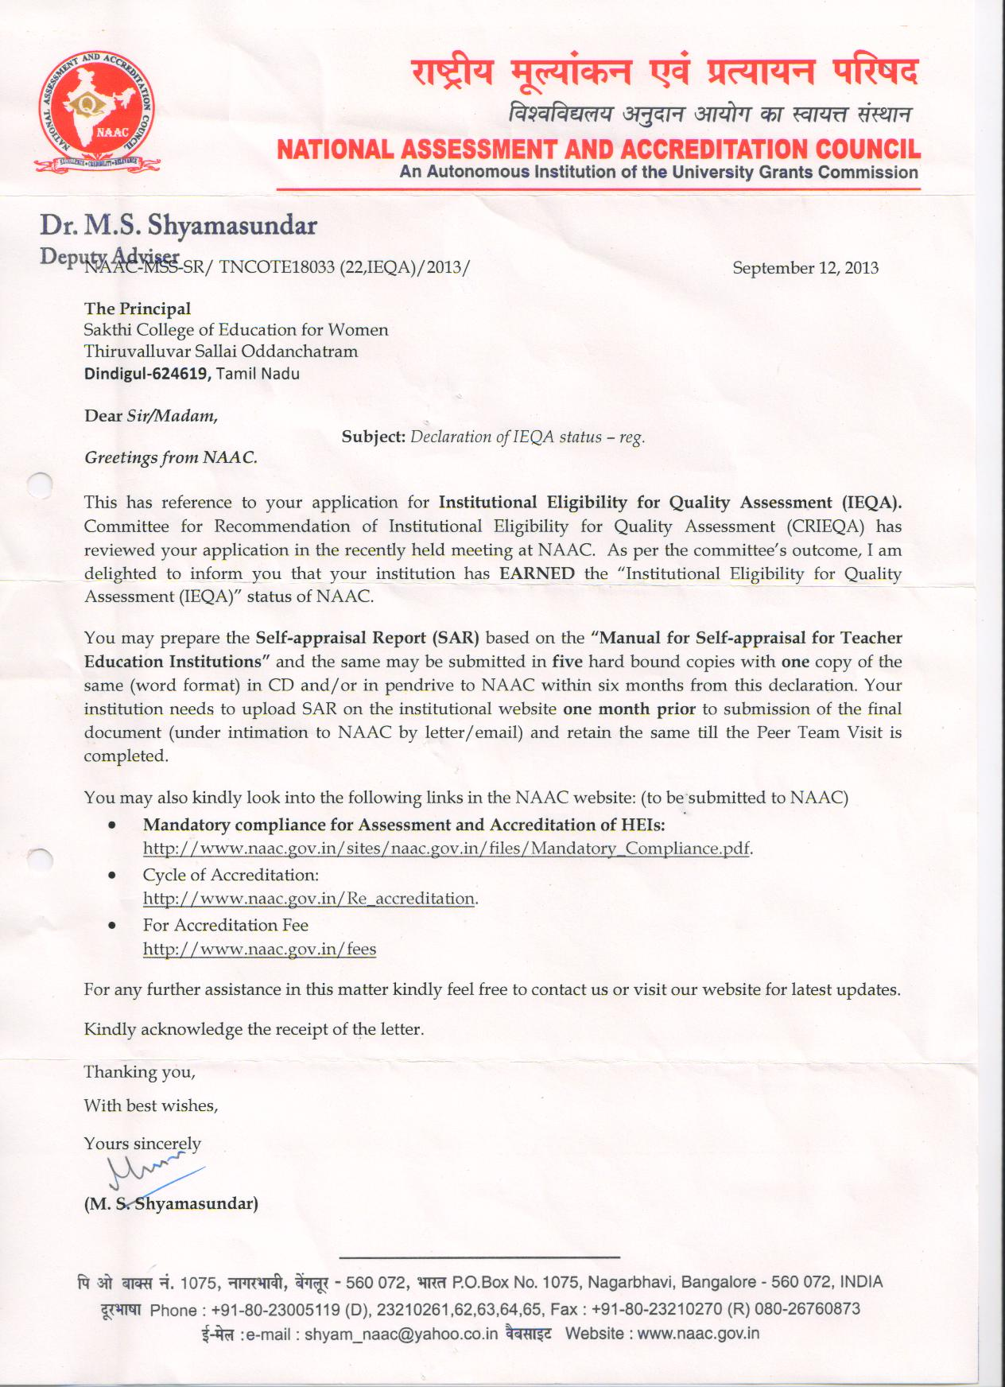
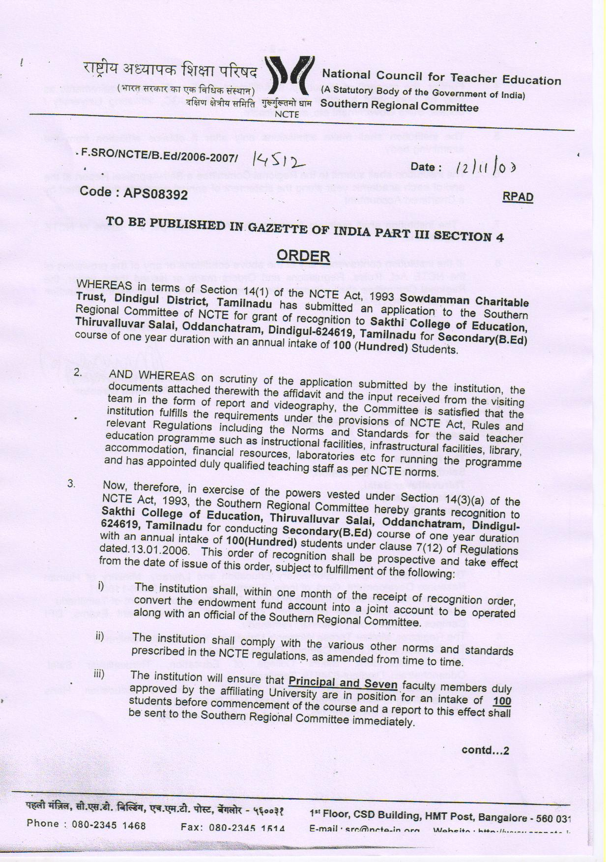

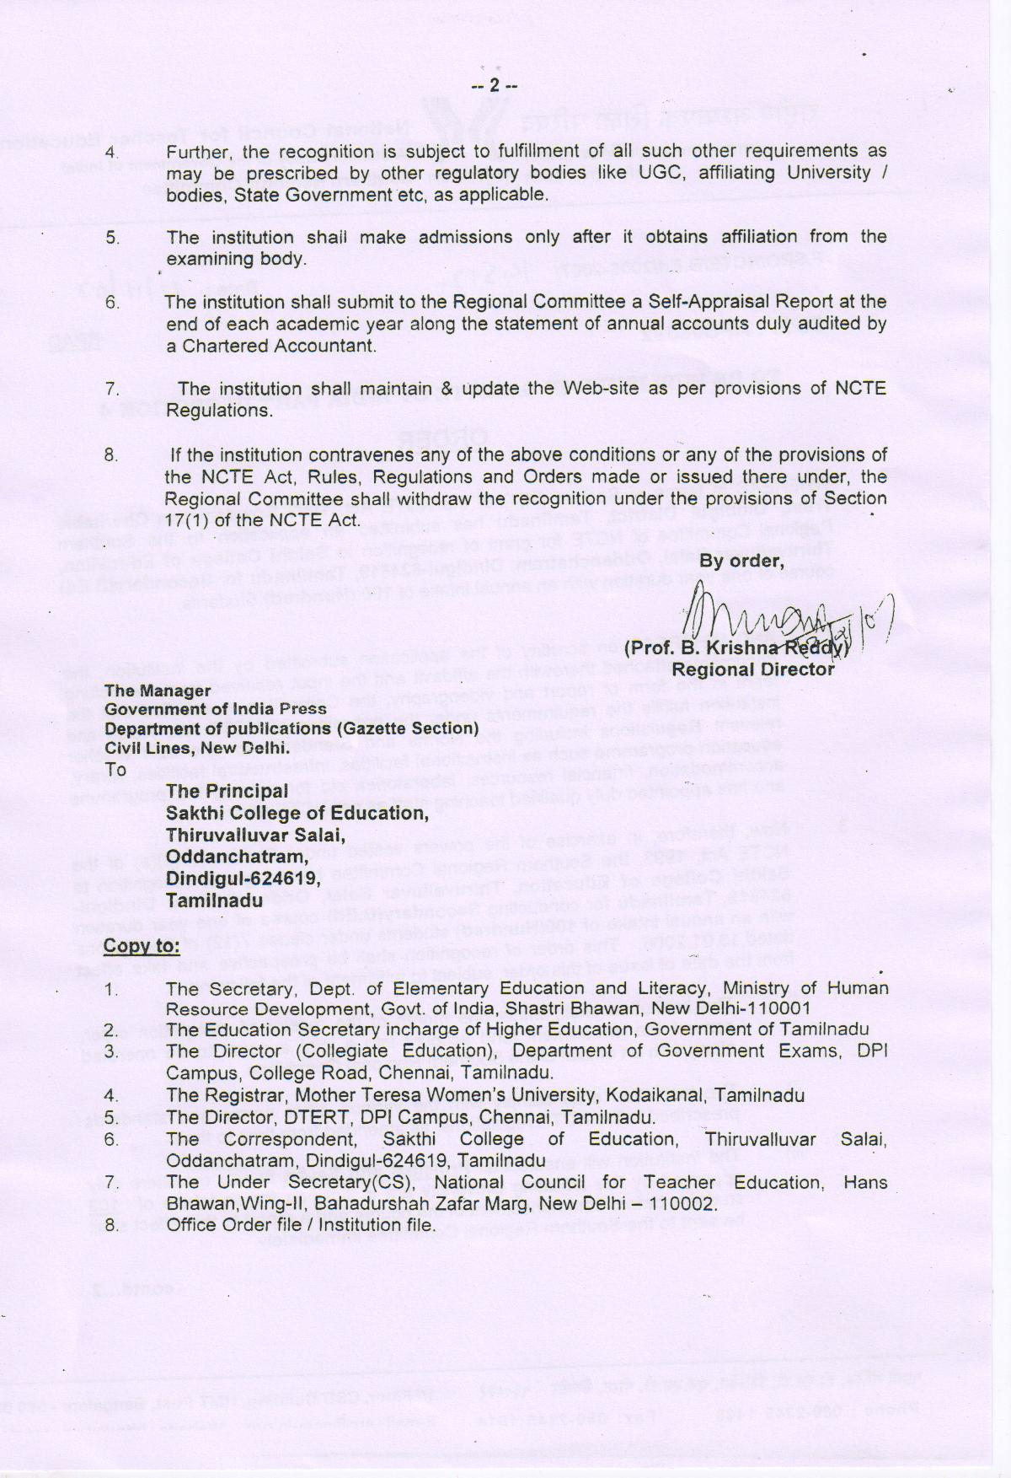

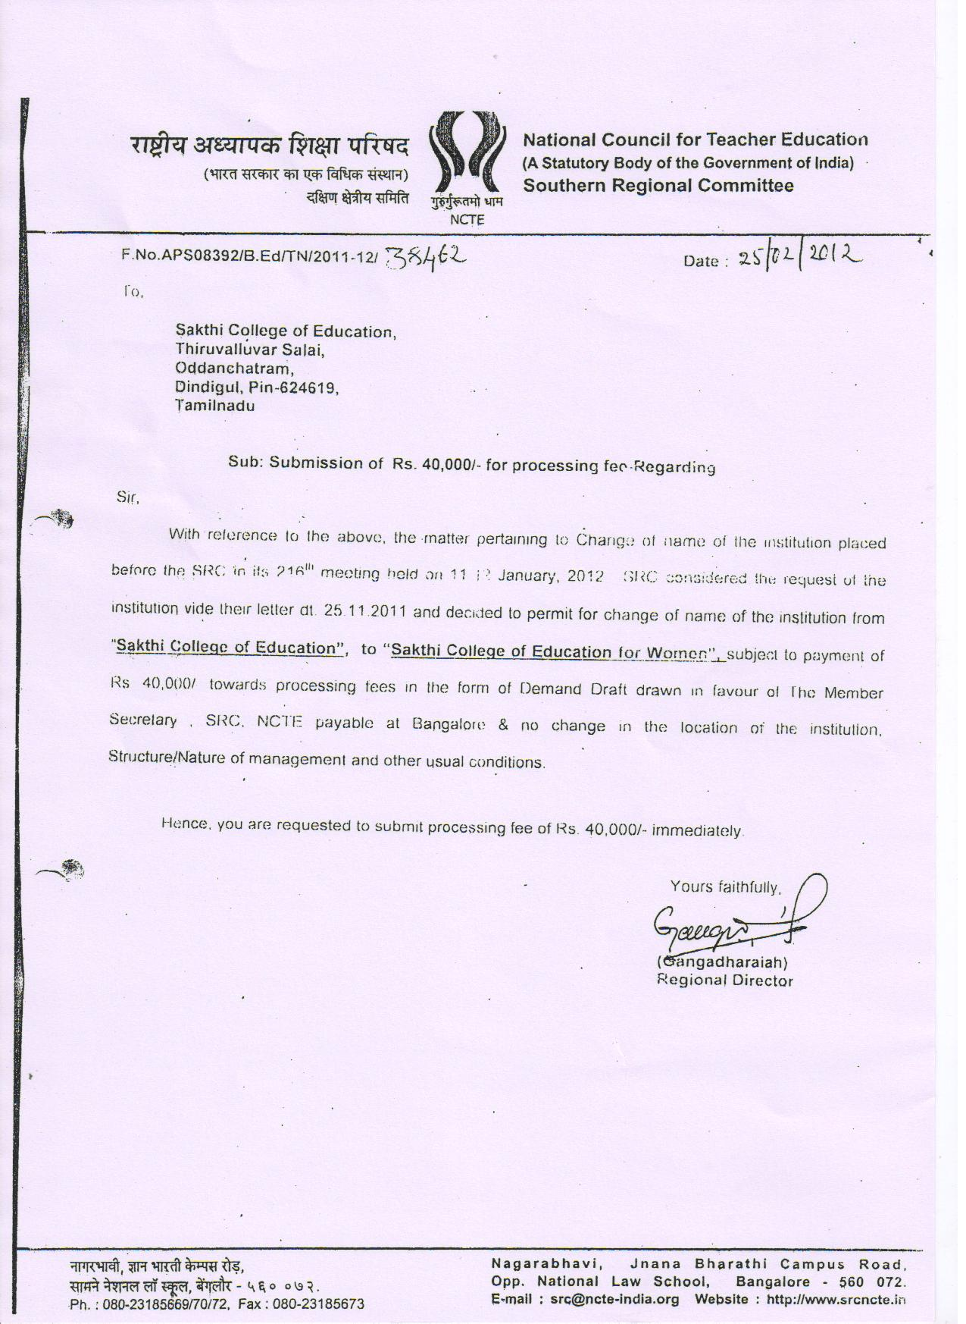

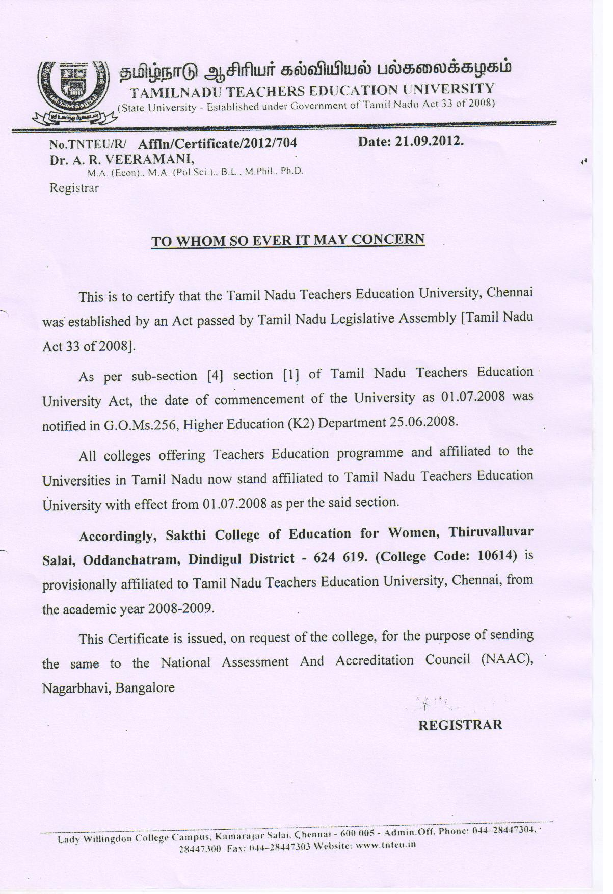

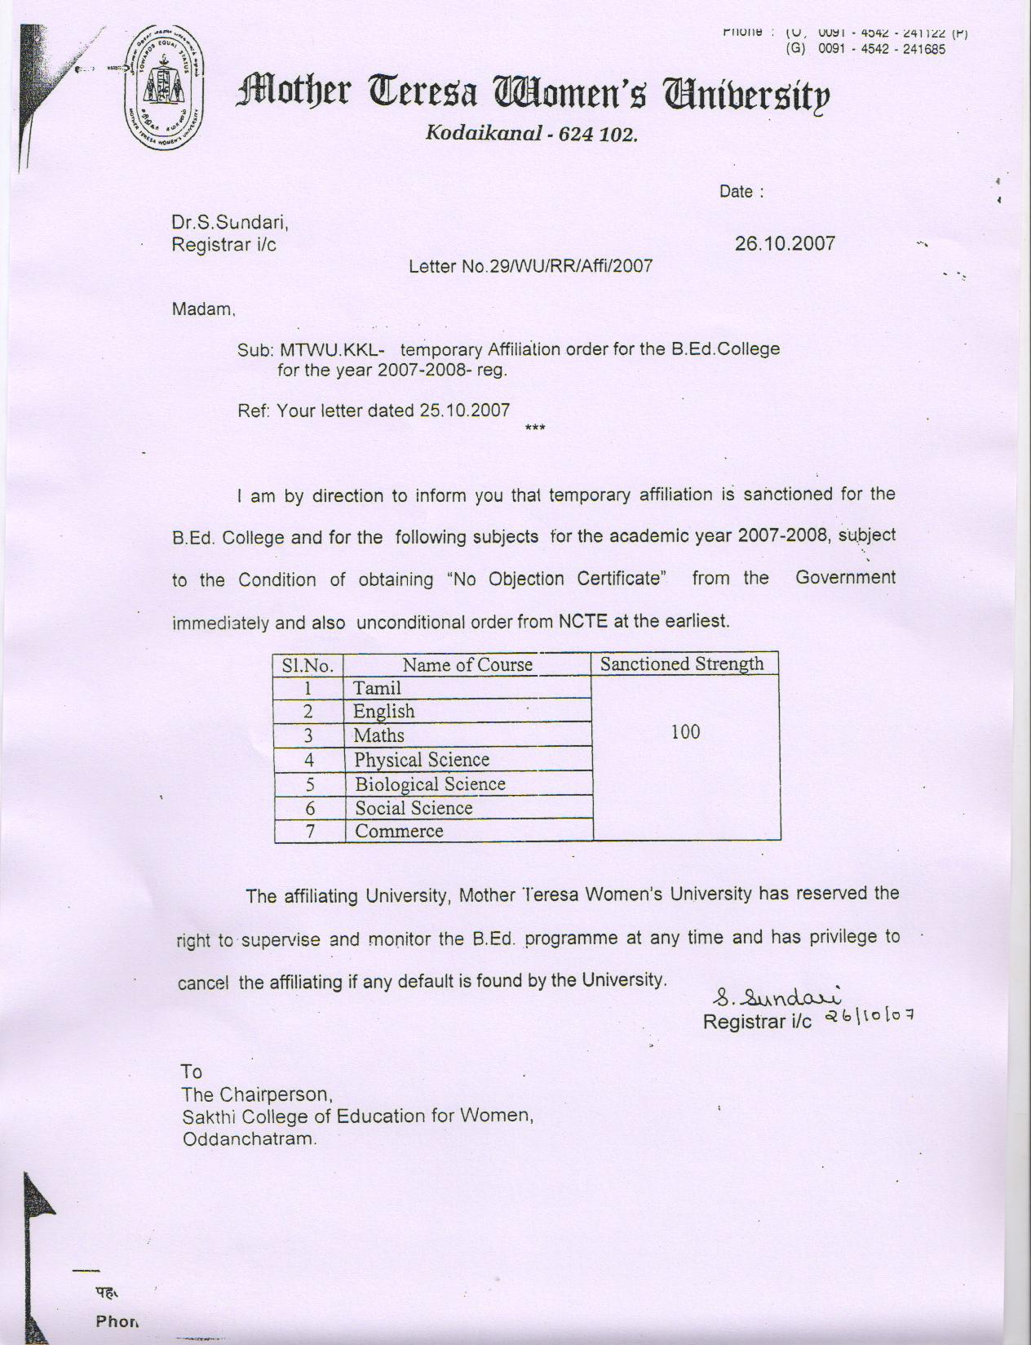

PREFACE
We, the Sakthi College of Education for Women, Thiruvalluvar salai, Dindigul – Palani Main road, Oddanchatram – 624 619, Dindigul (Dt), Tamilnadu (NAAC track id is TNCOTE18033, Dated: 19.07.2013) are extremely inspired by the tenet of NAAC that the process of “Assessment and Accreditation is essentially for the collective endeavour of an institution and the members of the faculty to constantly and consistently move forwards and upwards in the direction of relevance, effectiveness and credibility of the professional work they are engaged in“ considering this as touchstone, our college volunteered to seek, assessment about the level of performance as we are ahead in pursuit of excellence. The enhancement of self – esteem is governed in each and everybody through the implementation of high quality consciousness. Great hope is expressed on the aspect of candid self - assessment which will definitely help the college to perceive the strength and weakness. Accomplishment of performance and quest for excellence evolve naturally while marching along with quality improvement.
This effort of ours is a collaborative and participative process, as it should be, under the able and far sighted leadership, benevolent supervision and advice of the college management.

The steering committee includes representatives from various constituents:
Management Committee
Dr.K.Vembanan, M.B.B.S., M.S.,
Dr.K.Gokila Vembanan, M.B.B.S., DGO.,
Mr.K.Sivakumar, M.Sc., M.Ed., M.Phil.,

Chair Person
Dr.K.Gokila Vembanan, M.B.B.S., DGO.,

Secretary
Mr.K.Sivakumar, M.Sc., M.Ed., M.Phil.,
Criterion Wise Heads:

Criterion Name
I. V.Renukadevi
II. C.Samundeeswari & D.Vasantha Priya
III. A.Sutha
IV. G.Sasikala
V. T.Petroshia & R.Shanthi
VI. R.K.Sharmila
VII. A.Leeli Suvakyanal

This report consists of the following contents.
Part I: Institutional Data
Part II: Evaluative Report
Annexure

This Self Appraisal Report is submitted with a sense of satisfaction and with high hopes for an exemplary future.

